
FS1935
Electrical Powered
Heavy Duty Cold Water
High Pressure Cleaner

WATER JETTING SOLUTION

USER GUIDE & SPARE PARTS MANUAL
Original instruction

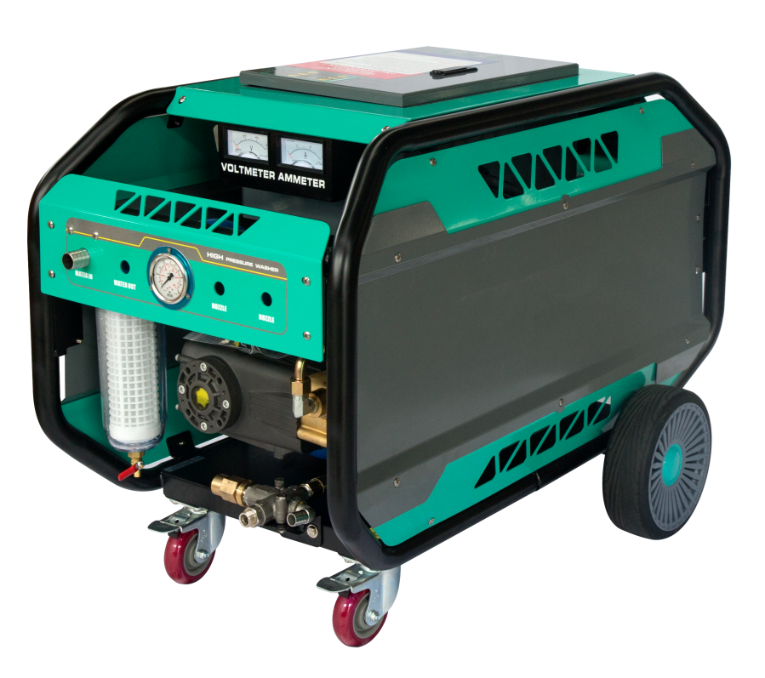

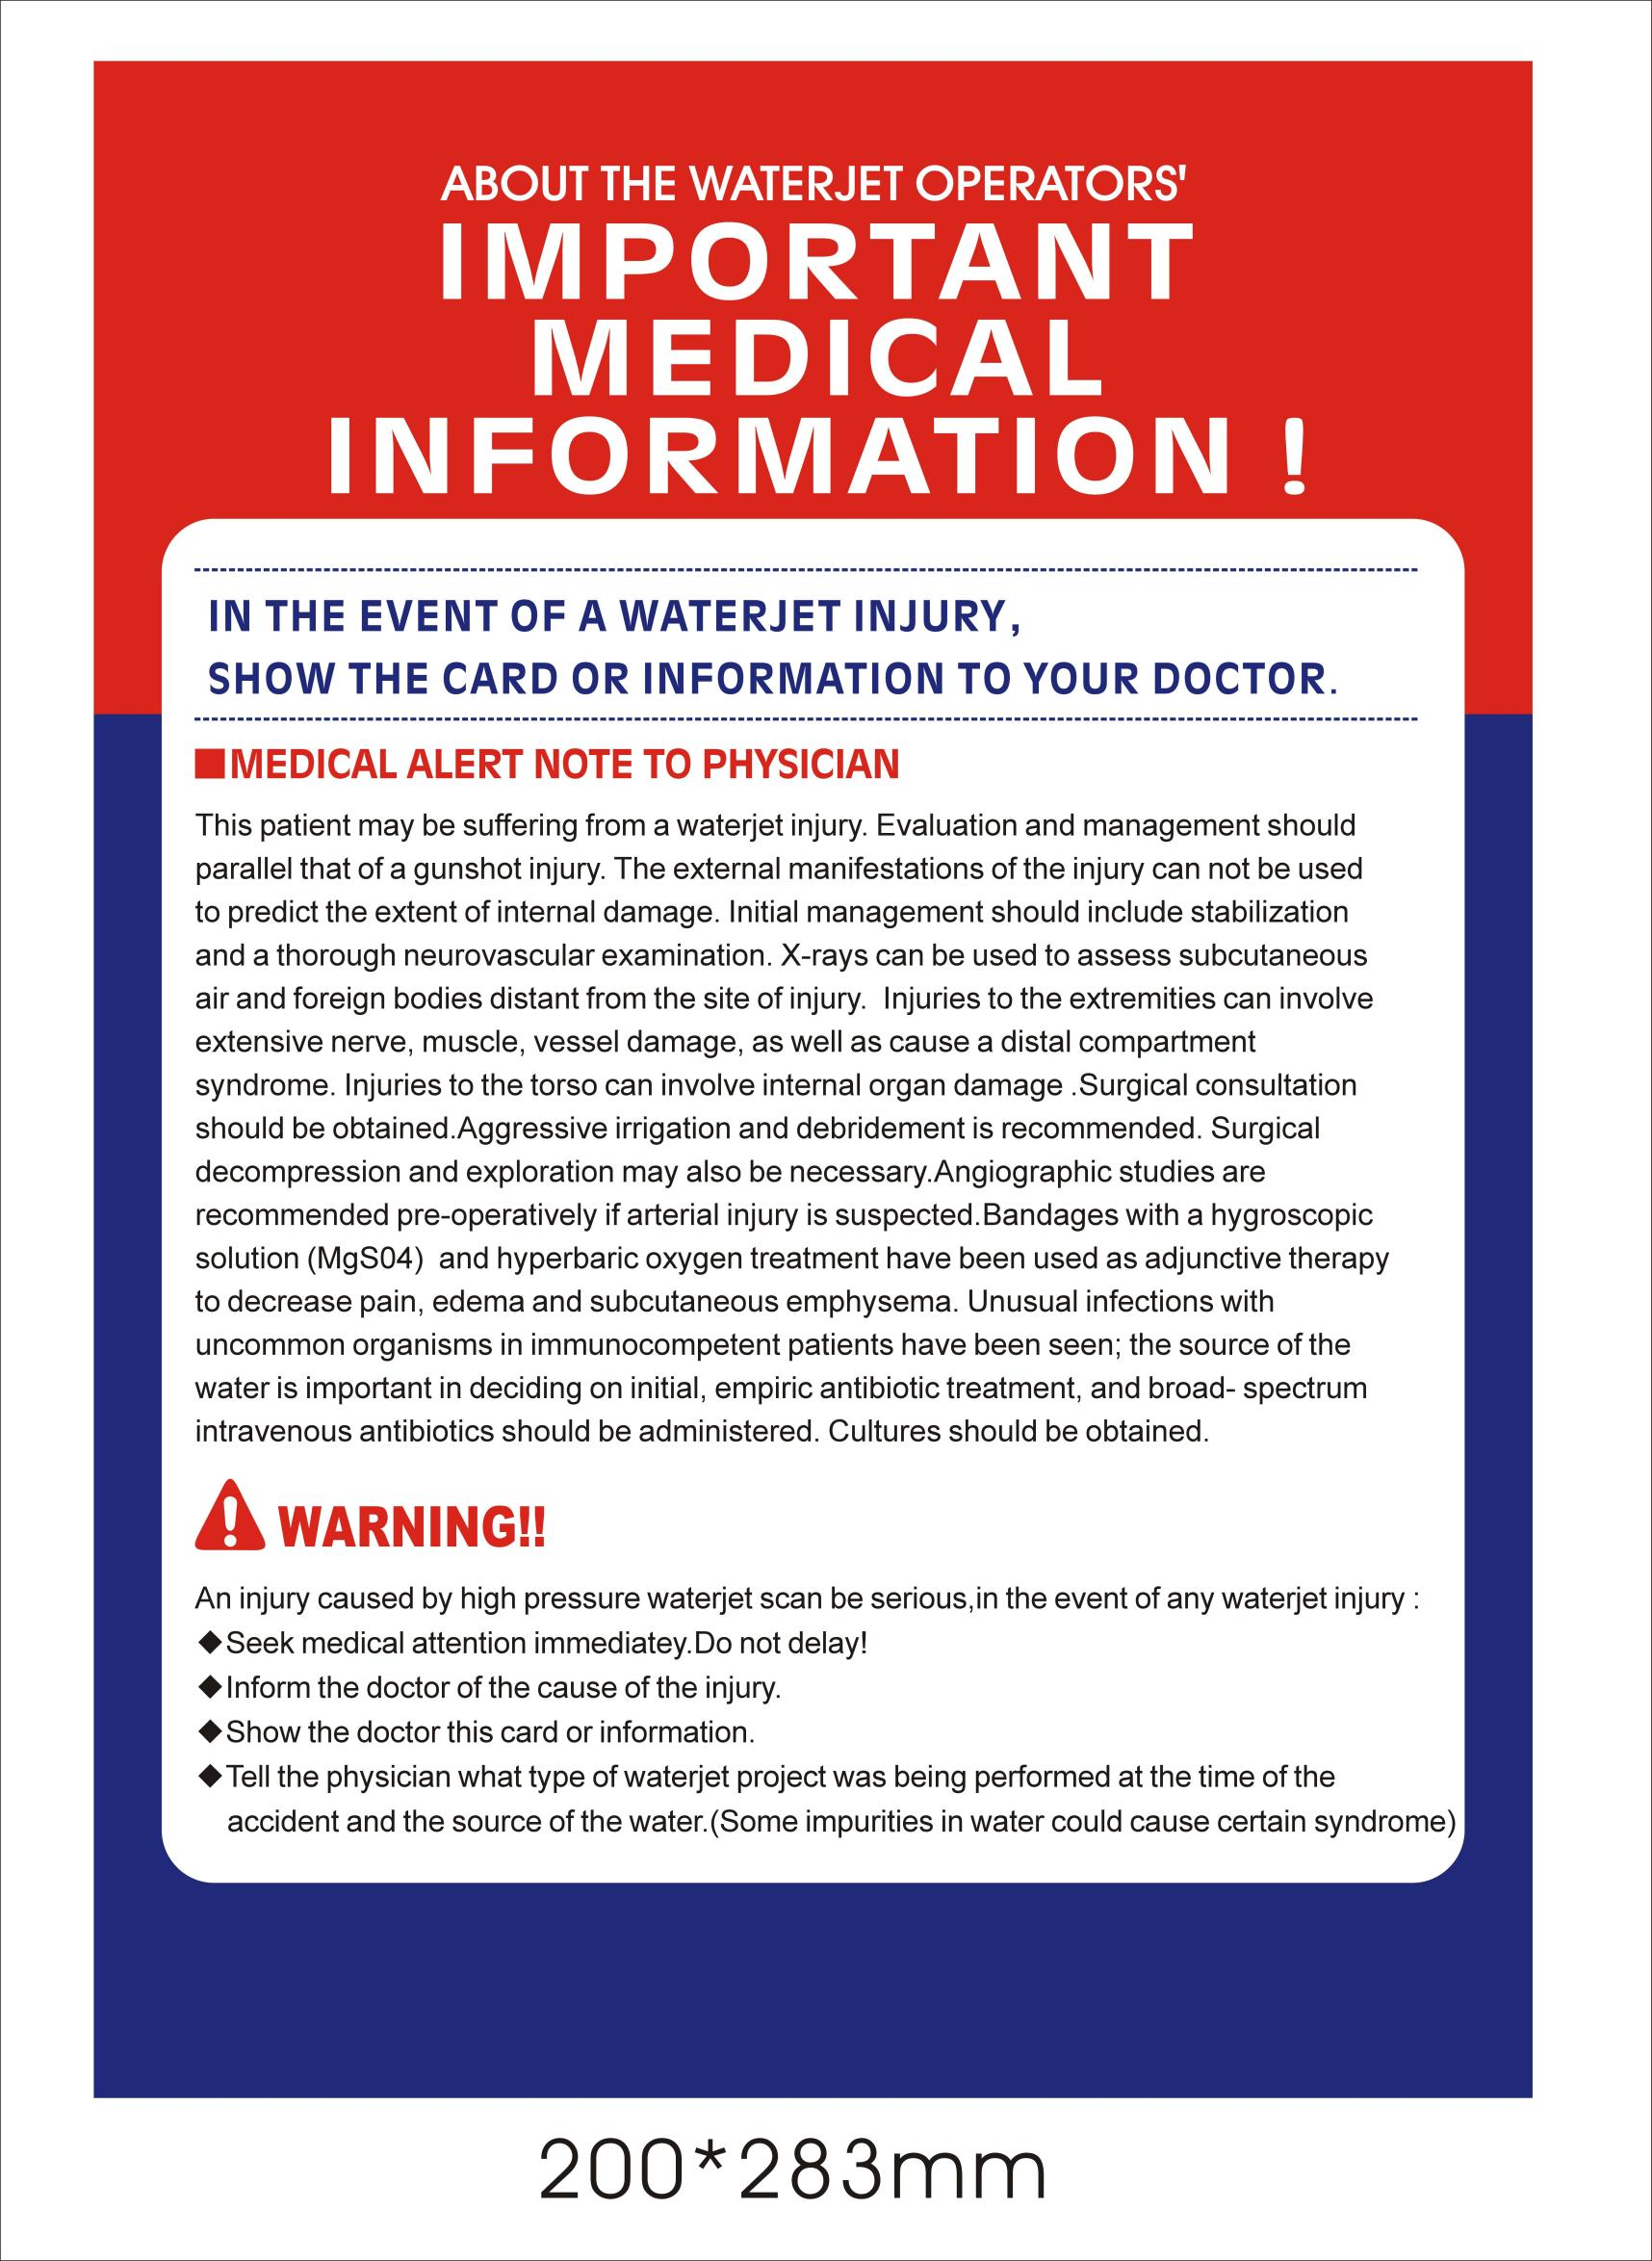
Introductions

Congratulations on your purchase of the BOTUOLINI FS1935Water Blaster.

BOTUOLINI makes no warranty of any kind with regards to this material, including, but not limited to, the implied warranties of merchantability and fitness for a particular purpose.

BOTUOLINI expressly disclaims all responsibility and liability for the installation, use, purpose, maintenance, and support of third party products.

This Original Instruction or part of it may not be photocopied, or in any other way reproduced, or translated to other languages without the prior written consent of BOTUOLINI.

Warning

Read this user manual before you start up your Water Blaster the first time.

This machine is a Water Blaster producing water jet under high-pressure, which is why severe injuries can occur if the safety precautions are not observed.
Therefore a full understanding of the contents of this instruction manual is required, in order to prevent injuries to you, objects and persons nearby.

Safety
The following symbols are used in this manual to indicate procedures that if not followed, may results in personal injuries or damage to equipment.




WARNING is used to alert the reader of procedures or practice which if not followed correctly could result in personal injuries.

WARNING




CAUTION is used to alert the reader of procedures or practice which if not followed correctly could result in damage to machine or other equipment.

CAUTION




NOTE is used to highlight important information that may assist the reader carrying out the procedure or understanding the text.

NOTE



HOT SURFACE is used to caution user of hot surface that may cause injuries. Any maintenance work to be done after the surfaces had cool down.
EAR PROTECTION is used to caution of high noise machine level. User must wear ear plug or ear muffler. High noise level will damage user hearing.

Operation Information

High Pressure Machine has IP55 rating. Parking the machine outdoor will not pose any damage to the machine. Ensure that the ventilation to the motor must not be blocked. During operation, the machine must not park at an incline angle of 10deg. The machine will become unstable and may endanger user. When hose is pull up to a high, pressure will drop due to gravity.

This machine is designed to deliver clean water or non-aggressive water. Using any other water source or sea water will damage the pump unless authorized in writing by BOTUOLINI.

Prior to beginning work, all equipment must be inspected to ensure that it is in safe working condition. Inspection shall include verifying the integrity of hoses and connections, tips, lances. Personal protective equipment must be worn.

Prior to commencing any water blasting work, the area must be barricaded to restrict unauthorized access.

We recommend to practice to employ 2 operators* blasting method. The role of the 2nd operator is to attend the pump unit keep close watch on the 1st operator for tiredness. Therefore, the operators can take turns to operate the machine.

- Operators must be trained on how to operate the machine (BOTUOLINI) and the basic blasting protocol before allow to use the machine.
  - How to prepare machine for usage
  - Correct way of holding the trigger gun for blasting due to the recoil force from the trigger gun.
  - Understand how to operate the machine correctly.
  - Basic Maintenance and Troubleshooting.

 BOTUOLINI Training program is available upon request. Please contact us for details 




IMPORTANT that user read the manual guide to understand the operation of the machine before usage.

NOTE




USE ONLY FRESH WATER . No other chemical or sea water is to be used. Any authorize liquid that are used without the approval from manufacturer will void the warranty and destroy the machine components.

NOTE

Version : Nov 2022

Revision | Rev.No.
Manual Updating
Manual Updating,
Manual Updating,
Manual update
Manual update

Table of contents
Introductions 1
Table of contents 3
- Getting acquainted with your Water Blaster 4
Fast and efficient cleaning 4
Specifications 4
Applications 5
Unpacking 5
SV- Safety Valve Operation 6
UV-Unloader Valve Operation 6
Hose Type 7
Machine ID Plate 7
Machine Highlights 8
Machine Installation / setup 12
- Safety and protection information 14
General safety 14
Safety devices 16
Transporting the machine 17
Machine Lifting Configuration 17
Safety precautions 18
Safe use of machine Guidelines 19
Safe Application guidelines 20
- Maintenance and troubleshooting 21
Maintenance Schedule 21
Machine Do`s and Don`ts 22
Troubleshooting 23
Service Instructions 24
- Spare parts list 31
Main Chassis Assembly 31
Main Chassis Assembly spare-parts list 32
Motor & Pump Assembly 33
Motor & Pump Assembly spare-parts list 33
Filter Assembly 35
Filter Assembly spare-parts list 35
Pump assembly 35
Pump assembly spare-parts list 36
Pump Spares Kit List 38
Un-loader valve assembly 39
Un-loader valve assembly spare-parts list 40
Safety valve assembly 41
Safety valve assembly spare-parts list 41
Trigger / gun / lance & hose assembly 42
Trigger / gun/ lance & hose assembly spare-parts list 43
Lance, Complete with different length 43
Rotating Nozzle Type 1 44
Rotating Nozzle Spare-parts list 44
Rotating Nozzle Repair Kit 44
Rotating Nozzle Type 2: Barracuda 46
Rotating nozzle assembly spares-parts list 46
Sand and & slurry blasting kit 48
El-box assembly spare-parts list 50
5. Wiring diagram ( 50/60Hz) 51
6. Warranty 52

Getting acquainted with your Water Blaster

Fast and efficient cleaning

The BOTUOLINI FS1935 enables you to get more cleaning done in less time.

This BOTUOLINI cold water Blaster offers you high performance and a design optimized for heavy duty use. The design of the surrounding frame safeguard the vital parts during transport and use, and the high performance gives you the opportunity to solve an array of blasting tasks. The Water- blasters are designed for industrial and for offshore use. All pump parts fittings and pipes in contact with water are made of non-corrosive materials. Together with the ceramic pistons, long life seals and stainless steel valves, it ensures long life and high durability.

Specifications

Model | Motor |  | Motor  Speed | Working Pressure |  | Flow Capacity * |  | Power  Supply | Dimensions  LxWxH | Weight
 | Hp | kW | rpm | Rated PSI  /Max PSI | Bar/Max  Bar | gpm | l/min | Voltage | mm | kg
E19500-60Hz | 15 | 11 | 1450 | 4350/5000 | 300/350 | 5.2 | 19 | 380V 50Hz | 1244x 506x 1141 | 230

* Temperature of high pressure water is about 60DegC

Machine Dimension
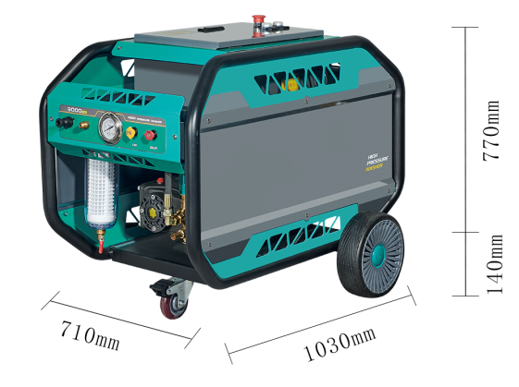

FS1935

Applications

These heavy-duty Water Blasters are capable of removing most kind of dirt:

  - Descaling
  - Surface preparation
  - Paint and rust removal
  - Concrete removal
  - Cargo Area

And with the option for use of accessories even many more jobs are to be dealt with:

  - Sandblasting
  - Drain cleaning




This machine is only to be used for the purposes it is designed for. Any other use shall be considered improper and therefore potentially dangerous. The manufacturer is NOT to be held responsible for any damages caused by improper use or modification.

CAUTION

Unpacking

Remove the Water Blaster and its accessories from the packing material, if any. For transport and packing reasons some accessories are supplied disassembled.

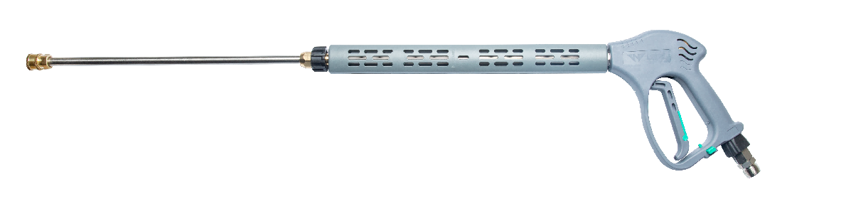
Standard items:

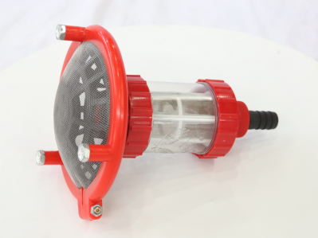
Trigger Gun

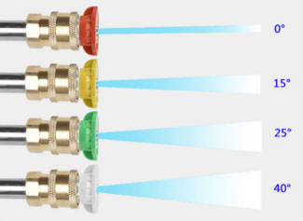

Water inlet filter

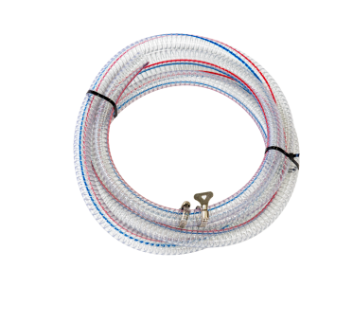

Nozzle

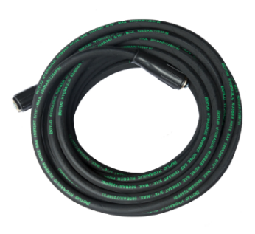

High Pressure Hose
Water Inlet hose

FS1935

High Pressure Machine Schematic Diagram FS1935

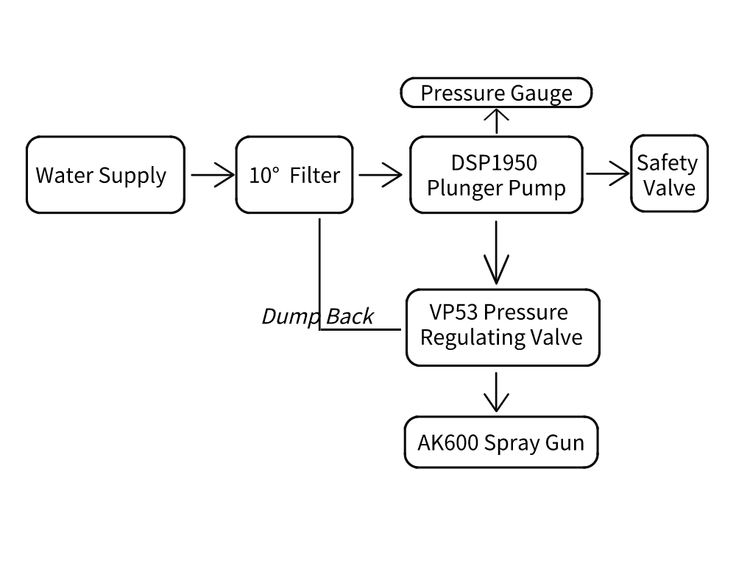

Remarks:

- SV : - SV (Safety Valve) is set at factory about 20~30Bar more than PG 2(Pressure Gauge)
- TG: - TG (Trigger Gun –Dry) is normally close, pressurize when trigger is pressed.
- UV: - UV (Unloader) is normally open, pressurize when trigger is pressed.

CAUTION
Machine is manufactured with factory preset settings for its Unloader and Safety valves. Please do not try to change these setting. Adjusting the setting will affect the machine performance or machine become unstable. A trained personal is required to change the settings if necessary.

SV- Safety Valve Operation

Safety valve is a system to protect the machine from over pressure. Over pressure occurs when nozzle size is wrong or the nozzle is chocked. Another possible cause is the unloader setting is wrongly set. When machine is over pressurized, the safety valve will start to open and excess water is dumped. The setting of the safety valve system is factory set, do not try to reset them.

UV-Unloader Valve Operation

Unloader valve system is a system to regulate the pressure for the machine. The setting of the unloader valve system is factory set. Do not try to reset the setting. There should about 5% water dump back into the water tank if the nozzle is use correctly

Hose Type:
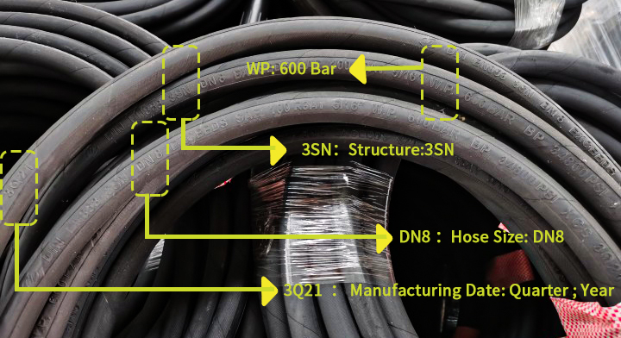

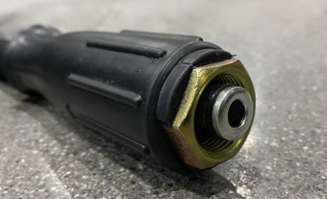

CAUTION
Do not bend the hose or squeeze between doors. Replace the hose if
the hose wire is exposed. Read the WP allow on the hose before using the machine. Always switch off and depressurize the machine before attach or dettached the hose to the machine.

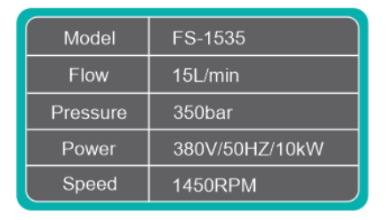
Machine ID Plat & Lable

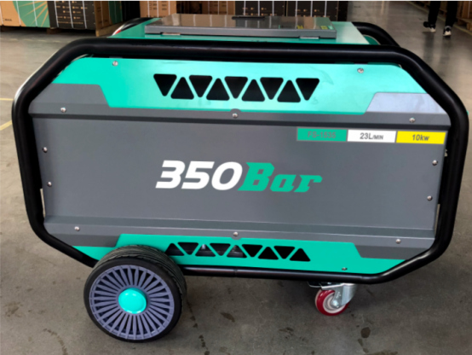


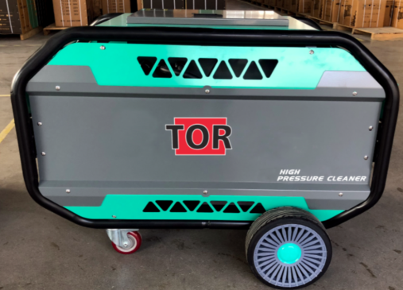





The information contained in this user guide is subject to
change without notice

Main Equipment Layout

FS1935

Machine Highlights

Max. 1000bar Pressure Range
Pressure Gauge

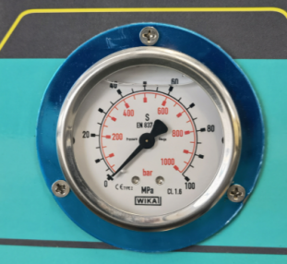
Safety valve
Voltmeter

Ammeter
Water Inlet G3/4

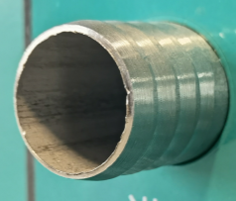
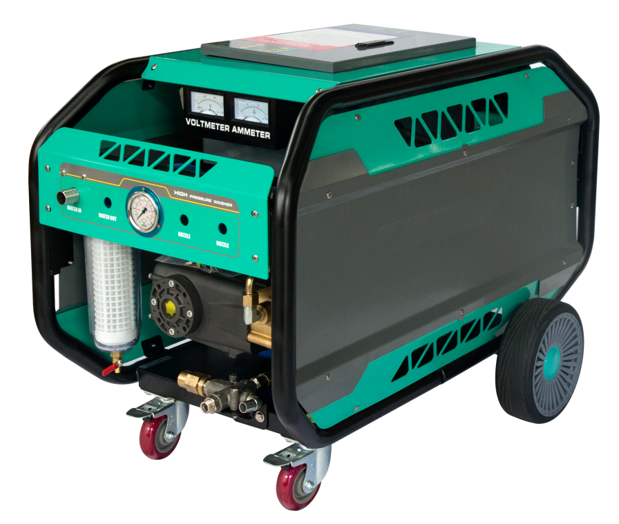

Inlet filter

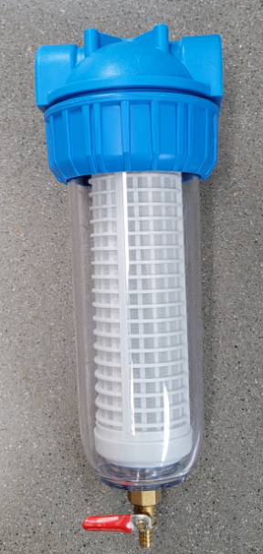

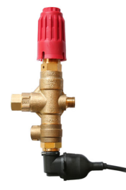
10” solid wheel
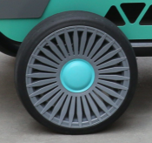
Universal wheel

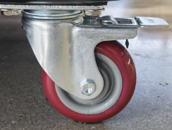
Regulator

HOT SURFACE is used to caution user of hot surface that may cause injuries. Any maintenance work to be done after the surfaces had cool down.

FS1935

HIGH PRESSURE MACHINE LOCKOUT/TAGOUT PROCEDURE

This procedure establishes lockout on the high pressure machine that could cause injury to personnel. All operators shall comply with the procedure. Equipment shall be locked out to protect against accidental or inadvertent operation when such operation could cause injury to personnel. Do not attempt to operate any switch, valve, or other main switch bearing a lock.

Responsibility
The responsibility for seeing that this procedure is followed is binding upon all operators. All operators shall be instructed in the safety significance of the lockout procedure by (designated individual). Each new or transferred affected operator shall be instructed by (designated individuals) in the purpose and use of the lockout procedure.

Sequence of Lockout Procedure
- Notify all affected operators that a lockout is required and the reason therefor.
- If high pressure machine is operating, shut it down by the pressing the stop button. Only turn off the booster pump switch when the motor has come to a stop.
- Turn the main isolator to the off position.
- Release residue pressure in the trigger gun.
- Lockout the main isolator with a lock assigned individual lock. This is to disable the operation of the machine.
- Lock the electrical box and the keys are kept with an assigned individual lock to prevent any unauthorized modification to the machine control settings.
- Lockout the trigger with a lock that is assigned individual lock. This is to prevent accidentally activate the trigger or sabotage. Possible way to lock the trigger gun as shown below.
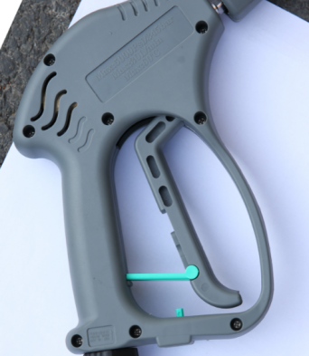

Lock

After ensuring that no personnel are exposed and as a check on having disconnected the power sources, operate the start push button and main switch to ensure the high pressure machine will not operate. CAUTION: Return operating controls to neutral position after the test.
- The equipment is now locked out

Restoring Equipment to Service
- When the high pressure machine is to operate at is normal service, check the area around the machine that no one is exposed. Barrigate the area of working zone to prevent people entering the working zone.

- When equipment is clear, remove all locks. Turn on the main switch, unlock the trigger gun lock and start the normal operating procedure to start using the high pressure machine.

FS1935

Unloader/Safety Valve Protection

Machine’s unloader Valve /Safety Valve are factory pre- set. Purpose of the Unloader is to regulate the machine pressure according to nozzle size. Safety valve is to prevent the machine from over pressure.

Therefore, it is not recommended to adjust the setting on these valves. If setting is required, a trained personal must performed the task. Incorrect adjustment to the valve may results machine damage which will cause warranty void.

To prevent unauthorized adjustment to the valves, these valves are applied with tempered proof sealant. Once the sealant cracked, it showed that unauthorized activities occur on the valves.

CAUTION

Important!

The unloader valve is factory set. Only trained/ authorized personal is qualified to perform any adjustment in the event the tempered sealant is broken.
The Unloader Valve system is designed to allow a small amount of water flow through the by-pass port during operation. This is to ensure a smooth by-pass operation, and prevents any unwanted pressure spikes when the gun is shut. See pg. 30 for proper setting/ adjustment of valve when required.

Unloader Valve:

Tempered Proof
Sealant

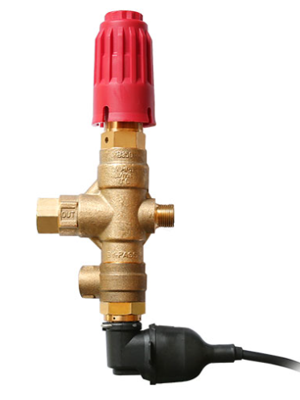

Machine Installation / setup

Step 1. Make sure that the machine is operating on flat floor or inclined not more than 10Deg. The machine must be parked or securely tighten to structure.

Step 2.Prepare the water supply, by attaching water hose to the
G3/4 male-coupling.

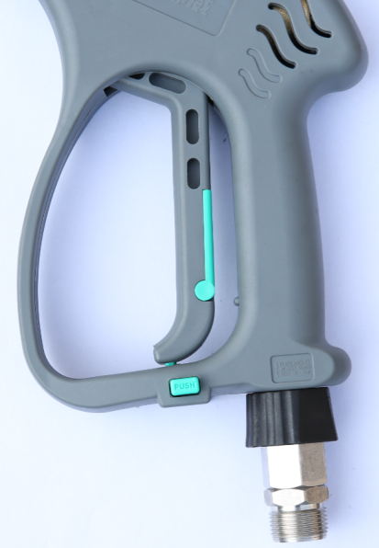
Step 3. Next, mount the trigger gun with lance to the other end of the 22*1.5 high-pressure hose. Always use two wrenches when tightening the hoses.
It is important to use FRESH water. Any other liquid or chemical will damage your pump. Using recycle water, please make sure that the impurity (sand, stone…) must be filtered. It is recommended to use additional filter (130um) to filter incoming water before going into the tank or pump’s water inlet when using recycle water. Please note that any recycle water not process properly will shorten its pump life span.

Step 5. Turn on the water supply tap and fill the water tank with water. When water tank is full, the water will be cut off.

Step 6. Connect the main power cord to a grounded 3-phase main power supply.
Connect the power supply (power cable 4×16MM2 ). Check all connection terminals for looseness
and pressure insulation. The ground wire is reliably connected
to the motor ground before power on

Machine Start Up Procedure
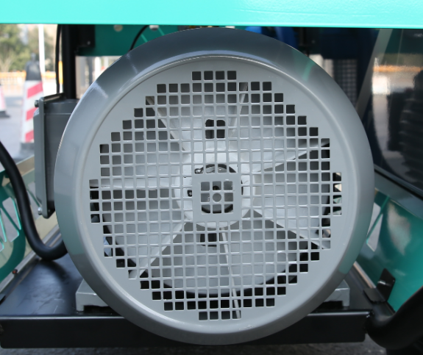
Step 1. Press the green “Start” button to start the main motor. Ensure the motor (D) turns clockwise (view from motor fan end) indicated by the arrows on the motor fan cover. Please allow the main motor to run for a few seconds for the star delta connection to switch over automatically. The Water Blaster is now ready for operation. Get a firm grip with both hands on the spray-gun handle and the lance. Press the trigger and start blasting.

D

Machine Shut Down Procedure

Step 1. Pressed the red “Stop” button and ensure the motor comes to a complete stop.

Step 2. After shut down of the Water Blaster, always release the pressure inside the high-pressure hoses by pulling the trigger on the spray-gun before dismantling the high-pressure hoses.

Step 3. Dis-connect the lance and hose/s, and carefully store them in a safe place.

It is NOT allowed to connect this Heavy Duty Pressure washer directly to a portable water supply! If portable water is used, it is strictly necessary to include a water break tank in accordance to EU standards EN 1717


Make sure your local power supply specifications are in accordance with the motors specification Refer to the ID-plate located at the electrical box or frame. Do not let the machine recycle the water (running with Spray-gun trigger not activated) for more than 10 minutes; this can cause serious damage

CAUTION

.Using method of operation
- Connect the power supply ( Power cable 4×16MM2 is recommended for 18.5KW machine). Check all
connection terminals for looseness and pressure insulation. The ground wire is reliably connected to the
motor ground.
2. Connect the water supply (water supply is recommended to use DN20 or G3/4 water pipe).
3. Connect the high-pressure outlet pipe and check that the surface of the high-pressure pipe is not damaged,
and the joint is not loose.
4. Change the pump plug to a breather plug and check the oil level.

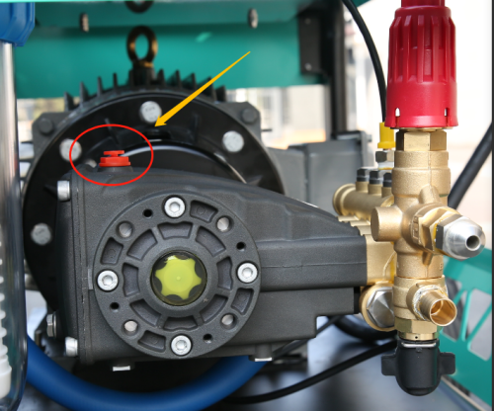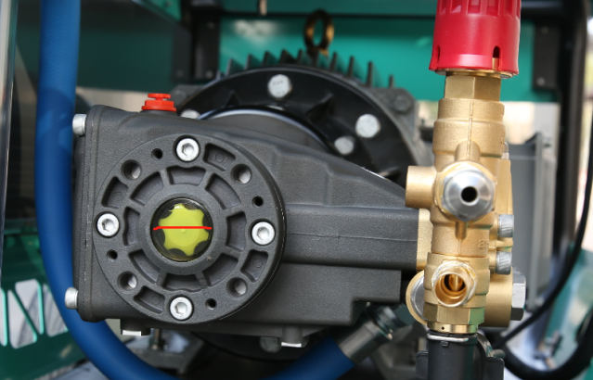
5. Rotate the pressure regulating valve to the unpressurized state (ie, the spring free state).

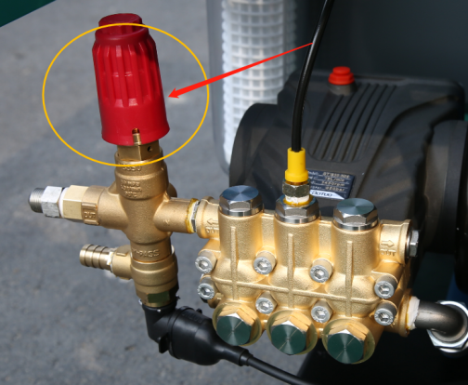
6. Turn on the power, Step 01, press the butten “START" , check the motor rotation direction; After confirming
that the rotation direction is correct, start the device and drain the air in the pipeline and equipment.
7. Check if the nozzle model matches the device (FS1935 adapter nozzle model 035 or 040).
8.FS1935 adopts gun stop delay control(The voltage of the pressure switch control circuit is 380v, and the operation should pay attention to the safety of electricity)After completing the above 1 to 7, directly start the water source booster pump and the main motor. After opening the cleaning gun, rotate the pressure regulating valve's pressure regulating nut or handle, and adjust to the specified maximum pressure of 350 bar.
9. BF-2550 adopts soft start control. After completing the above 1 to 7, start the water source booster pump and the main motor. After opening the cleaning gun, rotate the pressure regulating valve's pressure regulating nut or handle to the maximum pressure of 350bar. This model cleaning machine does not set off the gun to stop.
10. When the equipment is stopped, the water in the equipment should be excluded, the power supply should be cut off, and the pressure regulating valve should be rotated to the non-pressurized state (ie, the spring free state). Wipe the surface clean and wind up the high-pressure hose.
11. When using in winter, pay attention

2.Safety and protection information

EAR PROTECTOR EQUIPMENT must be worn at all time when using the machine. This is to prevent user from hearing related injuries. Noise warning sticker can be found on the machine to warn high noise emission values
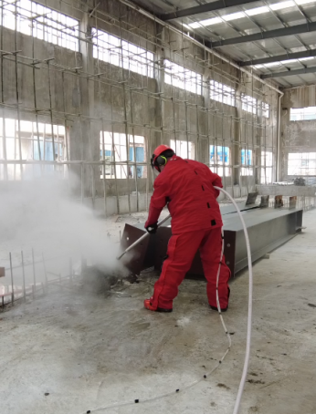
It is recommended to put on ear protection equipment, etc. ear plug or ear muffler to protect the user from pro-long under high noise environment.

Recoil Force of Trigger Gun:

Trigger Gun Complete

Based on calculated value, there will be a recoil force of 147~158N acting on the trigger gun to the user.
Therefore, a shoulder rest is provided with every machine. Holding a trigger gun in a correct position will
prevent any unnecessary injuries as shown.

Be more caution when using the trigger gun. Shoulder rest is for the user to rest its trigger gun on its own body weight to counter react to the recoil force created by the trigger gun. Release any residual pressure from the gun when the machine is shut down.

CAUTION
Trigger Gun Vibration:

The declared vibration emission value ahd is 6.3 m/s2 with an uncertainty K of 1.1 m/s2”. Pro-long working with the
trigger gun will cause tiredness to the user. It is recommended to work with the trigger gun not more than
20min continuously.

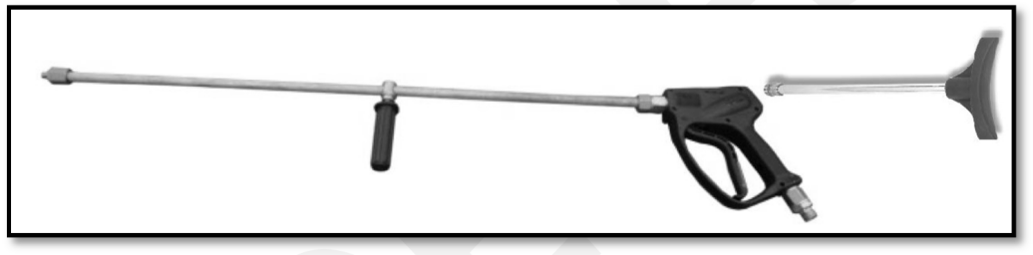

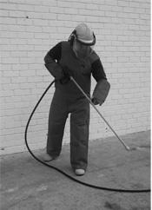

CAUTION
Caution must be observe when working with trigger gun . Do not work continuously without rest in between jobs. Release any residual pressure from the gun when the machine is shut down

Immediate hospital attention should be given personnel who sustain equipment related injuries while operating the system. In such cases, it is vital that medical personnel be apprised of all facts relevant to such injuries. Therefore, all operating personnel should be provided with waterproof emergency medical alert tags or cards, describing the nature of their work and the possibility of injury inherent in the use of water jetting equipment. The below example of a standard card can be photo copied, laminated and used as medical alert tag.

IMPORTANT MEDICAL INFORMATION

WARNING

Obtain medical treatment immediately for ANY high-pressure water-jet injuries.

Inform the doctor of the cause of the injury.

Show this card to the doctor.
This card is to be carried by personnel working with high- pressure water jetting equipment.

BOTUOLINI - a division of Nilfisk Pte Ltd. No.5 Tuas Ave 2, Singapore 639445
Tel: +65 6268 1006 Fax: +65 62684916

MEDICAL ALERT NOTE TO PHYSICIAN

This patient may be suffering from a water jet injury. Evaluation and management should parallel that of a gunshot injury. The external manifestations of the injury cannot be used to predict the extent of internal damage. Initial management should include stabilization and a thorough neurovascular examination.
X-rays can be used to access subcutaneous air and foreign bodies distant from the site of injury. Injuries to the extremities can involve extensive nerve, muscle, vessel damage, as well as cause a distal compartment syndrome. Injuries to the torso can involve internal organ damage. Surgical consultation should be obtained. Aggressive irrigation and debridement is recommended.
IMPORTANT
MEDICAL INFORMATION
Surgical decompression and exploration may also be necessary. Angiographic irrigation studies are recommended pre-operatively if arterial injury is suspected. Bandages with a hygroscopic solution (MgSO4) and hyperbaric oxygen treatment have been used as adjunctive therapy to decrease pain, edema and subcutaneous emphysema.
Unusual infections with uncommon organisms in immune competent patients have been seen; the source of the water is important in deciding on initial, empiric antibiotic treatment, and broad spectrum intravenous antibiotics should be administered.
Cultures should be obtained

NSafety devices

The machine is equipped with the following safety devices:

- To reset the machine, turn the button clockwise and release. Machine will remain in its neutral state. To start up the machine again, user needs to press the start button again.
- Safety valve protecting against over-pressure. The safety valve will start to open and excess water is dumped. The setting of the safety valve system is factory set. Incorrect setting may void warranty for the machine.
- Thermal sensor and overload relay. The thermal sensor and the overload relay protect the motor against overloading. When overload trip, open up electrical box and reset the overload.
- If there is leakage current occurs, the RCCB installed will tripped. To reset, switch the lever to “ON” position. This device will protect the user from leakage current.
- When the incoming source is overloaded, the 40A MCB will protect the machine from damage. To reset, switch the lever to “ON” position.
- The front castor can be locked in place to prevent the machine from rolling from an incline surface of not more than 10º .
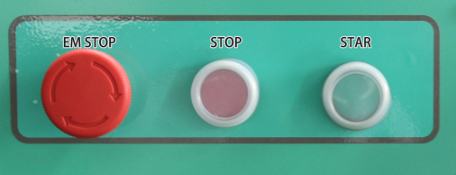
Electrical Box Warning Pictogram

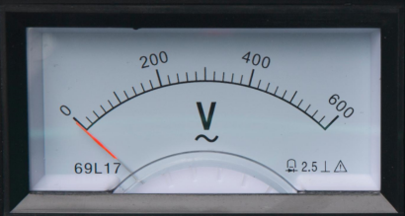

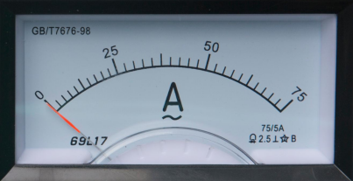

10In Big Wheel

Universal wheel

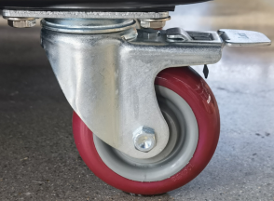
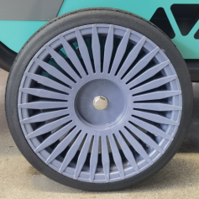

Safety precautions
Eye protection- Operators must wear visors and goggles to guard against spray and flying debris. A combination of both goggles and visor is advisable. And will protect the eyes and the face during both water- blasting as well as abrasive water-blasting  Head protection- Helmets must be worn at all time by personnel within the work area.  Helmet material must be able to withstand mechanical shock without fracturing.  Hearing protection- Operators and other personnel exposed to noise levels of more than 90-dBa for more than 1 hour must wear suitable ear protection. Ear plugs or ear muffs are usually sufficient. | 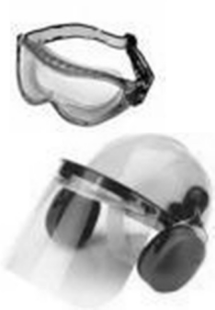  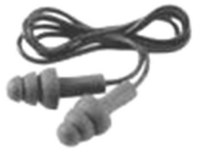
Hand protection- Shear proof gloves must be worn by the operator at all times. A glove combination of a cloth inner lining and a water tight outer layer is preferred. | 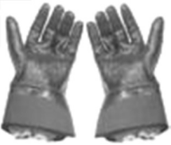
Foot protection- Safety footwear with steel toecaps must be worn. Basic safety footwear must also be equipped with metatarsal guards to protect the instep. Safety boots are available in other designs than the illustration.  Gaiters- This is an additional layer of protection to the user foot that are not protected by the steel top cap. It is intended to be worn outside of the user’s regular protective boots. Five clips ensure that gaiters securely stay in place. The entire area is protected. Very comfortable and light to wear. | 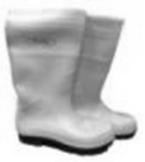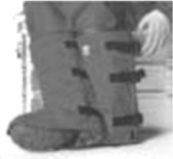
Body protection- Waterproof garments protect the operator only from spray and flying debris. They do NOT deflect direct jet impact. Therefore, an operator must take care never to point a water-jet either at themselves or other personnel.  Hose protection- Protect user from high pressure water injuries incase hose connection is loose. | 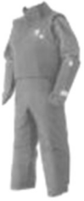  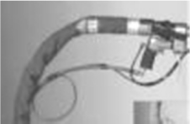





WARNING
The following protective clothing and devices should be worn both by personnel operating the water blaster system and equipment and by those working nearby.

Safe use of machine Guidelines

- Treat the machine as a high-speed cutting tool.
- Anyone under the age of 18 is NOT allowed to use the machine.
- Always use a proper plug and socket specially designed with ground to earth wiring. Only connect to an installation with earth wiring. A certified electrician shall make the installation. It is strongly recommended that the electric supply to the machine include a Residual Current Device/GFCI.
- Always keep the Water Blaster and its accessories in good working condition. Check the machine for defects, especially the insulation on the electric cable. DO NOT start up the machine if there is any defect. Have the machine serviced.
- When using the Water Blaster and its accessories, eye protection must be worn to protect against repelling or ricocheting matters causing eye damage.
- Suitable clothing and footwear must be worn while using the equipment to protect the operator. Do not try to clean clothes or footwear with the machine.
- Precautions must be made to keep bystanders away from the working range.
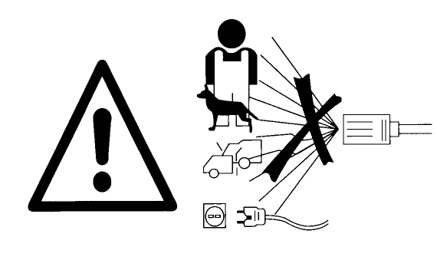
- DO NOT spray-clean on yourself, others or live animals. The high-pressure jets are capable of making severe injuries.
- DO NOT spray at electrical equipment OR the machine itself.
- While repairing or servicing the equipment and its accessories always make sure the machine is turned off and disconnected from the main power supply.
- Only allow instructed personnel to operate the machine.
- Activating the trigger/gun can cause backward force therefore always hold spray lance with both hands.
- When pausing during operation, turned off the main switch of the machine and ensures that the trigger/gun is locked.
- Only use high-pressure hoses, connections and nozzles specified by BOTUOLINI.
- IMPORTANT – Do not use the machine in a possible explosive environment in accordance with EN-50014.





WARNING
To prevent accidents from happening, ensure the safety of the person(s) who uses the equipment and to protect bystanders and nearby placed inventory or machinery, a few safety precautions needs attention jobs.

Safe Application guidelines

Hydro blasters can be operated safely if proper procedures are followed:

  - No one should operate this equipment without training and proper equipment. Please refer to the training video and user manual that comes together with the machine for set up and usage.
  - All personnel forming the operational team must have received prior familiarization and training with regard to the equipment. This must include clear knowledge of the operational capabilities of the equipment, as well as its limitations and precautions to be taken during its use. Staff must be aware of the high level of danger associated with incorrect operation of such equipment at high pressures. They must be familiar with the natural recoil of the nozzle while under pressure, and the operator’s stance to be adopted to counteract this recoil.
  - Personal protective equipment is essential, including a full face shield, hearing protection, hard hat, as well as certified jackets, trousers and boots against high pressure jets.
  - Triggers must never be taped, tied, or otherwise altered so the equipment stays in the "on" position. If the lance is dropped it will whip about wildly, causing serious injuries
  - The lance should be a minimum of One (1) metre length to keep the operator from pointing it at himself and reducing recoil.
  - Never point a lance at other staff. Always treat the machine as a high-speed cutting tool.
  - When laying hoses, handle them with care. Also, check each hose to be sure it is marked with the manufacturer's symbol, a serial number, and the maximum operating pressure. Only use high-pressure hoses, connections and nozzles specified by BOTUOLINI.
  - Pad the hose at sharp corners or suspend it where necessary.
  - Examine all hoses and fittings for defects prior to their use each day, and replace if worn.
  - When carrying out replacement of components or repairs to the system, the unit must be locked out and tagged out so that the equipment cannot be brought into use till the work is completed.
  - Hydro blasting systems should be depressurized if not in use and left unattended, or replacement of components or repairs are being made to the system.

Maintenance and troubleshooting Maintenance Schedule

Regular Service Period as indicated | Each use | 1st  50hrs | Every month / Every  500hrs | When needed | Procedure / Remarks
Check pump oil  level |  |  |  |  | - Top up if necessary.
Change pump oil  Recommended Oil : 15W 40 or SAE 30  Usage : Approx.1.2 kg of oil  Note: If the machine is for heavy usage (eg.8~10Hrs/day), oil change is necessary every 200hrs. |  |  |  |  | Renewal of oil:  - Turn off High Pressure Cleaner.  - Loosen bolt (Hex) at bottom of pump housing.  - Drain oil into a waste oil-tray.  - Tighten bolt(Hex)  - Add oil through pump inlet on top of the pump until the red point of the oil control glass has been reached.  Note:  Do not dispose used oil into drain. Always pour the used oil into recycle container or plastic bag with “Waste oil” labeled.  Contact recycles company to collect the waste oil for proper dispose.  Always let the pump cool before service
Check water-filter inside the water- tank |  |  |  |  | - Clean or replace with new filter
Check water inlet  filter |  |  |  |  | - Clean or replace with new filter
Check booster  pump filter |  |  |  |  | - Clean or replace with new filter
Check for air- bubbles inside hose, pump |  |  |  |  | - If bubbles found inside hose, tighten the hose clamps  - Loosen screw of booster pump filter to let out air trapped inside booster pump filter  - Run the machine without depress trigger for a few minutes to purge out air bubbles
Check booster pump pressure Gauge;  (Range 5-6bar) |  |  |  |  | Booster pump filter is clog or dirty. Pump needs min. booster pressure of 4-5bar.  - Replace or clean the filter
Cleaning of motor fan ( to  ensure sufficient airflow ) |  |  |  |  | - Clean the motor fan cover.  - Clean the motor fan blade.  Do NOT operate the machine with damaged or fan cover removed!

General Preventive Maintenance Guide
No | Part No. | Description | Quantity required | Service Hours
1 |  | Piston Kit | 1 | 500
2 |  | Valve Kit | 1 | 500
3 |  | Brass O Ring kit | 1 | 500
4 |  | Water seal kit | 1 | 500
5 |  | Plunger rod Seal | 3 | 500
6 |  | Plunger Rod 16mm | 3 | 1000
Unloader Valve
7 |  | Repair kit | 1 | 400
Safety Valve
8 |  | Repair kit | 1 | 400
Trigger Lance
9 |  | Repair kit | 1 | 400




Above guide is based on machine operating with fresh water of ambient temperature not more than 30 degree Celsius.

NOTE

Machine Do`s and Don`ts

Do | Don’t | Action | Cause
 |  | Spray directly onto the machine  with high pressure water | Electrical shock may occurs
 |  | Operate the machine with  damaged or removed fan cover | Motor will be overheated and  malfunction
 |  | Operate/keep machine with frost  built up | Flush pump with antifreeze  fluids before use.
 |  | Check hose and cord are not  vehicle run over by heavy or squeezed in door opening | May cause machine not function properly.
 |  | Check electrical cord and high pressure hose for wear and  cracks | To prevent electrical shock and safety to the user
 |  | Ensure coupling parts free from dirt to ensure long life of O-ring  seals preventing water leaks. | Extend life span of the pump seals and maintaining correct  pressure.





WARNING
Used oil must be properly disposed. Do not dispose used oil into the environment that will cause pollution to the environment.

Symptom | Causes and rectifications
Main switch is turned on the High Pressure Cleaner will not run. | - Check power supply connection for faulty components.  - Make sure the socket is inserted correctly  - Check if fuse is blown, replace if necessary.
Motor is humming & Pump does not give pressure or low pressure | - Voltage is too low as compare to specification.(Check main voltage)  - Motor phase is missing (For 3 phase application). Check the connection box voltage with a meter
High pressure cleaner does not reach the proper working pressure (low) when the spray-gun handle is activated | - Nozzle has worn. Replaced nozzle.  - Pressure packing’s worn. Replaced.  - Worn or dirt in the by-pass valve. Required serviced.
High Pressure Cleaner only works with approximately 2/3 of the maximum pressure, and the high-pressure hose is vibrating. | - Inlet water filters is clogged. Service or replaced.  - Water supply is in-sufficient to accommodate pump  - Low inlet booster pressure. Check booster pump  - Valves are dirty or worn. Required service.  - Remove the dirt and check to ensure the valve flaps are movable and fit tightly.
High pressure pump exceeds its rated pressure, and safety discs burst, or safety valve dumps water | - Nozzle has clogged. Removed nozzle and clean out debris or replaced.  - Check machine is operating at the correct frequency.
Noisiness in pump crankcase | - Crankcase or motor bearings worn out. Replace the bearings.  - Check oil level. Re-fill or changed oil in crankcase
Water in the pump crankcase | - Worn oil seals. Replaced.  - High moisture in the air (conBOTUOLINIg inside the crankcase). Renewal of crankcase oil more often.





NOTE

Troubleshooting

For any further inconveniences, not mentioned in this user guide or any damages of the machine, we strongly suggest you to make contact with your dealer for the repair or possible replacement of any original spare-parts

Setting and servicing the un-loader/safety valve assembly

The un-loader and safety valve must be reset correctly by a trained personal after repair or inspection.
The working pressure will decrease as the nozzle wears.
When servicing of the machine, ensure that the machine is cool down. Disconnect the machine from the main electrical source before attempt to service the machine.




WARNING
Incorrect setting of the Unloader / Safety valve will damage or endanger the user. Therefore, a trained personal must perform the setting to ensure the machine is working correctly.
The un-loader and safety valve must be reset correctly after repair or inspection The working pressure will decrease as the nozzle wears.
(Please refer to Un-loader Assy, Pg 38~39 and Safety Valve Assy, Pg 40~41)

Setting of un-loader/safety valve

The pressure setting must be done with the system running and spray gun opened.
To produce a pressure increase, simply turn the regulation screw/knob screwing it (unscrewing for a decrease).
If, before reaching the desired pressure, screwing the screw/knob doesn’t occur any more pressure increase: check if the nozzle is worn out or correct size (refer to part list pg. 42)

ADJUSTMENT OF THE UNLOADER VALVE’S MAXIMUM
PRESSURE: Acting on the adjustment knob increase the pressure until you reach the desired value (with the gun opened). Repeat some operations of closing and opening of the high pressure water spray gun and then check (always with the gun opened) that the set pressure is really the one wanted. Once the pressure is regulated:
- switch off the system;
- unscrew the ring nut to the highest position (up to the brass knob);
- block the ring nut by tightening the stop dowel.
For a correct and lasting use of the valve ensure that, with the pressure adjustment occurred, at least 5% of the water flow provided by the pump is regularly discharged through the by-pass. The maximum pressure set in this way could still need some fine tuning adjustments, consequently always make sure the adjustment matches that required.

Torque specification
Ceramic tube Bolts 22 Nm (2.2 kgm)
Connecting Rod Screws 17 Nm(2.2 kgm)
Checking valve Bolts...................................................................22Nm(2.2 kgm)
Pump head bolt............................................................................85-90Nm(8.5-9 kgm)
Side cover M8 bolt......................................................................35-45N(3.5-4.5 kgm)

Filter Assembly

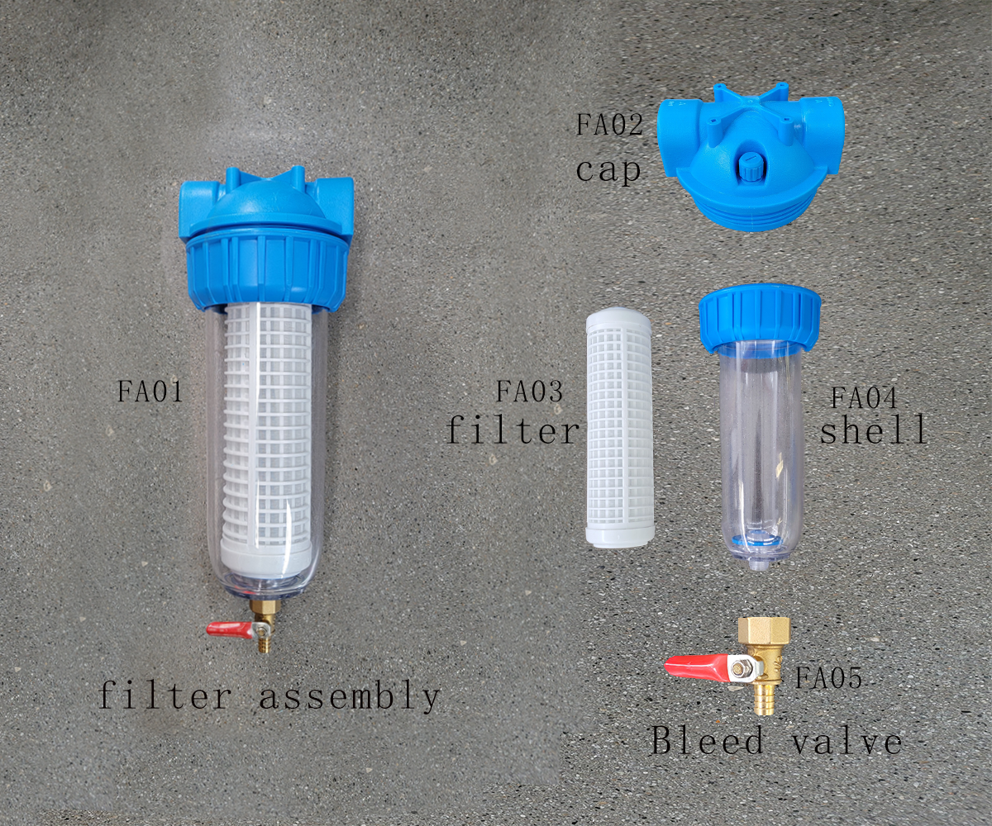

Filter Assembly spare-parts list

Pos: | Part no.: | Qty.: | Description:
FA01 |  | 1 | G3/4" FILTER ASSEMBLY
FA02 |  | 1 | FILTER GAP
FA03 |  | 1 | FILTER
FA04 |  | 1 | SHELL
FA05 |  | 1 | BLEED VALVE

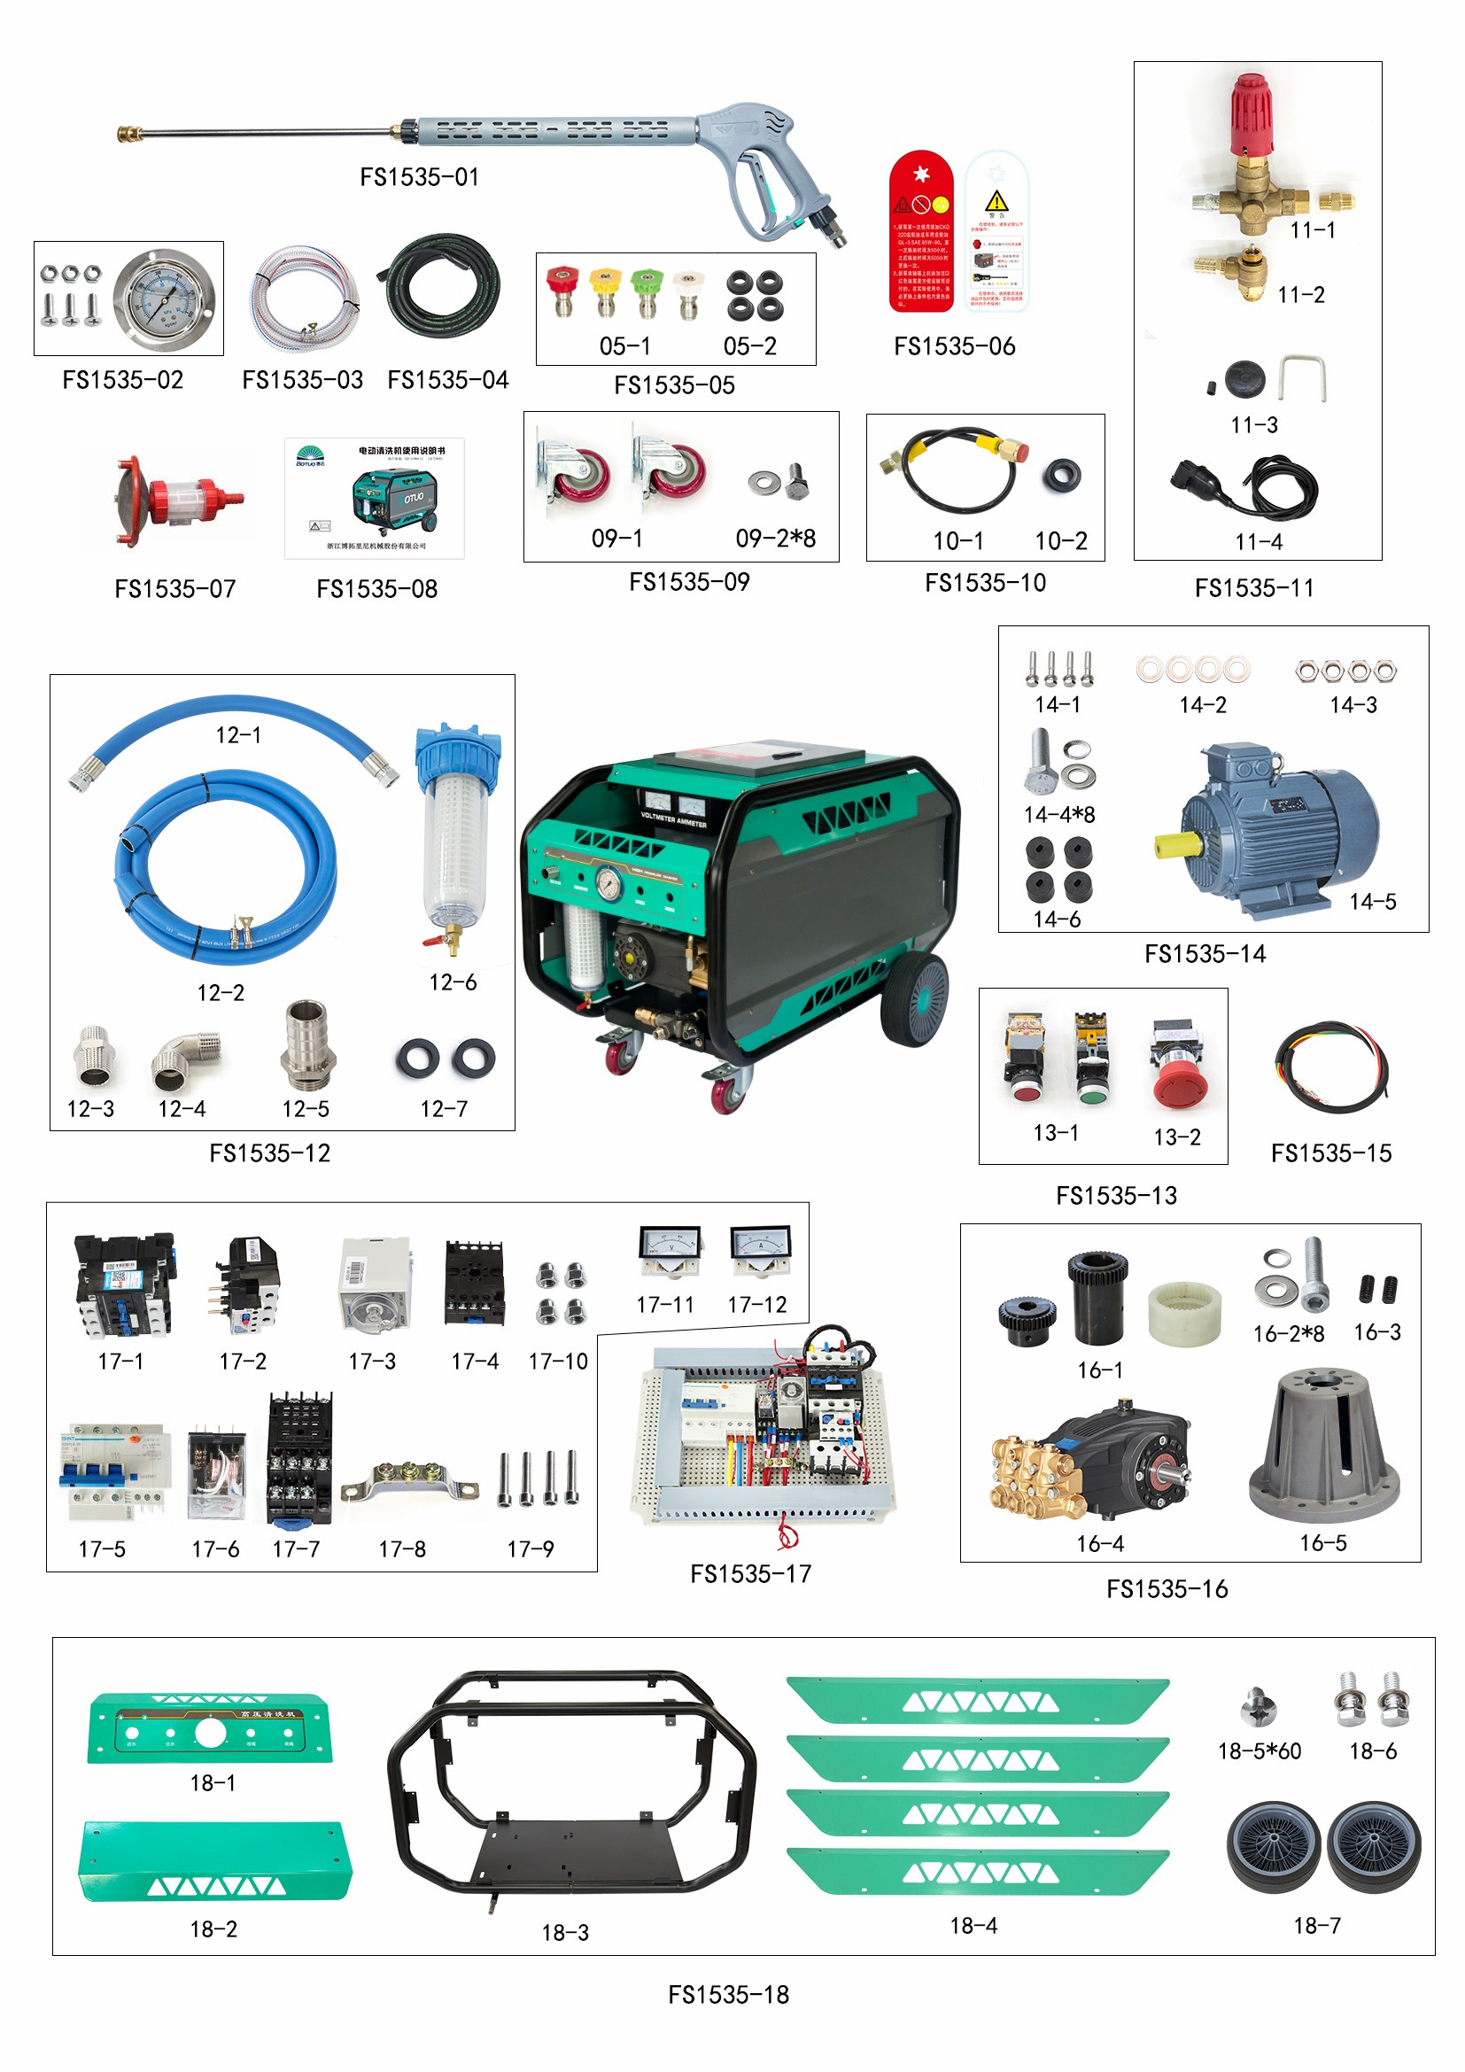

S/N |  | PARTS# | PARTS NAME | QTY | REMARK
FS1535-01 |  | 590418300 | Long gun M350 | 1
FS1535-02 |  | 500014035 | 1/4轴向带法兰 | 1
 |  | 590203005 | M4 | 3
 |  | 590208301 | M4*12/SUS201 | 3
FS1535-03 |  | 590403010 | water inlet pipe | 4
 |  | 590402060 | clamp | 2
FS1535-04 |  | 590408530 | Double layer steel wire high pressure pipe | 1
FS1535-05 | 05-1 | 590407110 | white sprinkler | 1
 |  | 590407270 | red sprinkler | 1
 |  | 590407450 | yellow sprinkler | 1
 |  | 590407630 | green sprinkler | 1
 | 05-2 | 101700080 | Nozzle ring | 4
FS1535-06 |  | 101063032 | danger sign | 1
 |  | 101000020 | refueling sign | 1
FS1535-07 |  | 590415010 | Filter | 1
FS1535-08 |  | 101010072 | FS Instructions | 1
FS1535-09 | 09-1 | 590405061 | Universal wheel | 2
 | 09-2*8 | 590204005 | flat gasket | 8
 |  | 590202004 | M8*25 | 8
FS1535-10 |  | 590408821 | pressure gauge hose | 1
 |  | 590110010 | Combination pad | 1
FS1535-11 | 11-1 | 832506010 | Pressure regulating valve | 1
 |  | 590502024 | pass through | 1
 |  | 502403120 | water nozzle connector | 1
 | 11-2 | 303012501 | PR1 pressure switch assembly | 1
 | 11-3 | 101270380 | Pressure switch soft cover | 1
 |  | 101270390 | Switch core sheath | 1
 |  | 101270400 | U-shaped card | 1
 | 11-4 | 304226108 | VB350 pressure switch line | 1
 |  | 590501005 | pagoda | 1
FS1535-12 | 12-1 | 590403060 | water inlet pipe | 0
 |  | 101769411 | Hydraulic ferrule connector | 2
 |  | 5900904001 | black rubber gasket | 2
 |  | 101270841 | Stainless Steel Sheath | 2
 | 12-2 | 590403040 | water inlet pipe | 4
 |  | 590402060 | clamp | 2
 | 12-3 | 590502022 | pass through | 1
 | 12-4 | 590503021 | straight bend | 1
 | 12-5 | 590501003 | pagoda | 1
 | 12-6 | 590404031 | filter | 1
FS1535-13 | 13-1 | 101270810 | power switch button | 1
 |  | 101270812 | power switch button | 1
 | 13-2 | 101270750 | Emergency stop switch | 1

FS1535-14 | 14-1 | 590202024 | M10*40 | 4
 |  | 590204006 | flat gasket | 8
 | 14-2 | 590204004 | 10*20*1.5 | 4
 | 14-3 | 590203001 | Hex nuts | 4
 | 14-4*8 | 590202026 | Hexagon Screw | 8
 |  | 590204004 | flat gasket | 8
 |  | 590204101 | Double-sided tooth pad | 8
 | 14-5 | 590616010 | motor | 1
 | 14-6 | 590409130 | Motor shock pad | 4
FS1535-15 |  | 101271350 | electric wire | 1
FS1535-16 | 16-1 | 590306290 | Nylon sleeve coupling | 1
 | 16-2*8 | 590201045 | Hexagon socket head screws | 8
 |  | 590204005 | flat gasket | 8
 |  | 590204103 | Double-sided tooth pad | 8
 | 16-3 | 590209020 | Coupling Screw | 2
 | 16-4 | 811101060 | High pressure plunger pump | 1
 | 16-5 | 500012010 | flange | 1
FS1535-17 | / | 304226009 | Electrical control box | 1
 | 17-1 | 101270120 | 380V AC contactor | 1
 | 17-2 | 101270230 | Thermal overload relay | 1
 | 17-3 | 101270200 | Time Relay | 1
 | 17-4 | 101270210 | time relay base | 1
 | 17-5 | 101270151 | 380V earth leakage circuit breaker | 1
 | 17-6 | 101270250 | Small relay | 1
 | 17-7 | 101270260 | Small relay base | 1
 | 17-8 | 101271190 | Terminal block | 1
 | 17-9 | 590201150 | Hexagon socket head screws | 4
 | 17-10 | 590203202 | Cap Nut | 4
 | 17-11 | 500014041 | Voltmeter | 1
 | 17-12 | 500014040 | Ammeter | 1
FS1535-18 | 18-1 |  | Rack Front Bezel | 1
 | 18-2 |  | rack back panel | 1
 | 18-3 | 590710072 | FS rack | 1
 | 18-4 |  | rack side panel | 4
 | 18-5*60 | 590208203 | Phillips pan head screw | 60
 | 18-6 | 590204005 | flat gasket | 2
 |  | 590202019 | Hexagon Screw | 2
 | 18-7 | 590405033 | 10 Inch Sunflower Wheel | 2

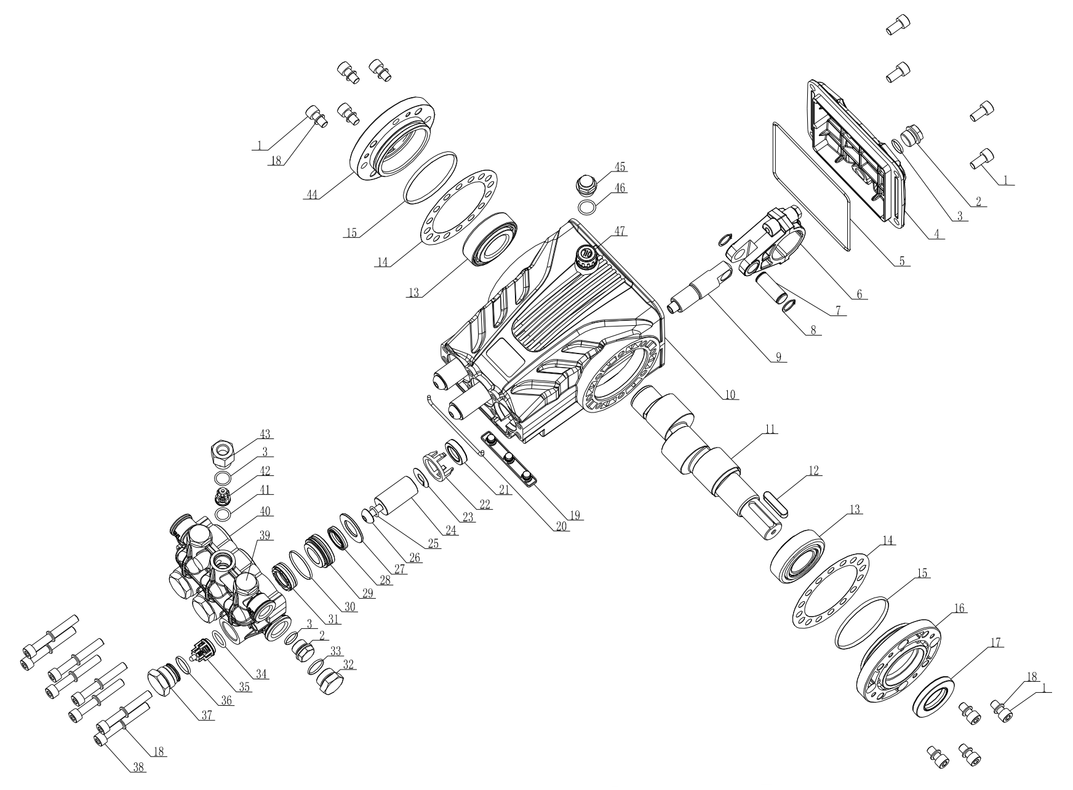

Pump assembly

spare-parts list

S/N | PARTS # | APRTS NAME | QTY
1 | 590201006 | Hexagon socket head screw | 12
2 | 500010001 | BM-G3/8 plug | 2
3 | 590101021 | O-ring | 5
4 | 501102020 | ST back cover | 1
5 | 590101196 | O-ring | 1
6 | 501102030 | ST connecting rod assembly | 3
7 | 501102040 | ST plunger pin | 3
8 | 590206001 | Circlip for shaft | 6
9 | 501102140 | ST20 plunger rod | 3
10 | 501102150 | ST20 crankcase | 1
11 | 501102160 | ST14-N24 crankshaft | 1
12 | 500011002 | Flat key | 1
13 | 590303004 | Tapered Roller Bearings | 2
14 | 501002080 | DS clearance adjusting gasket | 2
15 | 590101102 | O-ring | 2
16 | 501002030 | DS extension flange | 1
17 | 590108003 | TC skeleton oil seal | 1
18 | 590204103 | double sided tooth pad | 16
19 | 501102090 | ST crankcase bottom cover | 1
20 | 590101068 | O-ring | 1
21 | 590107002 | TC4 skeleton oil seal | 3
22 | 500602080 | TK22 support frame | 3
23 | 501102060 | ST water barrier | 3
24 | 501102130 | ST20 ceramic tube | 3
25 | 590101113 | O-ring | 3
26 | 501102080 | ST ceramic tube locking bolt | 3
27 | 501101120 | ST20 auxiliary water seal flat gasket | 3
28 | 590105004 | 20 pairs of water seals | 3
29 | 501101101 | HZT20 rear guide ring | 3
30 | 590101073 | O-ring | 3
31 | 590104067 | Main water seal three-piece set | 3
32 | 500010002 | BM-G1/2 plug | 1
33 | 590101035 | O-ring | 1
34 | 590101223 | O-ring | 3
35 | 501101040 | ST water inlet check valve | 3
36 | 590101040 | O-ring | 3
37 | 501101061 | ST water inlet check valve screw | 3
38 | 590201046 | Hexagon socket head screw | 8
39 | 501101070 | ST outlet check valve screw | 2
40 | 501101240 | HZT20 pump head | 1
41 | 590101015 | O-ring | 3
42 | 501101060 | ST water outlet check valve | 3
43 | 501101171 | ST outlet hole check valve screw | 1
44 | 301041001 | DS side cover assembly | 1
45 | 101702010 | oil plug | 1
46 | 590101019 | O-ring | 1
47 | 301150101 | BM oil standard components | 1

Pump assembly spare-parts list

(1 Kit for Complete Pump Repair)
Checking valve Kit (▲) – 301191004
Pos: | SET.: | Individual Components Description
301191101 | 1 | Water inlet checking vlave &o-ring  Water outlet chekcing valve&o-ring
301221101 | 1 | Main water seal &vice water seal

Un-loader valve assembly
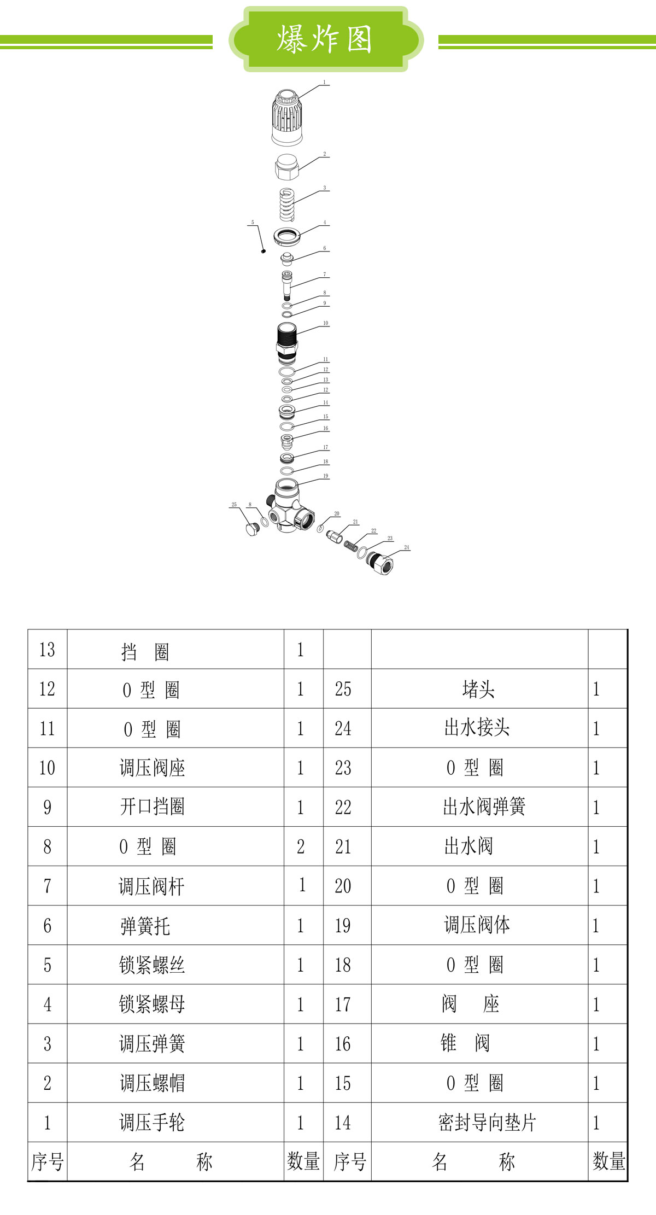

Un-loader valve assembly spare-parts list

S/N | APRTS# | PARTS NAME | QTY
1 | 502503140 | Pressure regulating hand wheel | 1
2 | 502503130 | Regulator nut | 1
3 | 502503090 | Regulator spring | 1
44 | 502503070 | fasten the screw nut | 1
5 | 590207002 | set screw | 1
6 | 502503040 | spring holder | 1
7 | 502503100 | Regulator stem | 1
8 | 590103001 | retaining ring | 1
9 | 590101004 | O-ring | 2
10 | 502503120 | Regulator Seat | 1
11 | 590101050 | O-ring | 1
12 | 590102007 | retaining ring | 1
13 | 590101116 | O-ring | 1
14 | 502503050 | Seal guide gasket | 1
15 | 590101034 | O-ring | 1
16 | 502503150 | Cone valve | 1
17 | 502503060 | Gasket | 1
18 | 590101029 | O-ring | 1
19 | 502503110 | Regulator body | 1
20 | 590101099 | O-ring | 1
21 | 502503010 | outlet valve | 1
22 | 502503020 | outlet valve spring | 1
23 | 590101032 | O-ring | 1
24 | 502503030 | Outlet connector | 1
25 | 500010008 | Plug | 1

El-box assembly (380V, 50Hz)

CAUTION !!!! : When servicing the Electrical Components
Unauthorized usage or sabotage

Only a qualified electrical trained personal to service or perform any troubleshooting on the electrical control box. Improper connection may cause damage to the equipment or person using the machine.

Electrical Components

Timer
Relay
380V earth leakage circuit breakerr

Small relay base
1
3

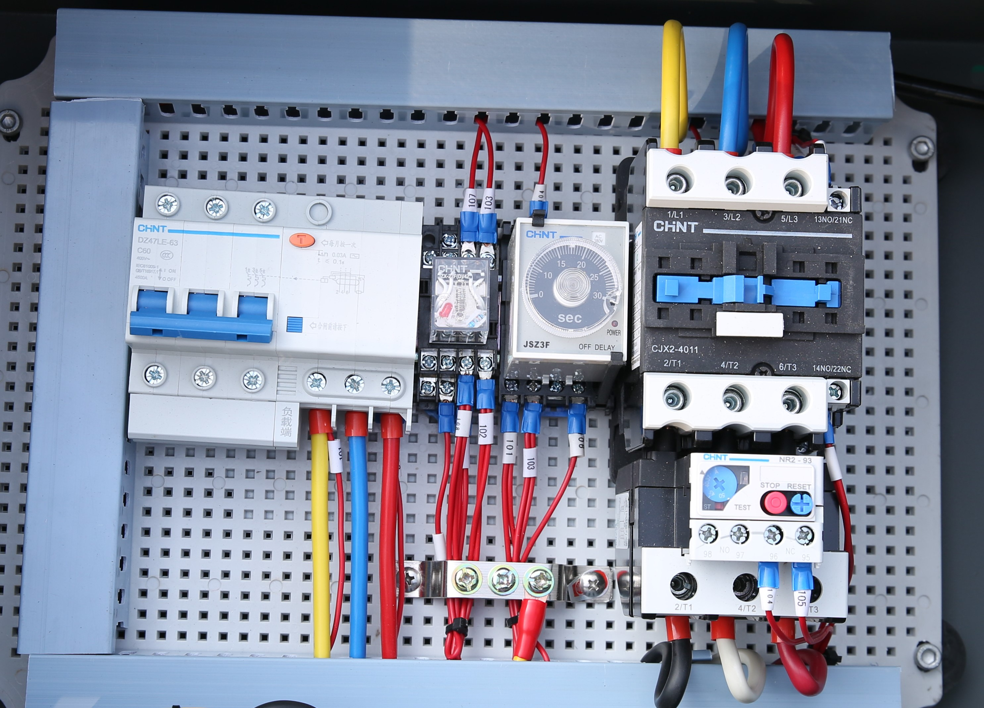
2

380V AC contactor
4

5
5
Thermal overload relay

El-box 18.5KW assembly spare-parts list
Pos: | Part no.: | Qty.: | Description:
1 | 101270130 | 1 | 40A /Circuit breaker /DZ158LT-125
2 | 101270250 | 1 | Small relay base
3 | 101270200 | 1 | Timer Relay
4 | 101270110 | 1 | 380V AC contactor
5 | 101270230 | 1 | Thermal overload

OPERATION PROCEDURE FOR START-UP， ROTATING

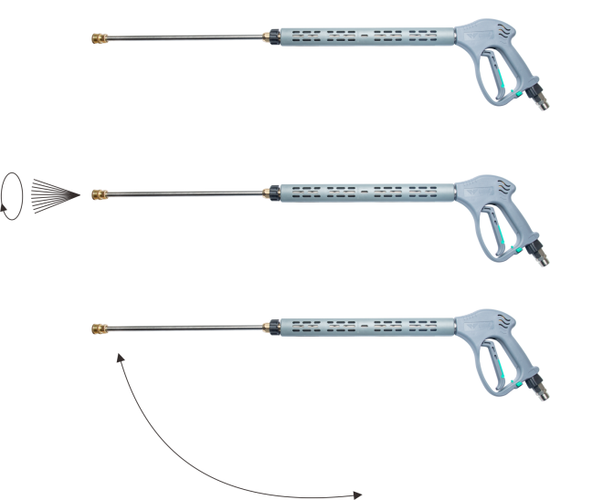

3. Keep trigger squeezed .move nozzle to horizontal blasting position.

2. Squeeze trigger， observe nozzle rotate.
1. Hold gun upright nozzle facing down

FS1935 Page 48 of 51



Ensure the rotating nozzle is pointing down before starting to blast. This will increase the life-span of the rotating nozzle.

WARNING
Prepare for blasting

- Hold the trigger gun with 2 hands, 1 on the trigger and the other on the handle.
- With the lance assembly pointing down
- Slowly press on the trigger to bring up pressure with the lance assembly pointing in the downward direction.
- Check that no over pressure and no leaking on the fittings.
- Release the trigger and make any holding position adjustment.
- Start blasting by follow the procedure from 2~4.

Note: Do not point the lance at any person at any time.

5. Wiring diagram (380V, 50Hz）

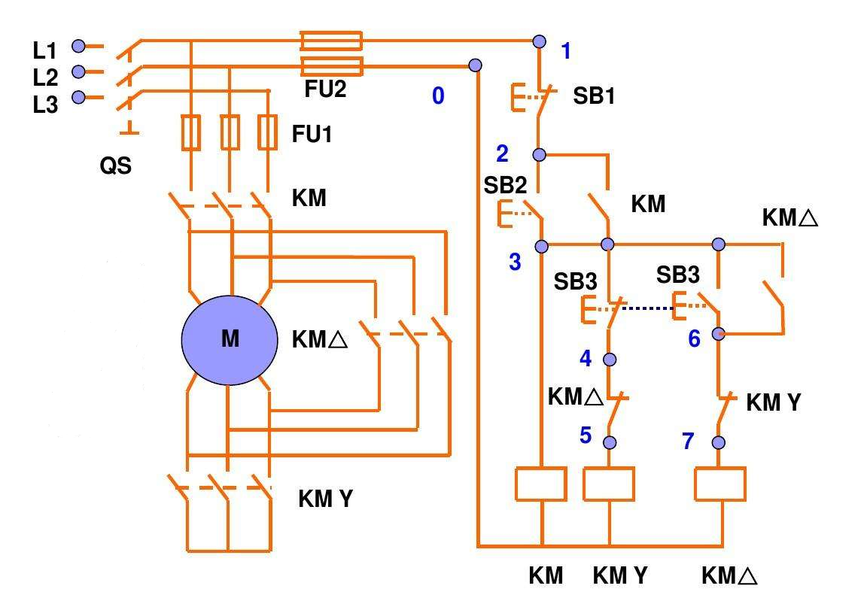

6. Warranty

BOTUOLINI warrants all equipment of its manufacture furnished under this agreement to be free from defect in workmanship and material for a period of one year from the date of invoice of the equipment. This warranty does not cover normal wear and tear, consumable items, or part failures caused by (i) accident, (ii) abuse, or (iii) failure to maintain the BOTUOLINI system containing the affected parts in accordance with BOTUOLINI technical specification. All labour is the responsibility, and the expense of the Buyer. The liability of Seller under this warranty is limited, at Seller's option, solely to repair or replacement with equivalent articles. This warranty is condition upon:

6.1 Seller being notified in writing by Buyer within one week after discovery of defects;

6.2 the return of defective articles to Seller, transportation charges prepaid by Buyer;

6.3 Seller's examination of such article disclosing to its satisfaction that such defects were not caused by negligence, misuse, improper maintenance, improper installation, accident, or unauthorized repair or alteration.

Accessories or equipment furnished by BOTUOLINI but manufactured by others, shall carry the warranty that its manufacturer has conveyed to BOTUOLINI, and which may be passed on to the purchaser. The original warranty period of any article, which has been repaired or replaced by BOTUOLINI, shall not thereby be extended.

