BT-1520B3
BT-1525B3
HIGH ELECTRIC CLEANER
INSTRUCTION MANUAL


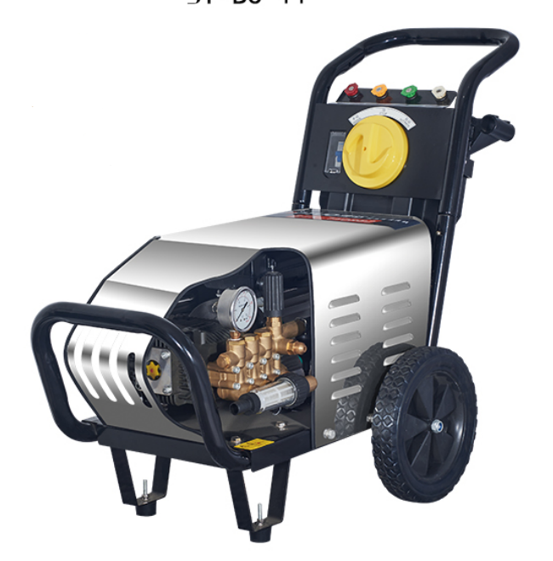


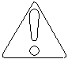WARNING

RISK OF INJECTION
OR SEVERE INJURY
TO PERSONS. KEEP
CLEAR OF NOZZLE.
HIGH PRESSURE SPRAY
CAN CAUSE SERIOUS INJURY

Never point or aim the gun/wand at yourself or anyone else.
Never put your hand, fingers or body directly in front of the spray nozzle.

CAUTION


READ OPERATOR’S
MANUAL
THOROUGHLY
PRIOR TO USE.

A. KNOW YOUR PRESSURE WASHING
EQUIPMENT
READ YOUR OWNERS MANUAL CAREFULLY.

Do not operate your power washer until you completely understand and can follow all operating instructions, precautions and safety rules.

Restrict the use of your power washer to users who have read, understand and can follow all operating instructions, precautions and safety rules.

WARNING
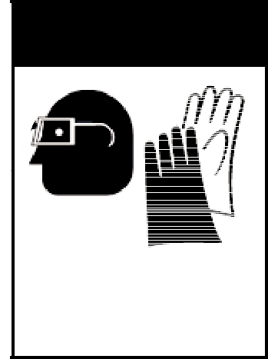

PROTECTIVE
EYEWEAR AND
CLOTHING
MUST BE WORN.

B. PLAN AHEAD

- Always wear ear protection to cut noise and eye protection and / or face shield to prevent debris from flying or ricocheting into eyes and face which could result in serious injury.

- Dress safely in long pants and wear boots or shoes. Other protective equipment is advisable when using chemicals, cleaning detergents or other corrosive or abrasive substances.

- Do not operate pressure washing equipment if you have consumed alcohol or taken medication.

- Keep pets, children and bystanders a safe distance away from your work area. A minimum of 50 feet is recommended.

- Do not spray directly at glass or fragile objects.

- CAUTION after turning off your pressure washer and water supply, there is still high pressure water trapped in the system. You must release the pressure by triggering the gun after the engine/motor has completely stopped.

- Know what chemicals you are using and read precautions.



WARNING

RISK OF FIRE.
DO NOT ADD FUEL
WHEN OPERATING
MACHINE.

PRECAUTIONS FOR GASOLINE

ENGINES/ELECTRIC MOTORS

Follow all safety precautions, operating procedures and maintenance listed in your engine operator’s manual which came with the pressure cleaner. This manual may be attained from your local small engine repair center.

DO NOT fill the engine with gasoline when the engine is running, hot or near an open flame. DO NOT SMOKE.

WARNING

RISK OF
ASPHYXIATION. USE
ONLY IN A WELL
VENTILATED AREA.
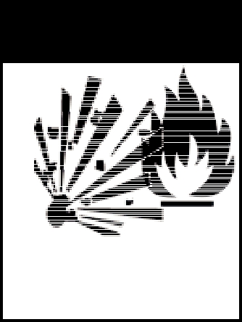

DO NOT run power washers in an enclosed area. Exhaust fumes contain poisonous carbon monoxide gas. Breathing exhaust gases can cause serious illness or death.

DO NOT touch or come in contact with hot mufflers, cylinders, cooling fins or hot exhaust gases as this may result in severe burns.

Never tamper with governor spring, governor links or other components which may increase the speed (RPM) of the engine.

WARNING

RISK OF EXPLOSION:
DO NOT SPRAY
FLAMMABLE LIQUIDS
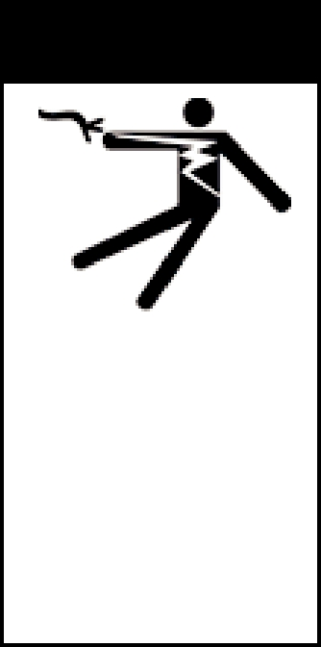
WARNING

RISK OF
ELECTRICAL
SHOCK. HAZARDOUS
VOLTAGE CAN
SHOCK, BURN OR
CAUSE DEATH.
GROUND SYSTEM
BEFORE
CONNECTING TO
POWER SUPPLY.

DO NOT operate pressure cleaners in the presence of flammable vapors or gases. When servicing pressure cleaning equipment, be sure to properly dispose of any flammable materials.

DO NOT make adjustments to your equipment without first removing the spark plug.

When transporting pressure cleaners, the fuel shut-off valve must be in the closed position, to prevent fuel from spilling out.

A circuit dedicated only to the electric pressure washer is recommended. This circuit should be installed by a licensed electrician and checked to supply adequate voltage under load（Voltage/Phase/Hertz）. If the distance from the panel is too long, the wire size is too small or the voltage is initially to low, this will cause the GFCI or Thermal overload to trip. If the trips or the thermal overload on the motor trips consult
factory. Plug your cord into the receptacle. DO NOT USE EXTENSION CORD!
USE ONLY THE FACTORY SUPPLIED BOTUOLINI.

INITIAL SETUP AND OPERATION OF YOUR NEW
PRESSURE WASHER

Inspection for freight damage

When you receive your commercial pressure washer be sure you check for concealed freight damage. Any damage should be noted with the delivering carrier. If you have any questions related to freight call your selling dealer.

Inspection of oil levels

Check all oil levels in the pump or engine if applicable. Failure to check all levels could result in pressure washer damage. Most pumps are shipped with oil from factory and the crankcases are sealed. You may have to remove a shipping plug and install a dipstick in the pump. Oil type is stated on the pump breakdown and in the engine manual.

Water Supply(The recommended minimum inlet pipe diameter is:DN15 OR 3/4'')

Your water supply must provide water to the equipment that exceeds the Gallon Per Minute 5GPM rate of your machine. You can check your GPM by using a 5 gallon bucket and a timer. If your machine is 5 GPM or less and the bucket fills in less than a minute you have adequate supply. Some water supply systems are affected by things like washing machines, livestock watering systems and flushing of toilets. Be sure the supply is still adequate when these operations are taking place.0 °C ＜ The water temperature＜ 50 °C and the pressure should not exceed 3Bar/47 PSI. Failure to secure adequate water supply to your commercial pressure washer will result in pump damage. DO NOT RUN PUMP DRY.

Water Quality

Your water should not contain particles larger than 80 microns. Although there are small filters installed on power washers that filter the water, they could only filter poor quality water for a short period of time before they clog. This would result in damage to the machine. Therefore you should insure no sand or scale particles are present in the water supply.

Supply Hose

Hook a garden hose from the faucet to the machine, when doing this be sure to check the inlet water filter or screen. This hose should be a least 5/8" diameter and a length at least 15 feet. This 15' length helps isolate the water supply from pulsations from the pump. Many states require a Vacuum Break or back flow preventor be installed at the faucet, before the garden hose, to insure the water source cannot be contaminated. Be sure to check local and state regulations upon installation.

Purge Air

Turn on the water supply and open the trigger gun, this will purge all the air from the system. Look for water leaks and stop any leak found. Leaks can cause erratic pump behavior.

Pump

Prior to turning on the power switch or starting engine, check the oil level in the pump. The pump oil should be changed after the first 50 hours of operation, then every 2 months or 500 hours of operation thereafter for average service or more frequently for extensive use or hostile environments {dusty or high moisture}.

Turn on Power
Turn on the power switch. Pull trigger gun and check for adequate pressure.

Filters

Water filters, hoses and fittings should be checked prior to every operation for cleanliness, leaks and repair needs. Repair or replace as needed.

The Unloader Valve

Pressure cleaners are built with one of two types of unloaders: The Trapped Pressure Unloader or the Flow Actuated Unloader. After the pump is filled with water, the direction of water flow must be controlled with the unloader or regulating valve. A positive displacement pump is always delivering a specific volume of water whether the spray gun is open or closed; therefore a device is needed to control the direction of flow, either to the open spray gun or redirecting the flow back to the inlet side of the pump when the spray gun is closed. Without an unloader valve, dangerously high pressure will be produced when the spray gun is closed because the water being forced out of the pump has no place to go. The unloader is used as a safety device to guard against failure of component parts, and the development of dangerously high pressures.

Hoses and Couplers

Factory supplied hoses are sized in length and diameter for best operational performance and size within the pressure capabilities. Additional hose added to the machine may change the performance of the machine. Consult factory if you have any questions. When replacing or disconnecting the quick couplers be sure the machine is shut off and relieve the pressure from all hoses.

During Operation

The pressure was set at the factory during the testing procedure, no adjustments to the machine should be required for operation. During operation do not leave the machine running for more than 2 minutes without the trigger gun being pulled. Although your machine has a by-pass valve on it and may have a thermal relief system, this can cause extensive pump damage. If machine will not be discharging water for more than 2 minutes, shut the machine off.

NOZZLE SELECTION GUIDE

Spray nozzle can be identified by the nozzle “number”, a five or six digit number that is stamped on the nozzle, which indicates the spray angle and orifice size. In most cases the second and third digits of the nozzle number indicate the spray angle in degrees. EXAMPLE: 00 is 0 degrees, 15 is 15 degrees and 40 is 40 degrees. The last two numbers of the nozzle number indicated the orifice size, a standard industry designation. EXAMPLE: 60 is a 6.0 orifice, 55 is a 5.5 orifice. These numbers correspond to the actual dimensions, giving the size of the orifice. They do not however directly indicate gallons per minute, flow rates or inches in diameter of the orifice. Some power washers come with an adjustable nozzle which is fixed to the end of the wand. The fan spray may be adjusted by turning the nozzle and chemicals may also be applied by pulling outward on the nozzle.

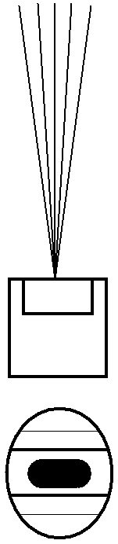
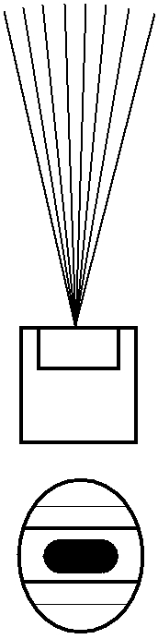
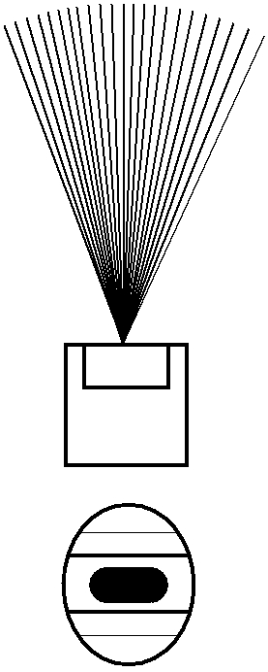

0 DEGREE 15 DEGREE 25 DEGREE 40 DEGREE

STANDARD SPRAY NOZZLE APPLICATIONS

Caution: The spray force from these nozzles can cause injuries if pointed directly at yourself or others. Before observing directly always disconnect from spray wand.

A. 0 DEGREE - BLASTING

Removing caked on mud from heavy construction, farm or lawn equipment.

Cleaning tar, glue or stubborn stains from concrete.

Cleaning overhead areas.

Removing rust from steel and oxidation from aluminum.

B. 15 DEGREE - STRIPPING

Removing paint from wood, masonry or metal. Removing grease or dirt from equipment.

Removing heavy mildew stains.

Removing marine growth from boats and marine equipment.

Removing rust from steel and oxidation from aluminum.

C. 25 DEGREE - CLEANING

General cleaning of dirt, mud and grime. Cleaning roofs, gutters and downspouts. Removing light mildew stains.

Removing algae and bacteria build-up from pools.

Rinsing surfaces in preparation for painting.

D. 40 DEGREE - WASHING

Light cleaning and washing.

Washing and rinsing of automobiles and boats. Leaning roofs, windows, patios and driveways.

The Main Equipment Layout
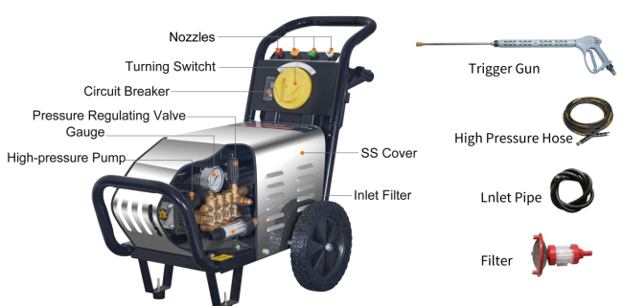

Working Principle
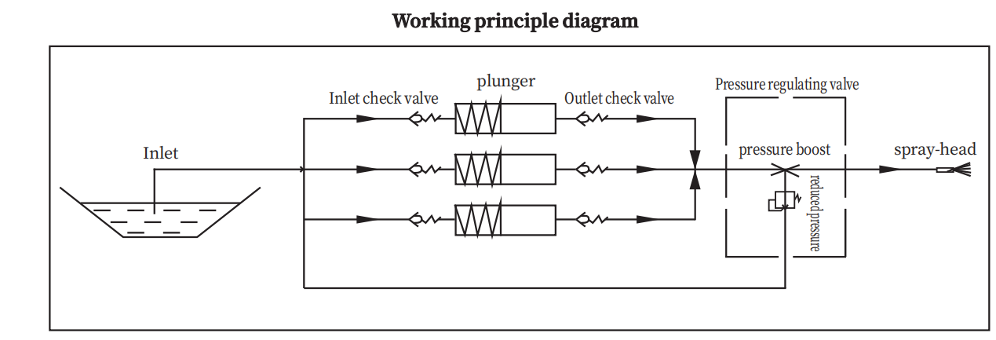
Working principle:

after the power is connected, the motor drives the high-pressure piston pump shaft to rotate, and the pump shaft makes reciprocating movement of the plunger through the crankshaft connecting rod mechanism.

When the plunger movement increases the volume of the pump chamber of the cylinder block, the inlet one-way valve is opened, the outlet one-way valve is closed, and the water enters the pump chamber through the inlet one-way valve.

When the movement of the plunger reduces the volume of the pump chamber, the inlet check valve is clos- ed, the outlet check valve is opened, and the water in the pump chamber passes through the outlet check valve and outlet pipe to the trigger spray gun. After pulling the trigger gun, the water is shot out of the spray gun.

When the trigger of the spray gun is not activated, the water pressed out of the pump cavity pushes the differential plunger in the pressure regulating valve, and the water returns to the water inlet from the outlet, that is, the water circulates inside the high-pressure pump. At this time, the water temperature will rise sharply, so the
high-pressure pump should try to avoid closing the spray gun for a long time when working, so as not to cause damage to the high-pressure pump.

Parameter

Model Number | BT-1520B3 | BT-1525B3
Maximum Flow | 15LPM/3.96GPM | 15LPM/3.96GPM
Maximum Pressure | 180BAR/2610PSI | 250BAR/3625PSI
Pump Model | BM1518 | BM1525
Pump Head Material | brass | brass
Regulator | VRC300 | VRC300
Autoswitch | YES | YES
Motor Power | 5.5KW | 7.5KW
Motor Speed | 1450RPM | 1450RPM
Voltage&HZ | 380V/50HZ | 380V/50HZ
Hose & Lenth | 10M | 10M
Water Inlet Hose | 3M | 3M
Filter | Yes | Yes
Gun&lance | Long Gun 350
Nozzle Tips | 4 Tips，quick connect nozzle
Net Weight | 67.3KGS | 87.35KGS
Product Size | 950*440*740MM
Shipping Size | 805*480*710MM

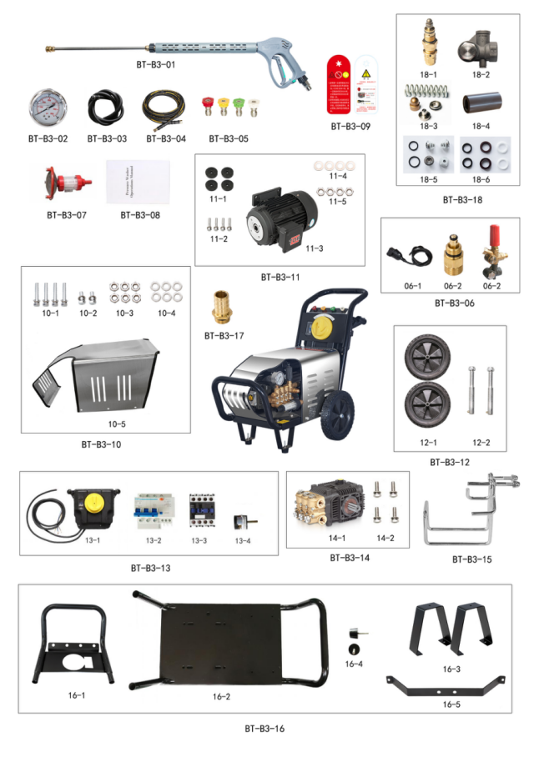
BT-1520B3/BT-1525B3 EXPLODED VIEW
S/N |  | PARTS# | PARTS NAME | 单位 | QTY
BT-B3-01 |  | 590418300 | long gun M350 | PCS | 1
BT-B3-02 |  | 500014006 | 400Bar pressure gauge | PCS | 1
BT-B3-02A |  | 500014008 | 600Bar pressure gauge | PCS | 1
BT-B3-03 |  | 590403030 | Inlet hose | PCS | 3
 |  | 590402050 | clamp | PCS | 2
BT-B3-04 |  | 590408240 | high pressure hose' 8mm/10M/M22*l.5 | PCS | 1
BT-B3-04A |  | 590408720 | Double layer high pressure hose' 8mm/10M/M22*l.5 | PCS | 1
BT-B3-05 |  | 590407260 | Red nozzle 045-0° | PCS | 1
 |  | 590407440 | Yellow nozzle 045-15° | PCS | 1
 |  | 590407620 | Green nozzle 045-25° | PCS | 1
 |  | 590407100 | White nozzle 045-40° | PCS | 1
BT-B3-06 | 6-1 | 304226107 | KBM pressure switch wire assembly | PCS | 1
BT-B3-06 | 6-2 | 306252405 | VC outlet fitting assembly M22*1.5 | PCS | 1
BT-B3-06 | 6-3 | 832406040 | The pressure regulating valve | PCS | 1
BT-B3-07 |  | 590415010 | Double filter | PCS | 1
BT-B3-08 |  | 101010030 | The instructions | PCS | 1
BT-B3-09 |  | 101063032 | Danger tags | PCS | 1
 |  | 101000020 | Refueling sign | PCS | 1
BT-B3-10 | 10-1 | 590202010 | Outer hexagonal screw | PCS | 4
BT-B3-10 | 10-2 | 590202019 | Outer hexagonal screw | PCS | 8
BT-B3-10 | 10-3 | 590203403 | locknut | PCS | 6
BT-B3-10 | 10-4 | 590204001 | Flat gasket | PCS | 32
BT-B3-10 | 10-5 | 590702040 | SS cover 5.5-7.5kw | PCS | 1
BT-B3-11 | 11-1 | 590409060 | Shock cushion for motor | PCS | 2
BT-B3-11 | 11-2 | 590202005 | Outer hexagonal screw | PCS | 6
BT-B3-11 | 11-3 | 590610040 | E-motor /5.5-4-380-C24 | PCS | 1
BT-B3-11 | 11-3A | 590612180 | E-motor /7.5-4-380-C24 | PCS | 1
BT-B3-11 | 11-4 | 590204005 | Flat gasket | PCS | 4
BT-B3-11 | 11-5 | 590203403 | locknut M8 | PCS | 4
BT-B3-12 | 12-1 | 590405030 | 10 "Solid wheels | PCS | 2
BT-B3-12 | 12-2 | 590708031 | Wheel Shaft / 55 * 15 | PCS | 2
BT-B3-13 | 13-1 | 304226001 | Electrical control box | PCS | 1
BT-B3-13 | 13-2 | 101270150 | 380V leakage circuit breaker | PCS | 1
BT-B3-13 | 13-3 | 101270120 | 380V AC contactor | PCS | 1
BT-B3-13 | 13-4 | 101769240 | switch | PCS | 1
BT-B3-13 | 13-5 | 304226107 | KBM pressure switch wire assembly | PCS | 1
BT-B3-14 | 14-1 | 810101060 | High pressure plunger pump | PCS | 1
BT-B3-14 | 14-2 | 590201044 | Hex socket round head screw | PCS | 4
BT-B3-15 |  | 590702030 | gun rack | PCS | 1
BT-B3-16 | 16-1 | 590702060 | The armrest | PCS | 1
BT-B3-16 | 16-2 | 590702010 | Main Frame 5.5-7.5KW | PCS | 1
BT-B3-16 | 16-3 | 590702010 | Main Frame feet | PCS | 2
BT-B3-16 | 16-4 | 590409010 | Main Frame shock cushion | PCS | 2
BT-B3-16 | 16-5 | 590702070 | Main Frame layering 5.5-7.5KW | PCS | 1
BT-B3-17 |  | 590501003 | Inlet Pagoda Connector G1/2-19 | PCS | 1
BT-B3-18 | 18-1 | 303012410 | VC regulator assembly | PCS | 1
BT-B3-18 | 18-2 | 502403160 | VC regulator body | PCS | 1
BT-B3-18 | 18-3 |  | VC Regulator Repair Kit | PCS | 1
BT-B3-18 | 18-4 | 500102110 | Solid Ceramic Tube | PCS | 3
BT-B3-18 | 18-5 | 301190102 | BM Aftermarket Check Valve Kit (8-19L) | PCS | 1
BT-B3-18 | 18-6 | 301220102 | BM18 Aftermarket Water Seal Kit | PCS | 1

EXPLODED VIEW—PUMP

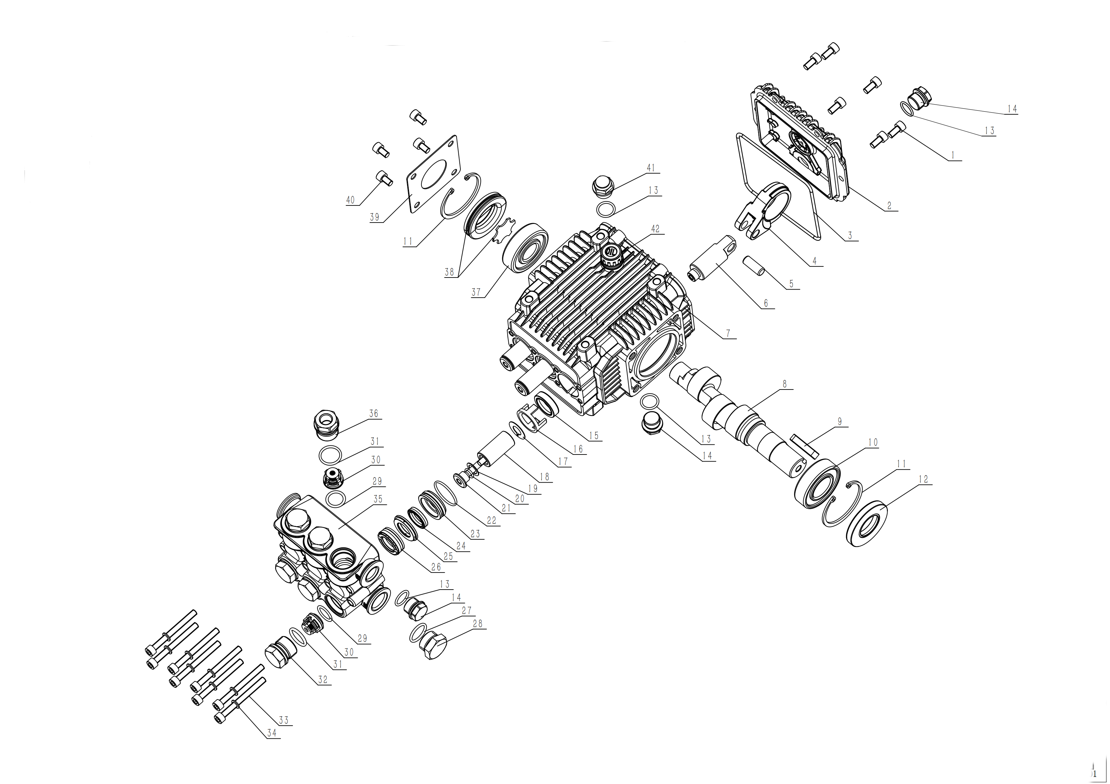

PARTS LIST — PUMP
PARTS # |  | Parts Description | QTY
BM -1 | 590201014 | Hexagon screw | 6
BM -2 | 301030101 | BM Rear Cover | 1
BM -3 | 590101011 | O-ring | 1
BM -4 | 500102200 | BM Connecting Rod | 3
BM -5 | 500102240 | BM Pin of plunger | 3
BM -6 | 500102100 | BM plunger lever | 3
BM -7 | 500102030 | BM Crankcase | 1
BM -8 | 500102350 | BM15 Solid Crankshaft 24mm(long) | 1
BM-9 | 500011001 | flat key | 1
BM -10 | 590302002 | Deep groove ball bearing 6205(2MM Male Shaft) | 1
BM -11 | 590205005 | Circlip,52-A | 2
BM -12 | 590108002 | Crankshaft Oil Seal for solid shaft | 1
BM -13 | 590101019 | O-ring | 4
BM -14 | 500010001 | BM Dipstick Gap | 3
BM -15 | 590107003 | Oil Seal - 18MM plunger | 3
BM -16 | 500102050 | BM 18MM Oil Seal Bracket | 3
BM -17 | 500102150 | BM WIPER | 3
BM -18 | 500102110 | Solid Ceramic Tube | 3
BM -19 | 500102210 | BM sheet gasket | 3
BM -20 | 590101105 | O-ring | 3
BM -21 | 500102224 | Locking bolt | 3
BM -22 | 590101063 | O-ring | 3
BM -23 | 500101050 | BM18MM Guide Ring | 3
BM -24 | 590105002 | BM18 Aux. Water Seal | 3
BM -26 | 590104008 | BM18 Main Water Seal | 3
BM -25 | 500101080 | BM Support Ring | 3
BM -27 | 590101035 | O-ring | 1
BM-28 | 500010002 | BM 1/2 Plug | 1
BM-29 | 590101023 | O-ring | 6
BM-30 | 500101150 | BM Checkign Valve-A(7-19L/min) | 6
BM-31 | 590101042 | O-ring | 6
BM-32 | 500101100 | BM Valve Nut | 5
BM-33 | 590201007 | Hexagon screw | 8
BM-34 | 590204102 | Washer D6 | 8
BM-35 | 500101020 | BM Cylinder | 1
BM -36 | 500101110 | BM Valve Nut9(with hole) | 1
BM -37 | 590302004 | Ball Bearing 6304 | 1
BM -37-1 | 590302012 | Ball Bearing 6304/4P(250bar) | 1
BM -38 | 301210101 | BM Side Oil Indicator | 1
BM -39 | 500102230 | BM Side Plate | 1
BM -40 | 590201016 | Hexagon screw | 4
BM -41 | 101702010 | Oil plug | 1
BM -42 | 301150101 | Oil leveler | 1
EXPLODED —REGULATOR
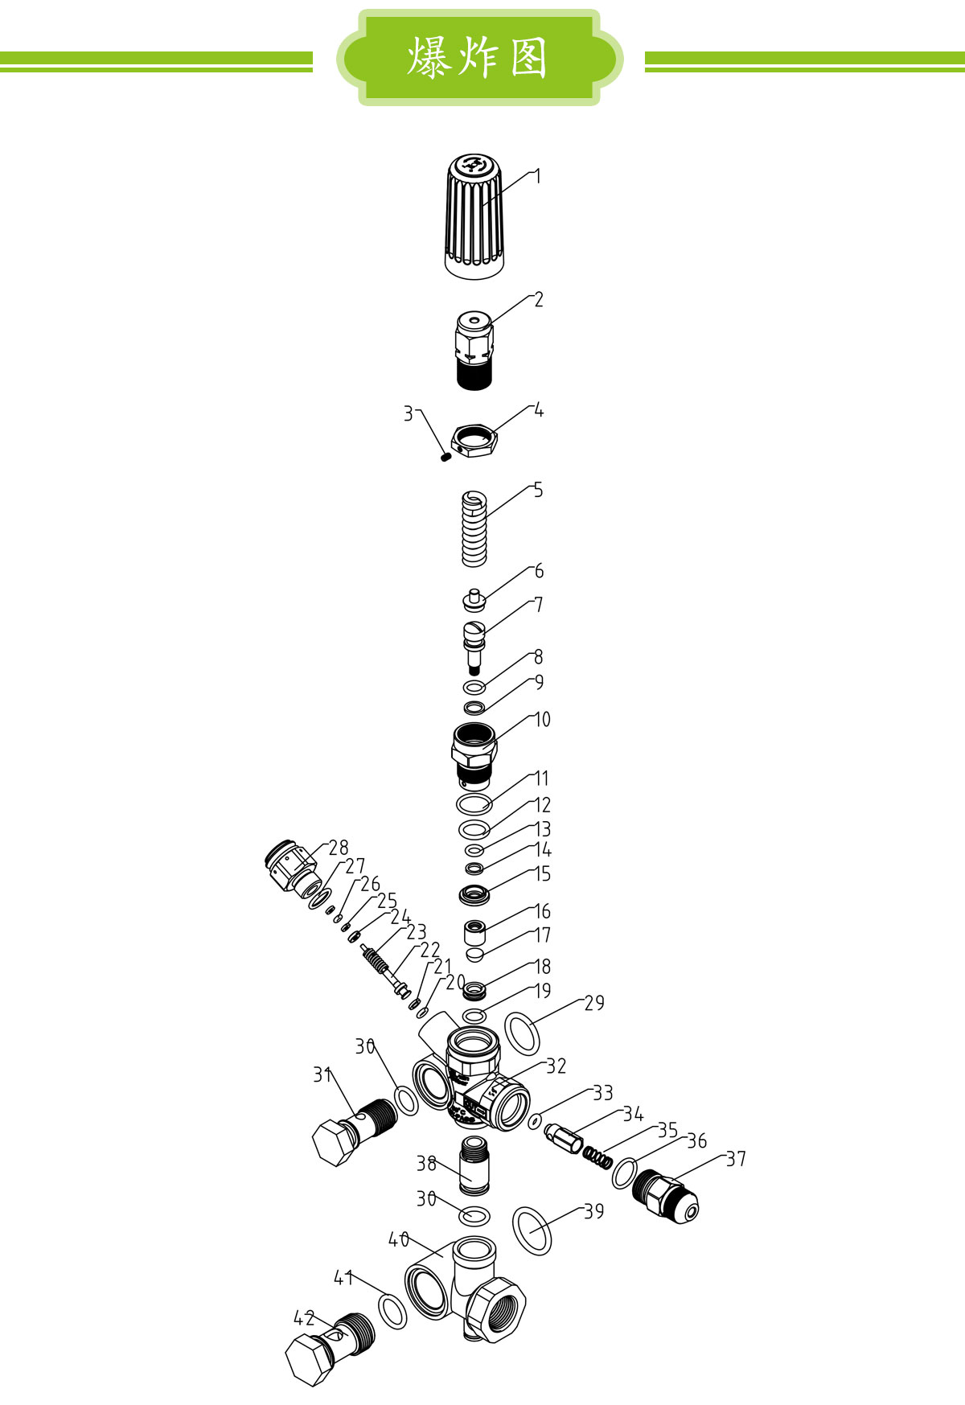

PARTS LIST — regulator
S/N | PARTS# | APRTS NAME | QTY
1 | 502403360 | Pressure regulating hand wheel | 1
2 | 502403340 | Regulator | 1
3 | 590207001 | set screw | 1
4 | 502403270 | fasten the screw nut | 1
5 | 502403350 | Regulating hard spring <180 Bar
5A | 502403280 | Regulating hard spring ≥180 Bar | 1
6 | 502403140 | spring holder | 1
7 | 502403290 | Regulator stem | 1
8 | 590102006 | retaining ring | 1
9 | 590101105 | O-ring | 1
10 | 502403310 | Regulator Seat | 1
11 | 590101029 | O-ring | 1
12 | 590101015 | O-ring | 1
13 | 590101100 | O-ring | 1
14 | 590102005 | retaining ring | 1
15 | 502403220 | Seal guide gasket | 1
16 | 303012411 | Cone valve | 1
17 | 502403010 | Return water bolt | 1
18 | 502403230 | Gasket | 1
19 | 590101113 | O-ring | 1
20 | 590101250 | O-ring | 1
21 | 590103025 | retaining ring | 1
22 | 502403520 | Stem | 1
23 | 502403530 | spring | 1
24 | 502403540 | spring washer | 1
25 | 590102023 | retaining ring | 1
26 | 590101247 | O-ring | 1
27 | 590101004 | O-ring | 1
28 | 502403550 | seat | 1
29 | 590101047 | O-ring | 1
30 | 590101010 | O-ring | 2
31 | 502403021 | outlet bolt | 1
32 | 502403510 | Regulator body | 1
32 | 502403510 | Regulator body | 1
33 | 590101071 | O-ring | 1
34 | 502403030 | outlet valve | 1
35 | 502403040 | outlet valve spring | 1
36 | 590101021 | O-ring | 1
37 | 502403100 | Outlet connector3/8 | 1
37A | 502403080 | Outlet connector22*1.5
38 | 502403250 | Inner return water long pipe | 1
39 | 590101059 | O-ring | 1
40 | 502403170 | Return valve body | 1
40 | 502403170 | Return valve body | 1
41 | 590101035 | O-ring | 1

Other Repairt kits list
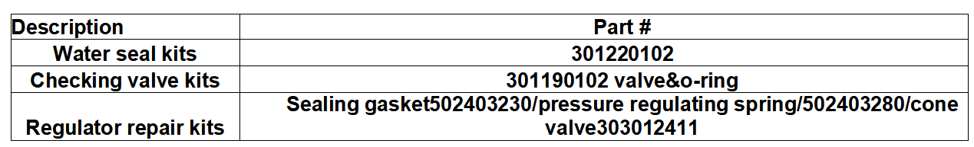

SHUT DOWN PROCEDURE
STORAGE
- Turn off the power switch on the commercial pressure washer.
- Relieve pressure on line by pulling trigger gun.
- Shut off water supply and disconnect garden hose.
- Be sure to check for water leaks or oil leaks that should be repaired before the next operation.

- If you are going to store the machine for extended period of times in cold climates be sure to antifreeze the equipment. A 50% anti-freeze solution may be drawn in through the inlet of the pump using a short remnant of garden hose. This fluid should be run through the pump when the fluid is discharged from the pump discharge your machine is winterized. Do not allow machine to freeze.

- Fuel stabilizer for gas if unit is to be stored for 30-90 days. If storing unit over 90 days drain fuel tank, shut off fuel valve and run unit until it stops.

PREVENT DAMAGES AND EXCESSIVE WEAR

- Avoid extending hoses across high traffic areas while using power washers, and never leave the hose where it may be run over by vehicles of any type.

- Never pull on the hose to move the pressure washer.

- Never pull your pressure hose around a tight corner or force it into a small loop. The wire braid hose has a minimum bend radius of 5", and should not be forced into any small bend.

- Wrap up the pressure washer hose when finished cleaning and store it on a hose hook, hanger, reel or other safe location.

  - Check oil levels (pump & engine) at every fueling to prevent low oil damage.

- Inspect inlet water filter for cleanliness and damage. If soiled or dirty, rinse with fresh water. If damaged, replace with new filter.

- When lifting or transporting power washers, secure and lift only with appropriate lifting handles.

PRESSURE WASHER CARE
- Follow recommended service instructions in owner manual for engine.

- Change oil in pump after the first 50 working hours (break in period) and then every 2 months or 500 hours of operation. The oil drain bolt is located on the bottom side of the pump. When refilling or adding oil to your pump, the pressure cleaner should be on level ground. Most pressure cleaners have a site glass located on the side of pump, the oil level must be in the center of the site glass. See pump manufacturer specification sheet for proper lubrication.

Prevent pump from freezing during freezing conditions. Flush pump with 1 to 1 mixture of automobile anti-freeze and water. This will also act as a lubricant.

TROUBLESHOOTING -
COMMON PROBLEMS AND SOLUTIONS

Low Nozzle Pressure

Low nozzle pressure is a common complaint. In a majority of instances, low nozzle pressure is generally caused by one of the following:

- Obstructed or clogged nozzle tip.
- Obstructed or clogged inlet filter.
- Unloader valve stuck open due to debris lodged under the check valve ball.
- Customer use of shutoff-type quick connectors.
- Plugged or obstructed hose.
- Insufficient flow in gallons per minute (not pressure) to the pump.

Why should I keep my nozzles clean?

Clogged nozzles can increase pump back pressure and possibly damage the pump. Immediate attention is required.

How do I clean clogged nozzles?
- Always disconnect your spray wand from the gun before cleaning your nozzles!
- Clear the nozzle with a small rigid piece of wire such as a paper clip.
- Flush the nozzle backwards with water.
- Reconnect the wand to the gun.
- Restart the pressure washer and depress the trigger on the spray gun.

If the nozzle is still plugged or partially plugged, repeat number 1-4. If the previous procedure does not clear the nozzle, replace with a new nozzle.

Surging Operation

Another condition is that pressure surges. That is, when the trigger is pulled, pressure is satisfactory for a moment then falls off. When the trigger is released, pressure builds up to normal levels. This is generally a sign that the water supply cannot provide the flow rate (gallons per minute) required by the pump. Following are some possible solutions:

- Make sure the supply is not restricted; that there are no under-sized fittings and the inlet screen is unobstructed.

- Make sure the flow rate of the water supply is sufficient for the pump. First, find the capacity of your pump in gallons per minute (gpm). Then determine the flow rate of your supply by measuring the gallons that can be delivered in one minute. If your supply does not deliver the gpm your pump requires, do not use the pump. It will suck air, causing cavitations which can quickly damage pump components.

- Check for leaks in the supply fittings. Any leak will cause the pump to draw air and perform poorly.

Soap Injector Not Working Properly

When a soap injector is not working properly, the problem is generally fairly easy to isolate. Check the following:

- If you have interchangeable tips, make sure the Black, soap tip is installed. Soap injectors will not work when high pressure nozzles are installed.

- Be sure that the soap injector valve is turned on, and turn selector valve to desired setting
- A piece of debris may be caught in the injector valve, injector ball valve, or orifice. Disassemble and clean the injector.

- If you have an adjustable nozzle, be sure it is in the low pressure position (away form the gun) to draw soap.

Notice

User maintenance procedures include replacing valves and seals. Unloader components are not user serviceable. Repairs involving unloaders and crankcase components should be referred to the factory or a factory authorized repair center.

TROUBLE SHOOTING

PROBLEM | POSSIBLE CAUSE | SOLUTION
LOW OPERATING | Faulty pressure gauge | Install new gauge
PRESSURE
PRESSURE | Insufficient water supply | Use larger supply hose;
 |  | clean filter at water inlet
 | Old, worn or incorrect | Match nozzle number of
 | spray nozzle | machine and/or replace with
 |  | new nozzle
 | Belt slippage | Tighten or replace;
 |  | use correct belt.
 | Plumbing or hose leak | Check plumbing system for
 |  | leaks. Retape leaks with
 |  | teflon tape.
 | Faulty or misadjusted | Adjust unloader for proper
 | unloader valve | pressure. Install repair kit
 |  | or replace when needed.
 | Worn packing in pump | Install new packing kit
 | Fouled or dirty inlet or | Clean inlet and discharge
 | discharge valves in pump | valves.
 | Worn inlet or discharge valves | Replace with valve kit.
 | Obstruction in spray nozzle | Remove obstruction.
 | Leaking pressure control valve | Rebuild or replace as needed.
 | Slow engine RPM | Set engine speed at proper
 |  | specifications.
 | Pump sucking air | Check water supply and
 |  | possibility of air seepage.

9

PROBLEM | POSSIBLE CAUSE | SOLUTION
LOW OPERATING | Valves sticking | Check and clean or replace if
PRESSURE |  | necessary.
 | Unloader valve seat faulty | Check and replace if necessary.
FLUCTUATING | Valves worn | Check and replace if necessary.
PRESSURE
PRESSURE | Blockage in valve | Check and replace if necessary.
 | Worn piston packing | Check and replace if necessary.
NOISY PUMP | Air in suction line | Check water supply and
 |  | connections on suction line.
 | Broken or weak inlet or | Check and replace if necessary.
 | discharge valve springs
 | Excessive matter in valves | Check and clean if necessary.
 | Worn bearings | Check and replace if necessary.
PRESENCE OF WATER | Water seal worn | Check and replace if necessary
IN OIL |  | and change oil.
 | High humidity in air | Check and change oil
 |  | twice as often.
WATER DRIPPING | Piston packing worn | Check and replace if necessary.
FROM UNDER PUMP
FROM UNDER PUMP | O-Ring plunger retainer worn | Check and replace if necessary.
 | Cracked piston | Check and replace if necessary.
 | Pump protector | Lower water supply pressure.
 |  | Do not run with spray gun
 |  | closed longer than 2 minutes.
OIL DRIPPING | Oil seal worn | Check and replace if necessary.
EXCESSIVE VIBRATION | Irregular functioning | Check and replace if necessary.
IN DELIVERY LINE | of the valves
DETERGENT NOT | Air leak | Tighten all clamps. Check
DRAWING |  | detergent lines for holes.
 | Filter screen on detergent | Clean or replace.
 | suction hose plugged

10

PROBLEM | POSSIBLE CAUSE | SOLUTION
DETERGENT NOT | Incorrect nozzle or adjustable | Install chemical nozzle or push
DRAWING | nozzle in wrong position. | adjustable nozzle forward
 |  | (away from gun).
 | Dried up detergent plugging | Disassemble and clean
 | metering valve injector | thoroughly.
 | High viscosity of detergent | Dilute detergent to
 |  | specifications.
 | Hole in detergent line(s) | Repair hole.
 | Low detergent level | Add detergent, if needed.
PUMP RUNNING | Pump sucking air | Check water supply and
NORMALLY BUT |  | possibility of air seepage.
PRESSURE LOW ON
INSTALLATION | Valves sticking | Check and clean or
 |  | replace if necessary.
 | Nozzle incorrectly sized | Check and replace if necessary
 | Unloader valve seat faulty | Check and replace if necessary.
 | Worn piston packing | Check and replace if necessary.
RELIEF VALVE
LEAKS WATER | Relief valve defective | Replace or repair.
ENGINE WILL NOT | Battery dead. | Charge or replace battery, add
START OR CRANK OVER |  | electrolyte if battery is new.
 | Pressure built up in system | Squeeze trigger gun to
 |  | relieve pressure.
 | Dirty battery connection | Clean connections.
 | Battery cables disconnected | Clean.
 | Engine, pump, or | Replace or repair seized part.
 | gearbox is seized
 | Keyswitch, solenoid and | Repair or replace.
 | starter on engine defective
ENGINE WILL NOT | Engine power switch is | Check engine power switch.
START BUT WILL | off or defective
CRANK OVER
CRANK OVER | Dirty or fowled spark plug | Replace spark plug.

11

PROBLEM | POSSIBLE CAUSE | SOLUTION
ENGINE WILL NOT | Low oil shut down is activated | Add oil to engine, check more
START BUT WILL |  | frequently.
CRANK OVER
CRANK OVER | Engine low or out of fuel | Add Fuel.
 | Fuel filter is clogged | Replace or clean fuel filter.
 | Fuel supply valve-off | Turn on fuel supply valve.
 | Engine flooded or starved | Choke only as required.
ENGINE BOGS DOWN | Incorrect or obstructed nozzle | Replace with the proper nozzle
UNDER LOAD, |  | or clear obstruction.
WHENEVER SPRAY GUN
IS TRIGGERED | Engine needs to be repaired | See engine manual or engine
 | or replaced | dealer.
 | Operating in high elevation | Lower the pressure of the unit
 |  | and check for correct engine
 |  | speed (RPM)
 | Carbon deposits on cylinder | Remove head and wire brush
 | head | deposits.
ELECTRIC MOTOR | No electric power | Check cord, plug, socket,
DOES NOT START |  | and breaker.
 | Thermal overload in the motor | Reset manual overload by
 | or starter has been tripped | depressing the thermal switch
 |  | on the outside of the motor
 |  | or starter after the motor has
 |  | cooled.
 | Power switch inoperative | Check power switch.
 | Electric motor or wiring | Replace or repair motor
 | failure | and/or wiring.

12

MAINTENANCE SCHEDULE

OIL CHANGE RECORD

Check pump oil level before first use of your new pressure washer. Change pump oil after first 50 hours and every -1-3 months or 500 hours thereafter. Fill465ML of CF4 15W-40 oil, non-detergent.

Date Oil Changed | No. of Operating Hours | Brand Name and
Month/Day/Year | Since Last Oil Change | Type of Oil (see above)

Maintenance Operation |  |  | Every 8 Hrs | 25 Hrs | 50 Hrs | 100 Hrs | 500Hrs | Yearly
 |  |  | or Daily | or Weekly | First Use | or 6month | 500Hrs
Check Oil |  | Pump |  | X
 |  | Engine | X
Change Oil |  | Pump |  |  | X |  | X
 |  | Engine |  |  | X
Air Cleaner /only for engine |  |  | Check |  | Clean |  | Clean | Clean
Spark Plug |  |  |  |  |  | X
Check Valve Clearance |  |  |  |  |  |  | X
Fuel Tank Filter |  |  |  |  |  | X
Water Filter/Clean |  |  | Check |  |  |  | Clean | X

Note

