APW-VCT-150P Explosion View
PART1
REF | DESCRIPTION | QTY |  | REF | DESCRIPTION | QTY
1 | Kit, water outlet joint出水接头 | 1 |  | 24 | CONNECTING NUT连接螺帽 | 1
1A | Absorption core吸液芯子 | 1 |  | 25 | RIGHT SHELL OF MICRO SWITCH停水开关右壳 | 1
1B | spring OF Absorption吸液弹簧 | 1 |  | 26 | SLIDE滑块 | 1
1C | Steel ball钢球5 |  |  | 26A | MICRO SWITCH微动开关 | 1
1D | O-Ring, Ф7x1.5mm |  |  | 26B | LEFT SHELL OF MICRO SWTICH停水开关左壳 | 1
1E | junction吸液接头 | 1 |  | 27 | SCREW自攻螺钉 | 5
1F | O-Ring, Ф10x1.5mm | 1 |  | 28 | SCREW内六角螺钉M8X25 | 1
2 | O-Ring, Ф22x2.4mm | 1 |  | 29 | Pump body 泵体 | 1
3 | spring弹簧0.6X10.5X4.5X12 | 1 |  | 30 | Screw Internal hexagonal 内六角螺M8x25 | 1
4 | blocking端盖 | 1 |  | 31 | Bearing , 51207 轴承 | 1
5 | O-Ring, Ф5x1.8 mm | 1 |  | 32 | Bearing housing , Al alloy 轴承座 | 1
6 | valve core阀芯 | 1 |  | 33 | o-ring ,O型圈, Ф90x2.65 | 1
7 | valve core spring阀芯弹簧 | 1 |  | 34 | O-ring，,O型圈, Ф13x1.9 | 6
8 | jacket阀套 | 1 |  | 35 | Inlet&outlet valve 进水水阀 | 6
9 | O-Ring, Ф4.5x1.8 mm | 1 |  | 36 | O-ring O型圈Ф16x1.9 | 6
10 | O-Ring, 16x2.4 mm | 1 |  | 37 | Valve cap 阀帽 | 6
11 | piston活塞 | 1 |  | 38 | V-ring V型油封Ф14X20X5 mm | 3
12 | spring OF piston活塞弹簧 | 1 |  | 39 | o-ring O型圈Ф18x1.9 | 3
13 | unloading valve set卸荷阀座 | 1 |  | 40 | Interspace ringer 中间套 | 3
13a | O-Ring, Ф15x2.4 mm | 1 |  | 41 | O-ring O型圈Ф24x1.9 | 3
13b | unloading valve stem卸荷阀杆 | 1 |  | 42 | Reinforced seal 骨架油封Ф14X22X5 mm | 3
14 | pump head泵头 | 1 |  | 43 | spring 柱塞弹簧 | 3
15 | screw内六角螺钉M8X20 | 4 |  | 44 | plunger 柱塞Ф14 | 3
16 | O-Ring, Ф18x2.4 mm | 1 |  | 45 | plunger clip 柱塞卡簧 | 3
17 | water inlet joint进水接头 | 1 |  | 46 | BEARING轴承 | 1
18 | filter滤网 | 1 |  | 47 | OIL SEAL油封20x30x9 | 1
19 | switch rod开关顶杆 | 1 |  | 48 | Induction Motor感应电机 | 1
20 | swtich rod spring顶杆弹簧 | 1 |  | 49 | MOTOR SHEATH电机护套 | 1
21 | connecting nut retaining ring 连接螺帽挡圈 | 1
22 | Y-ring Y形圈4x11x5 | 1
23 | O-Ring, Ф21x1.9 mm | 1

PART2 APW-VCT-B

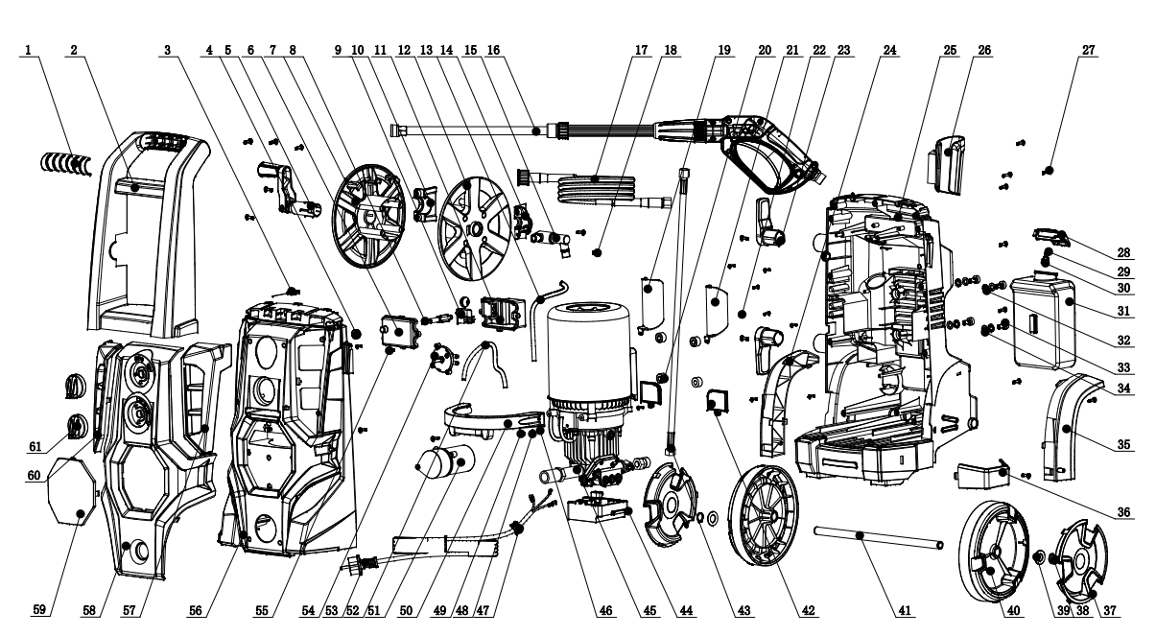
REF | DESCRIPTION | QTY |  | REF | DESCRIPTION | QTY
1 | HANDLE CAP手柄盖 | 1 |  | 33 | SCREW M8*30十字槽盘头螺钉M8*30 | 4
2 | HANDLE 手柄 | 1 |  | 34 | SPRING GASKET 弹簧平垫圈 | 4
3 | CLEANING PIN带柄通针 | 1 |  | 35 | RIGHT WHEEL PLATE右滚轮檐 | 1
4 | CABLE SEAL 电缆密封圈 | 4 |  | 36 | GUN HOLDER枪托 | 1
5 | HOSE REEL 摇柄组件 | 1 |  | 37 | WHEEL CAP轮盖 | 2
6 | switch BOX CAP 开关盒盖 | 1 |  | 38 | ELASTIC COLLAR 轴用弹性挡圈16 | 2
7 | LEFT HOSE REEL 左卷管轮 | 1 |  | 39 | FLAP GASKET￠16平垫圈-全角型-A级 | 2
8 | Nager拔杆 | 1 |  | 40 | WHEEL包胶滚轮 | 2
9 | SWITCH开关 | 1 |  | 41 | WHEEL AXLE轮轴 | 1
10 | LEFT PRESS PLATE FOR HOSE REEL卷管轮左压板 | 1 |  | 42 | DASH PLATE挡水板 | 2
11 | switch box开关盒 | 1 |  | 43 | INSIDE HOSE内置高压管 | 1
12 | RIGHT HOSE REEL右卷管轮 | 1 |  | 44 | PUMP FIXXING SEAT 150泵固定座 | 1
13 | soap TUBE内置吸液管 | 0.45M |  | 45 | MOTOR AND PUMP电机泵组件 | 1
14 | RIGHT PRESS PLATE FOR HOSE REEL卷管轮右压板 | 1 |  | 46 | SAWTOOTH GASKET锯齿垫片￠4 | 1
15 | three-way SET三通组件 | 1 |  | 47 | CABLE SHEATH 出线护套组件 | 1
16 | SPRAY GUN AG375枪 | 1 |  | 48 | SPRING GASKET弹簧平垫圈￠4 | 1
17 | HOSE 高压管 | 1 |  | 49 | SCREW M4*8 十字槽盘头螺钉 | 1
18 | SCREW ST4.8*16十字槽盘头自攻螺钉 | 29 |  | 50 | PRESS PLATE OF MOTOR 电机压板 | 1
19 | DASH plate of left accessory 左附件挡水板 | 1 |  | 51 | CAPACITOR电容组件 | 1
20 | VIBRATION DAMPING OF MOTOR电机减震圈 | 4 |  | 52 | SOAP TUBE OUTSIDE 外置吸液管 | 0.7M
21 | DASH PLATE OF RIGHT ACCESSORY 右附件挡水板 | 1 |  | 53 | CABLE电源线组件 SCREW 十字槽盘头螺钉M6*10 | 1
22 | SCREW ST3.5*13F 十字槽盘头自攻螺钉 | 22 |  | 54 | switcH FOR SOAP 调液开关组件 | 1
23 | CABLE HOOK挂线钩 | 2 |  | 55 | SCREW st4*16十字槽盘头自攻螺钉ST4*16 | 2
24 | LEFT WHEEL PLATE 左滚轮檐 | 1 |  | 56 | upper housing前壳 | 1
25 | bottOM HOUSING后壳 | 1 |  | 57 | UPPER RIGHT DECORATION PLATE前壳右装板 | 1
26 | GUN HOOK枪挂架 | 1 |  | 58 | DECORATION PLATE旋钮装饰板 | 1
27 | SCREW ST4.8*20十字槽盘头自攻螺钉 | 3 |  | 59 | LOGO PLATE LOGO板 | 1
28 | SOAP TANK CAP吸液壶盖 | 1 |  | 60 | UPPER LEFT DECORATION PLATE前壳左装板 | 1
29 | SOAP TANK FILTER TIP清洁瓶过滤嘴 | 1 |  | 61 | SWITCH 旋钮组件 | 2
30 | SOAP TANK FILTER清洁瓶过滤网 | 1
31 | BUILT-IN SOAP TANK内置吸液壶 | 1
32 | SAWTOOTH GASKET锯齿垫片￠8 | 4

