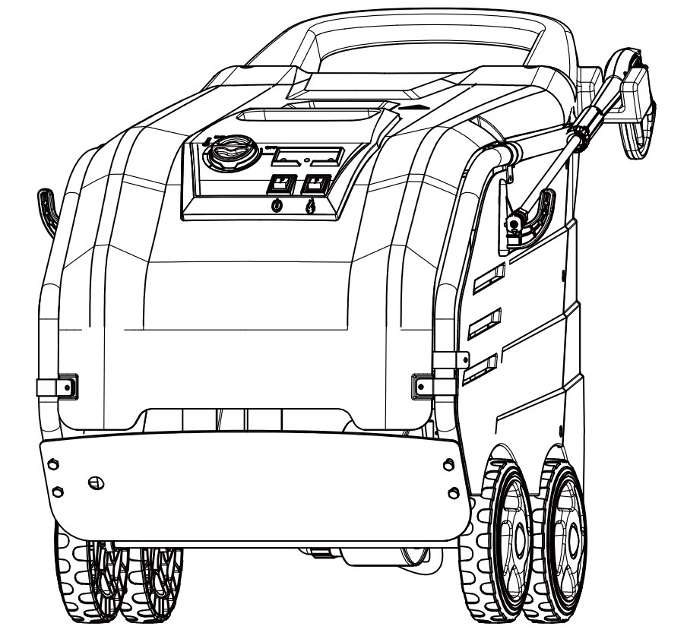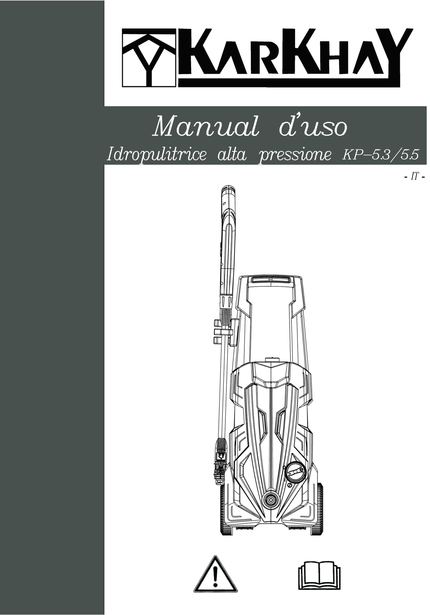

**OPERATOR’S MANUAL**

HOT WATER PRESSURE WASHER

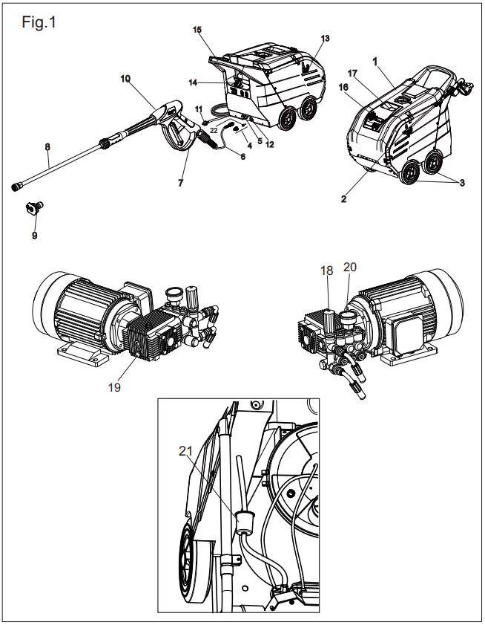

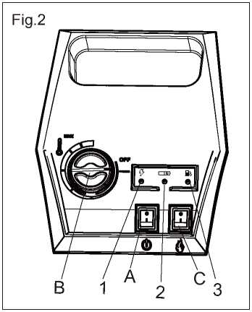

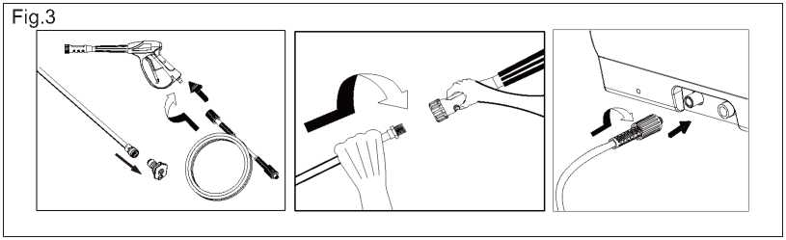

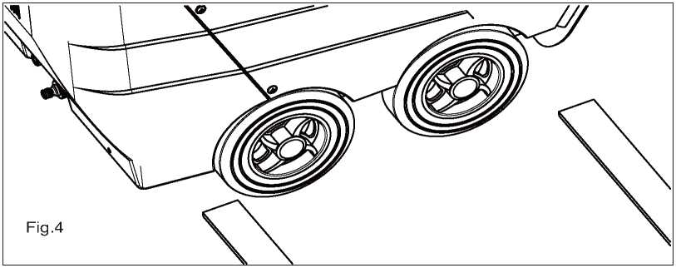

CAUTION: READ THE INSTRUCTIONS BEFORE USE

Please read and comply with these original instructions prior to the initial operation of your appliance and store them for later use or subsequent owners.

- Before first start-up it is definitely necessary to read the operating instructions and safety indications.

- In case of transport damage inform vendor immediately.

- Check the contents of the pack before unpacking.

Contents

Environmental protection................................3

Symbols in the operating instructions..............3

Overview...........................................................4

Symbols on the machine..................................4

Proper use........................................................4

Safety instructions............................................4

Safety Devices...................................................5

Start up.............................................................5

Operation.........................................................7

Storage..............................................................9

Transport...........................................................9

Maintenance and care......................................9

Troubleshooting..............................................10

Warranty..........................................................11

Accessories and Spare Parts............................11

CE Declaration of Conformity..........................11

Technical specifications...................................12

Recurring tests.................................................13

Pressure washer safety warnings.....................14

Environmental protection

|  |  |
| --- | --- |
|  | The packaging material can be recycled. Please do not throw the packaging material into household waste; please send it for recycling.  Old appliances contain valuable materials that can be recycled; these should be sent for recycling. Batteries, oil, and similar substances must not enter the environment. Please dispose of your old appliances using appropriate collection systems. |

|  |
| --- |
| Please do not release engine oil, fuel oil, diesel and petrol into the environment Protect the ground and dispose of used oil in an environmentally-clean manner. |

Symbols in the operating Instructions

Danger

Immediate danger that can cause severe injury or even death.

Warning

Possible hazardous situation that could lead to severe injury or even death.

Caution

Possible hazardous situation that could lead to mild injury to persons or damage to property

Overview

Device elements

**Figure 1**

1 Cover

2 Support for spray lance

3 Wheel

4 Water supply set

5 High pressure connection

6 High pressure hose

7 Safety latch of the hand spray gun

8 Spray lance

9 High-pressure nozzle

10 Hand spray gun

11 Power supply

12 Connection for water supply with filter

13 Support for power supply

14 Pouring vent for fuel

15 Handle

16 Operating field

17 Storage compartment for accessories

18 Pressure/quantity regulation of the pump unit

19 Oil drain screw

20 Manometer (optional)

21 Fuel filter

22 Water filter

Operating field

Figure 2

A Power switch

B Temperature controller

C Boiler switch

1 Power grid indicator lamp

2 Device ignition indicator lamp

3 Fuel indicator lamp

Symbols on the machine

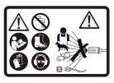

High-pressure jets can be dangerous if improperly used. The jet may not be directed at persons, animals, live electrical equipment or at the appliance itself.

Proper use

Cleaning of: Machines, Vehicles, Structures, Tools, Facades, Terraces, Gardening tools, etc.

**Danger**

Risk of injury! Follow the respective safety regulations when operating at gas stations or other dangerous areas.

|  |
| --- |
| Please do not let mineral oil contaminated waste water reach soil, water or the sewage system. Perform engine cleaning and bottom cleaning therefore only on specified places with an oil trap. |

Safety instructions

- Please follow the national rules and regulations for fuel spray jets of the respective country.

- Please follow the national rules and regulations for accident prevention of the respective country. Fuel spray jets must be tested regularly and the results of these tests must be documented in writing.

- The heating appliance of the machine is an ignition plant. All national laws and regulations about heating systems must also be followed.

- As per the applicable national guidelines, the first time this high-pressure cleaner must be taken into operation by a skilled person.

- We would like to point out that the appliance must be repeatedly checked by a skilled person as prescribed by the applicable national regulations. Please contact your dealer.

Safety Devices

Safety devices serve for the protection of the user and must not be put out of operation or bypassed with respect to their function.

Overflow valve and pressure switch

- While reducing the water supply at the pump head or with the Servopress - regulation the overflow valve opens and part of the water flows back to the pump suck side.

- If the hand-spray gun is closed, so that the whole water flows back to the pump suck side, the pressure switch at the overflow valve shuts down the pump.

- If the hand spray gun is opened, the pressure switch on the cylinder head turns the pump back on.

The overflow valve is set by the manufacturer and sealed. Setting only by customer service.

Safety valve

- The safety valve opens, when the overflow valve resp. the pressure switch is broken.

The safety valve is set by the manufacturer and sealed. Setting only by customer service.

Water shortage safeguard

- The water shortage safeguard prevents the burner to be turned on when there is water shortage.

Start up

**Warning**

Risk of injury! Device, tubes, high pressure hose and connections must be in faultless condition. Otherwise, the appliance must not be used.

Refill fuel

**Danger**

Risk of explosion! Only refill diesel oil or light fuel oil. Unsuitable fuels, e.g. petrol, are not to be used..

**Caution**

Never operate device with empty fuel tank, the fuel pump will otherwise be destroyed.

Refill fuel.

Close tank lock.

Wipe off spilled fuel.

Use with detergent

**Caution**

Risk of injury!

- Use only products suitable for pressure washer.

- Under no circumstances fill solvents (petrol, aceton, diluting agent etc.).

- Avoid eye and skin contact.

- Observe safety and handling instructions by the detergent manufacturer.

Install the hand-spray gun, the jet pipe, the nozzle and the high pressure hose

**Figure 3**

Connect the lance to the spray gun.

Tighten the screw connection of the spray lance fingertight.

Insert high pressure nozzle into covering nut.

Attention: the covering nut must return to its original position once the nozzle is inserted.

Connect the high pressure hose to the high pressure connection point of the machine.

Connect the high pressure hose to the hand-spray gun.

**Caution**

Always unwind high pressure hose completely.

Water connection

For connection values refer to technical specifications

Attach supply hose (minimum length 7.5 m, minimum diameter 3/4“) to the water supply set by means of a hose clamp.

Connect the supply hose to the water connection point of the machine and at the water supply point (for e.g. a tap).

**Note**: The supply hose and the hose clamp are not included in the scope of delivery.

Suck in water from vessel

If you want to suck in water from an external vessel, you have to follow the figure

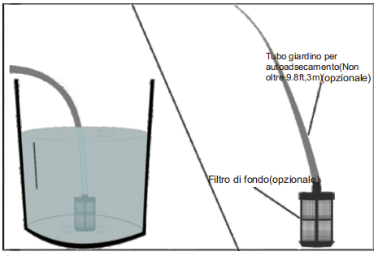

**Attention**

Obenperate to local legislation on water use. According to EN12779(BA) Equipment can only be connected to the water supply if the supply pipe is provided with a check valve. Risk of water mains contamination.

**Danger**

Never suck water from drinking water containers. Never vacuum up liquids containing solvents such as paint thinner, gasoline, oil or unfiltered water. Device seals are not resistant to solvents. Spraying mist is highly flammable, explosive and poisonous.

Power connection

- For connection values, see technical data and type plate.

- The electrical connections must be done by an electrician according to IEC 60364-1

The power supply must include a leakage current protection device) which interrupts the supply of electricity if a leakage of more than 30mA occurs for 30ms, or a device which proves the leakage of the circuit to the ground.

**Danger**

Danger of injury by electric shock.

- Unsuitable extension cables can be hazardous. Only use extension cables outdoors which have been approved for this purpose and labelled with a sufficient cable cross section.

- Always unwind extension lines completely.

- The plug and coupling of the extension cable used must be watertight.

**Caution**

- The highest allowed net impedance at the electrical connection point (refer to technical data) is not to be exceeded. In case of confusion regarding the power impedance present on your connection, please contact your utilities provider.

Use

**Danger**

Risk of explosion!

Do not spray flammable liquids.

**Danger**

Risk of injury!

Never use the appliance without the spray lance attached. Check and ensure proper fitting of the spray lance prior to each use. The screw connection of the spray lance must be fingertight.

Safety instructions

**Warning**

Long hours of using the appliance can cause circulation problems in the hands on account of vibrations.

It is not possible to specify a generally valid operation time, since this depends on several factors:

- Proneness to blood circulation deficiencies (cold, numb fingers).

- Low ambient temperature. Wear warm gloves to protect hands.

- A firm grip impedes blood circulation.

- Continuous operation is worse than an operation interrupted by pauses.

In case of regular, long-term operation of the device and in case of repeated occurrence of the symptoms (e.g. cold, numb fingers) please consult a physician.

Replace the nozzle

**Danger**

Switch the appliance off prior to replacing nozzle and activate hand spray gun until device is pressureless.

Operating modes

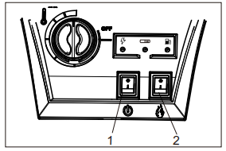

0/OFF =off I/ON =on

1 Cold water operation

2 Hot water operation

Turning on the Appliance

Set appliance switch to desired operating mode.

The device starts briefly and turns off, as soon as the working pressure is reached.

Unlocking the safety latch of the hand spray gun.

When activating the hand spray gun the device switches back on.

**Note:** If no water comes out of the high pressure nozzle, vent pump. Refer to "Help with malfunctions - appliance is not building up pressure"

Adjust cleaning temperature

Set temperature regulator to desired temperature.

**30°C to 95°C**

- Clean with hot water.

Set working pressure and flow rate

**Pressure/quantity regulation of the pump unit**

Turn the regulation spindle in a clockwise direction: Increase working pressure (MAX).

Turn the regulation spindle in an anticlockwise direction: Reduce working pressure (MIN).

Note: For long term work with low pressure, set pressure at the pump unit.

Operation with detergent

- For considerate treatment of the environment use detergent economically.

- The detergent must be suitable for the surface to be cleaned.

Cleaning

Set pressure/temperature and detergent concentration according to the surface to be cleaned.

**Note:** To prevent damage due to too much pressure, always position high pressure ray first from a greater distance towards object to be cleaned.

**Recommended cleaning method**

- Loosen the dirt:

Spray detergent economically and let it work for 1...5 minutes but do not let it dry up.

- Remove the dirt:

Spray off loosened dirt with the high pressure jet.

Operating with cold water

Removal of light contaminations and clear rinse, i.e.: Gardening tools, terrace, tools, etc.

Set operating pressure according to need.

Operating with hot water

We recommend the following cleaning temperatures:

- Light contaminations

**30-50°C**

- Contaminations containing protein, i.e. in the food processing industry

**max. 60 °C**

- Very oily dirt

**60-95°C**

**Operating with hot water**

**Danger**

Scalding danger!

Set temperature regulator to desired temperature.

Turn off the appliance

**Danger**

Danger of scalding by hot water. After the operation with hot water, the device must be operated with opened gun with cold water for at least two minutes.

- Set the appliance switch to “0/OFF”.

- Shut off water supply.

- Turn on pump shortly (appr. 5 seconds) with device switch.

- Pull main plug out of socket with dry hands only.

- Remove water connection.

- Activate hand spray gun until device is pressure less.

- Lock the trigger gun.

Storing the Appliance

Lock in the steel pipe into the holder of the appliance hood.

Roll up high pressure hose and electrical conduit and hang them into the respective holders.

**Note**: Do not twist high pressure hose and electrical conduit.

Frost protection

Winter storage and long-term storage.

If you have to store the appliance in a place with temperatures below 0'C(32F)，you can minimise the possibility of damage by following this procedure:

- Disconnect the water inlet and outlet hose.

- Switch on the switch (I/ON) for a few seconds to let the residual water out of the pump, then switch off immediately (0/OFF).

- Do not twist high pressure hose.

- Store the appliance and accessories in a room where there is no risk of freezing.

- Do not store the appliance near furnaces or other heat sources that can melt and excessively dry the internal parts of the pump and accessories.

- Add a non-corrosive, non-toxic, antifreeze liquid to the pump for the winter period (suction it from the water inlet connection)

- Before using the unit again, rinse the pump completely with clean water. Antifreeze products can damage paint, so be sure to remove the antifreeze in the system before any cleaning.

Storage

**Caution**

Risk of injury and damage! Note the weight of the appliance in case of storage.

Transport

**Figure 4**

**Caution**

Risk of damage! When loading the appliance with a forklift, observe the illustration.

**Caution**

Risk of injury and damage! Observe the weight of the appliance when you transport it.

When transporting in vehicles, secure the appliance according to the guidelines from slipping and tipping over.

Maintenance and care

**Danger**

Risk of injury by inadvertent startup of appliance and electrical shock.

First pull out the plug from the mains before carrying out any tasks on the machine.

Set the appliance switch to "0/OFF“.

Shut off water supply.

Turn on pump shortly (appr. 5 seconds) with device switch.

Pull main plug out of socket with dry hands only.

Remove water connection.

Activate hand spray gun until device is pressure less.

Lock the trigger gun.

Allow device to cool down

Your dealer will inform you about the performance of a periodic safety inspection resp. signing of a maintenance contract.

Maintenance intervals

**Weekly**

- Clean the filter in the water connection.

- Check oil level.

**Caution.**

In case of lacteous oil inform your dealer’s customer service immediately.

**After 300 operating hours, at least annually**

- Oil change.

**At least every 5 years.**

- Perform the pressure test as per manufacturer's instructions.

Maintenance Works

**Clean the filter in the water connection**

Take out filter.

Clean filter in water and reinstall.

**Oil change.**

Ready a catch bin for appr 1 Litre oil.

Loosen release screw.

|  |
| --- |
| Dispose of old oil ecologically or turn in at a gathering point. |

Tighten release screw.

Fill oil slowly up to the MAX marking.

**Note:** Air pockets must be able to leak out.

**Recommended oil 10W-40.**

Troubleshooting

**Danger**

Risk of injury by inadvertent startup of appliance and electrical shock.

First pull out the plug from the mains before carrying out any tasks on the machine.

Fuel indicator lamp comes on

- Diesel shortage.

Adding diesel.

Power grid indicator lamp goes off

- No mains voltage, see "Device does not work".

Check connection and power supply.

Device ignition indicator lamp comes on

Device switch on.

The device does not work

- Mains voltage failure.

Check connection and power supply.

The device does not develop pressure

- Air within the system.

Remove air from the pump:

With open hand spray gun turn device on and off multiple times with the device switch.

Open and close the pressure/quantity regulation at the pump unit with the hand spray gun open.

**Note**: By dismantling the high pressure hose from the high pressure connection the venting process is accelerated.

Check connections and conduits.

- Pressure is set to MIN.

Set pressure to MAX.

- Filter in the water connection is dirty

Clean the filter.

- Amount of water supply is too low.

Check water supply level (refer to technical data).

Device leaks, water drips from the bottom of the device

- Pump leaky

**Note**: 3 drops/minute are allowed

With stronger leak, have device checked by customer service.

Device turns on and off while hand spray gun is closed

- Leak in the high pressure system

Check high pressure system and connections for tightness.

Burner does not start

- Fuel tank empty.

Refill fuel.

- Water shortage

Check water supply, check connections.

Clean filter in the water shortage safeguard.

- Fuel filter dirty

Change fuel filter

- No ignition spark

Have device checked by customer service.

Set temperature is not achieved while using hot water

- Working pressure/flow rate to high

Reduce working pressure/flow quantity at the pressure/volume regulator in the pump unit.

- Sooty heating spiral

Have device de-sooted by customer service.

**If malfunction can not be fixed, the device must be checked by customer service.**

Warranty

The warranty terms published by our competent sales company are applicable in each country. We will repair potential failures of the appliance within the warranty period free of charge, provided that such failure is caused by faulty material or defects in fabrication.

Accessories and Spare Parts

Only use accessories and spare parts which have been approved by the manufacturer. The exclusive use of original accessories and original spare parts ensures that the appliance can be operated safely and trouble free.

CE Declaration of Conformity

We hereby declare that the machine described below complies with the relevant basic safety and health requirements of the EU Directives, both in its basic design and construction as well as in the version put into circulation by us. This declaration shall cease to be valid if the machine is modified without our prior approval.

**Product**: High pressure cleaner

**Model**: KPC-H5

**Relevant EU Directives**

97/23/CE2006/42/CE(+2009/127/CE)2014/30/UE

1999/5/CE2000/14/CE

**Applied harmonized standards**

EN 55014-1:2006+A1:2009+A2:2011EN 55014-2:1997+A1:2001+A2:2008

EN 60335-1

EN 60335-2-79

EN 61000-3-2:2014

EN 62233:2008

**Applied specifications:**

Based on AD 2000

Based on TRD 801

**Applied conformity evaluation method for 2000/14/CE**

Appendix V

**Sound power level dB(A)**

**KPC-H5 1511**

Measured: 86

Guaranteed: 88

**KPC-H5 2515**

Measured: 88

Guaranteed: 90

Technical data

KPC-H5 1511 KPC-H5 2515

**Main Supply**

Voltage V 230-240 380-400

Current type Hz 50 50

Connected load kW 3.1 7.5

Protection (slow) A 16 16

Type of protection IPX5 IPX5

Protective class I I

Maximum allowed net impedance Ohm (0,321+j 0,200) (0,321+j 0,200)

**Water connection**

Max. feed temperature °C 40 40

Min. feed volume l/h (l/min) 1000(16.7) 1260(21)

Suck height from open container (20 °C) m 0.5 0.5

Max. feed pressure MPa (bar) 0.6(6) 0.6(6)

**Performance data**

Water flow rate l/h (l/min) 350-660(5.8-11) 420-960(7-16)

Operating pressure of water (using

standard nozzle) MPa (bar) 5-12(50-120) 7-20(70-200)

Max. excess operating pressure (safety

valve) MPa (bar) 15(150) 25(250)

Max. operating temperature of hot water °C 95 95

Detergent suck in (optional) l/h (l/min) 0-45 (0-0.75) 0-45 (0-0.75)

Burner performance kW 58 74

Maximum consumption of heating oil L/h 4.7 4.7

Max. recoil force of hand spray gun N 28.4 53

Nozzle size 045 045

**Values determined as per EN 60355-2-79**

Noise emission

Sound pressure level LpA dB(A) 70 70

Uncertainty KpA dB(A) 3 3

PSound power level LWA + Uncertainty

KWA dB(A) 88 90

Hand-arm vibration value

Hand spray gun m/s² 1.3 1.5

Spray lance m/s² 3.4 3.4

Uncertainty K m/s² 1.0 1.0

**Fuel**

Fuel Fuel oil EL or Diesel Fuel oil EL or Diesel

Amount of oil l 0.75 0.75

Oil grade 10W40 10W40

**Dimensions and weights**

Length x Width x Height mm 1330x750x1060 1330x750x1060

Typical operating weight kg 106 132

Fuel tank l 22 22

Recurring tests

**Note:** The recommended testing frequencies of the respective statutory regulations of the

country of operation are to be followed.

|  |  |  |  |
| --- | --- | --- | --- |
| Testing done by: | External testing | Internal testing | Leak-proof tests |

|  |  |  |  |
| --- | --- | --- | --- |
| Name | Signature of the  authorised person/  date | Signature of the  authorised person/  date | Signature of the  authorised person/  date |
| Name | Signature of the  authorised person/  date | Signature of the  authorised person/  date | Signature of the  authorised person/  date |
| Name | Signature of the  authorised person/  date | Signature of the  authorised person/  date | Signature of the  authorised person/  date |
| Name | Signature of the  authorised person/  date | Signature of the  authorised person/  date | Signature of the  authorised person/  date |
| Name | Signature of the  authorised person/  date | Signature of the  authorised person/  date | Signature of the  authorised person/  date |
| Name | Signature of the  authorised person/  date | Signature of the  authorised person/  date | Signature of the  authorised person/  date |

Pressure washer safety warnings

Before using the device for the first time, read these safety warnings and the orignal operating instructions. Act according to the instructions.

Keep both booklets for future use or for a successful owner.

- Always observe both the directions in the instructions and the general safety/accident regulations in force.

- Warning and indication plates affixed to the device provide important information for completely safe use.

Danger levels

**DANGER**

● Indicates imminent danger resulting in serious injury or death.

**WARNING**

● Indicates a likely dangerous situation that could result in serious injury or death.

**PRUDENCE**

● Indicates a likely dangerous situation that could cause minor injury.

**ATTENTION**

● Indicates a likely dangerous situation that could result in property damage.

Personal protective equipment

**PRUDENCE**. ● Wear appropriate safety gloves while using the device. ● Wear hearing protection if the operating instructions state a sound pressure level above 80 dB(A), see chapter Technical data of the operating instructions. ● Wear appropriate protective clothing and goggles to protect yourself from dirt and splashing water. ● During the use of high-pressure cleaners, aerosols can be created. Inhaling aerosols can lead to health damage. The employer is obliged to conduct a risk assessment to determine, depending on the superhicie and the environment to be cleaned, the appropriate protective measures against aerosol inhalation. Respiratory protective masks of FFP class 2 or higher are suitable as protection from aqueous aerosols. ● Exhaust gases and soot can form when using hot water pressure washers with combustion engines. Inhalation of exhaust gases and contact with soot can cause health damage. The necessary protective measures against inhalation of exhaust gases and contact with soot must be specified. Therefore, use a suitable respiratory mask against exhaust gases and gloves edact against soot.

General safety warnings

**DANGER** ● Suffocation hazard. Keep packaging films out of the reach of children.

**WARNING** ● Use the device only in a manner that complies with the regulations. Comply with local conditions and while using the device, pay attention to third parties, especially children. ● The device should not be ufilized by persons with reduced physical, sensory or mental capabilities or who lack experience and/or knowledge. The device should be used only by persons who have been instructed in its respective use or who have proven that they know how to use the device and have been expressly instructed to use it. ● Supervise children to make sure they do not play with the device. ● The device should not be used by children and young people.

**PRUDENCE** ● Security devices are for your protection: never modify or circumvent the security device.

Danger of electric shock

**DANGER** ● Connect protection class I equipment only to properly grounded power sources. ● The voltage indicated on the nameplate of the device must match that of the power source. ● Observe the minimum protection of the electrical outlet, see chapter Technical specifications in the operating instructions. ● Use the device only through a differential (max 30 mA). ● Never touch and grasp the plug and electrical outlet with wet hands. ● Plug and joint of an extension cord should be waterproof and should not be placed in water. The jute should not be placed on the ground. Use cable spools that can ensure that outlets are at least 60 mm above the ground. ● All current-conducting parts in the work area must be protected from splashing water.

**WARNING** ● Connect the appliance only to an electrical connection installed by an electrical installer in accordance with IEC 60364-1. ● Check the mains cable with the plug before each use to make sure it is not damaged. Do not operate the device if there is any damage to the power connection. Have the damaged network cable replaced immediately by customer service/authorized electrician. ● Do not damage the power connection cable or extension cord by stepping on them, crushing them, pulling on them, or in any other similar way. Protect the power connection cable from heat, oil and sharp edges. ● Use only the manufacturer's intended connection cable, even when replacing the cable. For the order code and types, see the operating instructions. ● Unsuitable electrical extension cords can be dangerous. Outdoors, use only approved and marked electrical cable extensions with sufficient cable cross section. ● Replace connectors to the mains cable and extension cords only with others that have the same water tightness and mechanical strength.

**PRUDENCE** ● In case of long breaks and after use, turn off the pincipal switch and unplug it.

**ATTENTION** ● The insertion transient causes a temporary voltage decrease. ● In unfavorable grid conditions, other equipment may be damaged. ● Such damage is not expected, if the grid impedance is less than 0.15 Ohm.

Water connection

**WARNING** ● Do not operate the appliance if the high pressure hose is damaged. Immediately replace the damaged pressure hose. It is permissible to use only the hoses and connections recommended by the manufacturer. For the order code, see the operating instructions. ● The connections of the connection pipes must be leak-proof.

**ATTENTION** ● Observe the regulations of the water supply company.

Put into operation

**DANGER** ● If the device is used in hazardous environments (e.g. gas stations), the relevant safety regulations must be observed. ● Use in explosive environments is prohibited. ● NNever vacuum solvents, liquids containing solvents, or undiluted acids. This includes, for example, gasoline, paint thinner or heating oil. ● The spray is highly flammable, explosive and toxic. ● Damaged tires and their valves pose a life-threatening hazard. Tires and their valves can be damaged by the high-pressure jet and burst. The first symptom of this is a change in tire color. When cleaning tires and their valves, always maintain a spraying distance of at least 30 cm.

**WARNING** ● Do not use the device if there are people in the area without the appropriate protective clothing. ● When working with short lances, the hand may come in contact with the high-pressure jet. Never use the concentrated jet nozzles and rotating nozzles with lances shorter than 78 cm. ● The jet of water from the lance generates a repulsive force. The cranked lance causes the force generated to be directed upward. Firmly support the gun and spear. ● If cranked spray devices are used, repulsive and forcing forces may be modified. ● Do not direct the jet at yourself, for example, to clean clothing or footwear. ● Do not direct the high-pressure jet toward people, animals, active electrical equipment or onto the device itself. ● Do not direct the jet at equipment containing material hazardous to health (e.g., asbestos). ● Check equipment and accessories, such as high pressure hose, high pressure gun, and safety devices, before each use to make sure they are safe and in perfect condition. In case of damage, do not use the equipment. Replace damaged components immediately, using high-pressure flexibles, taps and couplings recommended by the manufacturer.

**PRUDENCE** ● Never leave the device unattended when in operation. ● Do not open the cover with the engine running. ● Do not lock the lance lever during use. ● After hot water operation let the fessible pipes cool down or briefly use the appliance with cold water. ● The supporting surface of the device must be stable flat. ● Before cleaning, it is necessary to assess the hazards posed by the surface to be cleaned to determine the requirements for safety and health protection. Take the consequent necessary protective measures.

**ATTENTION** ● Do not use the appliance in temperatures below 0°C. ● Carry out engine cleaning only in washing places equipped with oil separators.

Use with detergents

**PRUDENCE** ● Store cleaners in a place inaccessible to children. ● When using detergents, the safety data sheet of the detergent manufacturer should be observed, especially the directions regarding personal protective equipment. ● Use only the cleaning agents supplied or recommended by the manufacturer. Use of other cleaners or chemical agents may adversely affect the safety of the appliance. ● Do not use the recommended detergents without dilution. The products are safe as they do not contain acids, alkaline solutions or substances harmful to the environment. If the detergents come into contact with the eyes, rinse them immediately with plenty of water, and if swallowed, contact a doctor immediately.

Apparatus with a hand-arm vibration value > 25 m/s² (see technical specifications chapter of the operating instructions)

**PRUDENCE** ● Prolonged use of the apperecchio can cause vascular disorders in the hands, due to vibration. It is not possible to establish generalized times of use, as they are subject to several factors.

● Predisposition to poor blood circulation (fingers often cold and prickly).

● Low abiente temperature. Wear warm gloves to protect hands.

● If the object is grasped too firmly, blood circulation may be hindered.

● Operation interrupted by pauses is better than continuous operation.

We recommend a medical examination if there is regular and continuous use of the device or if symptoms occur repeatedly, for example, tingling and cold fingers.

Air-tire devices

**PRUDENCE** ● For devices with screw-on rims: Make sure all rim screws are securely fastened before adjusting pneumatic pressures. ● Make sure the pressure reducer in the compressor is properly adjusted before adjusting the tire pressure. ● Never exceed the maximum allowable pressure of the peumaphics. Read the tire pressure on the tire and possibly on the rim. If the values are different, it is necessary to respect the lowest value.

Hot water and gasoline engine appliances, combustion engine appliances

**DANGER** ● Unsuitable fuel can cause an explosion. Use only the fuel indicated in the operating instructions.

**WARNING** ● Exhaust gases are toxic. Do not breathe in exhaust gases. When operating the appliance indoors, accept that there is sufficient ventilation and that exhaust gases are removed. ● When refueling, make sure the fuel does not come in contact with hot surfaces.

**PRUDENCE** ● Danger of burns. Do not bend over or rest your hands on the exhaust opening. During operation, do not touch the boiler. ● Never obstruct exhaust gas openings. ● Ensure that near the air intakes, no exhaust emissions are occurring. ● Observe the safety warnings for appliances with gasoline engines in the operating instructions.

Care and maintenance

**WARNING** ● Before cleaning, maintenance and replacement of components, turn off the appliance and, if the appliance works connected to the mains, disconnect it from the socket. ● Before starting any work on the appliance and accessories, epressurize the high pressure system.

**PRUDENCE** ● Repairs should only be carried out by authorised service centers or experienced personnel familiar with all applicable safety standards.

**ATTENTION** ● Perform safety checks for professional mobile devices required by local regulations. ● Short circuits or other damage. Do not clean the appliance with a jet of water or a jet of water at high pressure. ● Do not use acetone, undiluted acids or solvents, as they damage the materials used on the appliance.

Accessories and spare parts

**PRUDENCE** ● Only use accessories and spare parts authorised by the manufacturer. Original accessories and spare parts guarantee safe and trouble-free operation of the appliance. ● To avoid risks, have the repair and installation of spare parts carried out only by authorized customer service.

Transport

**PRUDENCE** ● Turn off the appliance before transporting it. Fix the appliance by weight, see chapter Technical specifications in the operating instructions. ● Danger of accidents and injuries. During transport and storage, pay attention to the weight of the appliance, see chapter Technical specifications of the manual.