# **STEAM CARPET VACUUM CLEANER INSTRUCTION MANUAL**

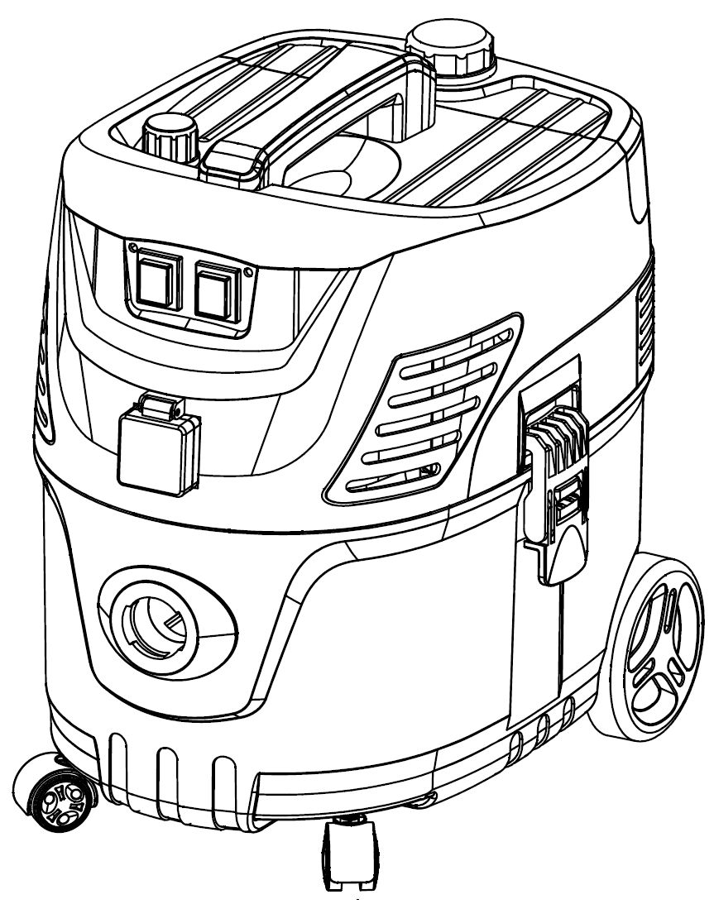

**Host structure**

6

1

7

2

8

3

9

4

5

10

|  |  |  |
| --- | --- | --- |
| No. | Parts Name | Function and description |
| 1 | Steam adjustment switch | Regulate steam flow |
| 2 | Main engine | Used to install steam heater components and dust suction motors |
| 3 | Steam switch | Control the steam heater to heat or power off |
| 4 | Steam outlet | Steam pipe connection |
| 5 | Suck mouth | Vacuum hose connection |
| 6 | Water injection knob | Open the water tank cover and add water to the water tank through the water injection hole |
| 7 | Water storage tank | Water storage container to provide the necessary water to generate steam |
| 8 | Vacuum switch | Control the vacuum motor to work or power off |
| 9 | Bucket clip | Fix the host on the dust bucket |
| 10 | Dust bucket | Storage the dust |

**Accessories list**

|  |  |
| --- | --- |
| Control handle | **360截图1814122110894145** |
| Extension tube-1 | **TIM截图20200916101432** |
| Extension tube-2 | **TIM截图20200916101820** |
| Steam pipe-1 | **TIM截图20200916113327** |
| Steam pipe-2 | **TIM截图20200916113219** |
| Floor brush | **TIM截图20200916112917** |
| Hair brush strip | **TIM截图20200916110001** |
| Sofa brush | **TIM截图20200916113517** |
| Glass brush head | **TIM截图20200916113653** |
| Hair brush head | **TIM截图20200916113919** |
| Point spray nozzle | **TIM截图20200916114139** |
| Cloth filter |  |
| Measuring cup |  |

**Control handle composition structure**

3

20

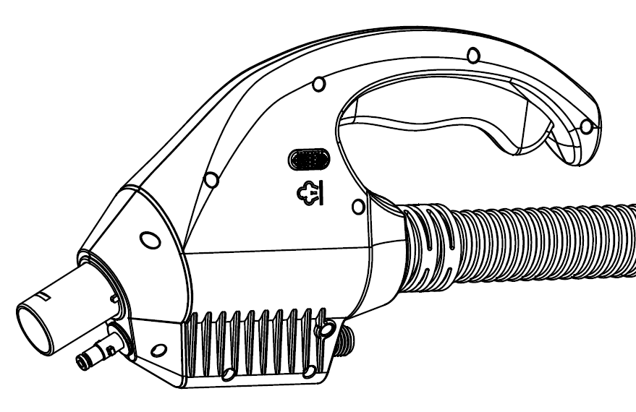

1

5

4

|  |  |  |
| --- | --- | --- |
| No. | Parts name | Function and description |
| 1 | Vacuum connector | Dust suction pipe for connecting accessories |
| 2 | Steam lock | Press to lock the steam switch to prevent accidental touch |
| 3 | Steam switch | Control the on and off of steam |
| 4 | Steam quick connector | Steam outlet, used to connect aluminum steam pipe |
| 5 | Steam threaded connector | Steam inlet, used to connect the handle steam pipe |

**Indicator light description**

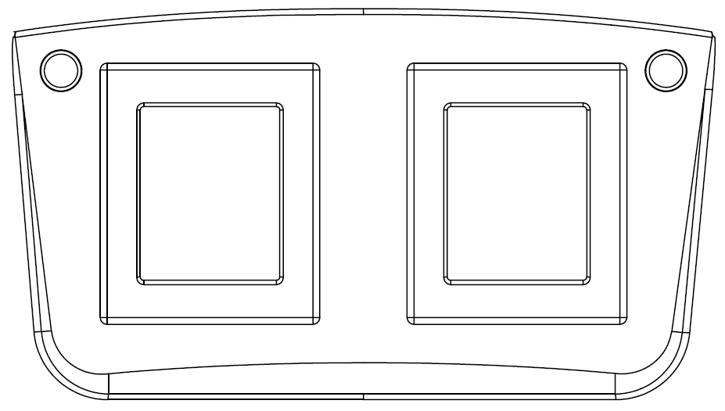

Vacuum power switch

Steam power switch

|  |  |  |
| --- | --- | --- |
| No. | Parts name | Function and description |
| 1 | Steam indicator | Constant red light: the machine is powered on.  Green light flashes: heater warm-up stage.  Steady green light: the heater has finished preheating and works normally. |
| 2 | Vacuum indicator | Steady red light: The machine is powered on.  Steady green light: The vacuum motor is working. |
| 3 | Steam power switch | 一: Steam function  O: Steam function off  二: Drainage function &Cleaning function |
| 4 | Vacuum power switch | 一: Dust-suction function  O: Dust-suction function off |

### **Machine instructions**

### 1、Add water

Please add water to the water tank with a measuring cup before use.

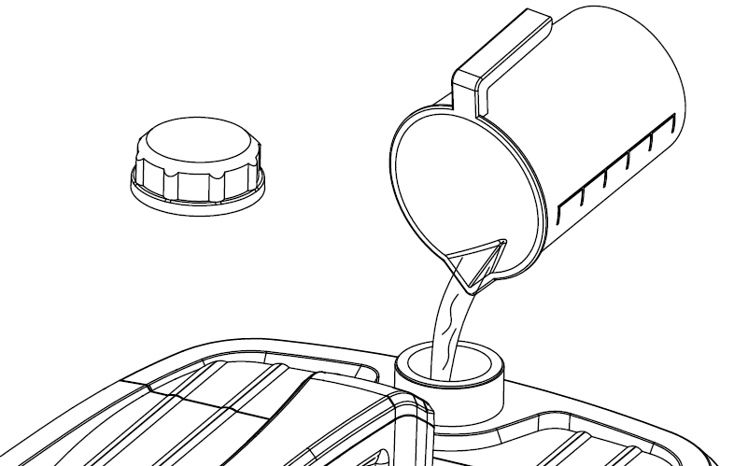

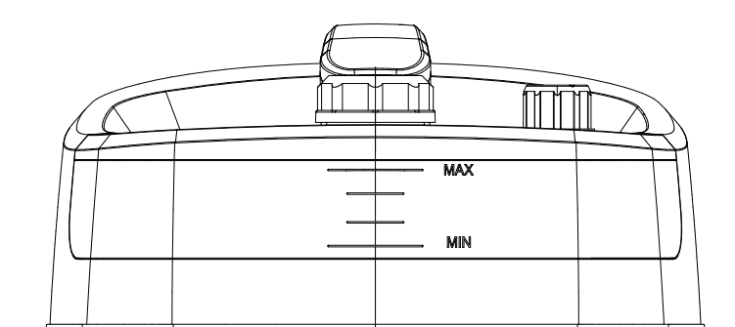

**Warning:**

**Only pure water or distilled water can be added to the water tank, and the amount of water cannot exceed the maximum water level scale of the water tank. If the machine will not be used for a long time, please pour out the water in the water tank.**

**2、Power Connect**

Plug the power cord into the socket and observe the status of the indicator lights. If the power connection is normal, both indicator lights will be red.

**Do not plug in the power plug with wet hands. There is a risk of electric shock.**

**Do not use the power cord or power plug if the shell is damaged, otherwise it may cause electric shock, short circuit or fire.**

### 3、Use operation

**Use of steam function**

Connect the control handle and accessories first, and then press the steam power switch. The green indicator light flashes. When the steam indicator light stays green, it means the heater has finished preheating. Press the steam switch on the handle to use it. (Please refer to the accessory instruction for the correct connection method of the accessory)

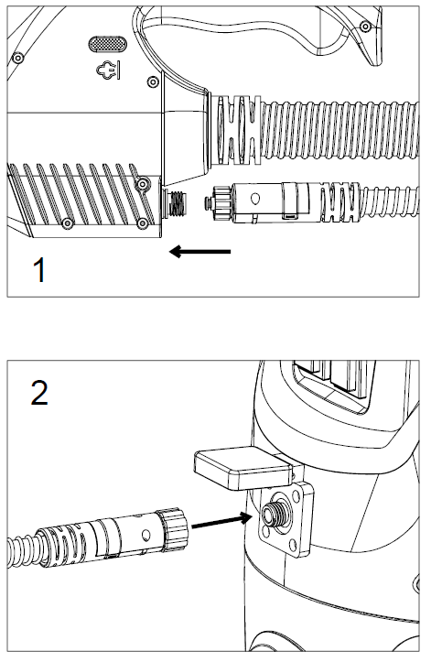

**Steam adjustment knob**

The steam adjustment knob on the top of the machine can control the amount of steam, and the humidity of the steam will also change with the amount of steam. Sofas, carpets, wooden floors and other fabrics are suitable for dry steam cleaning, and floor tiles, glass, etc. are suitable for wet steam cleaning. It is recommended to turn the knob to the middle position first, and then adjust the steam according to the actual use scene.

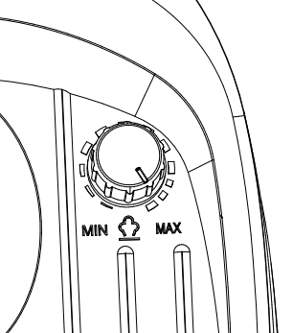

**Note：**

1. The steam emitted for the first time will contain a lot of water droplets. Please avoid cleaning carpets, curtains, clothing and other textiles that are easy to absorb water. It is recommended to spray the first steam into a water tank or high temperature container. The steam will return to normal after 5-6 seconds, please rest assured to use it.
2. Do not spray steam on the surface of the object to be cleaned for more than 3 seconds. High-temperature steam may scald the surface of the object (such as wooden floors, glass windows, sofas, carpets, etc.)
3. During use, regularly observe the water level of the water tank, and if there is no water, turn off the power switch, and then add water to continue using.

**If the user is away for a long time, please turn off the power and unplug the power plug.**

**Do not remove or replace accessories during use. You must first turn off the steam power switch, let the steam in the pipe, and then wait for the accessories to cool down before removing or replacing them.**

**Please avoid the machine running short of water for a long time, which may cause the heater temperature to be too high, blow the thermal fuse and damage the water pump.**

### Using of vacuum cleaner functions

Check whether the filter is installed, connect the vacuum hose connector to the vacuum bucket, connect the accessories that need to be used, and then press the vacuum power switch, the indicator light shows a steady green, and you can vacuum.

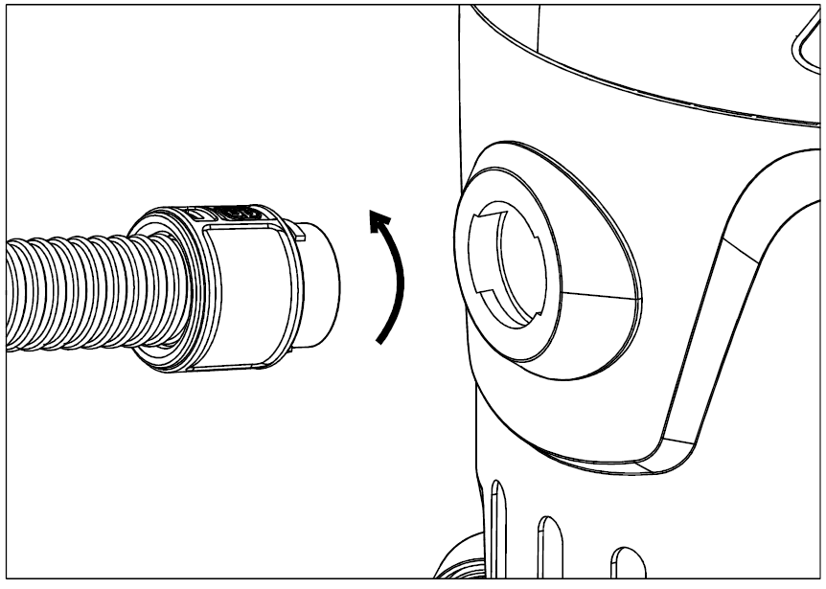

**Note：**

1. Vacuum function and steam function can be used at the same time.

2. When the dust collection function is used alone, the intelligent control chip inside the machine will increase the power of the dust collection motor, and the suction power will also increase to ensure high efficiency.

3. When the vacuum function is used alone, the noise of the machine will become louder. This is caused by the increase in the power of the vacuum motor, which is a normal phenomenon.

**When the suction power is obviously weakened, please clean the filter in time to avoid damage to the motor.**

**Please do not use it to inhale flammable and explosive objects, such as cigarette butts, gasoline, etc.**

**Please do not use it to suck sharp objects.**

**Using accessories instructions**

### Extension tube

If you need to use a floor brush or clean high glass, you can use an extension tube. There are two extension tubes, one is connected to the floor brush and the other is connected to the control handle (floor brush-extension tube-2-extension tube-1-control handle.)

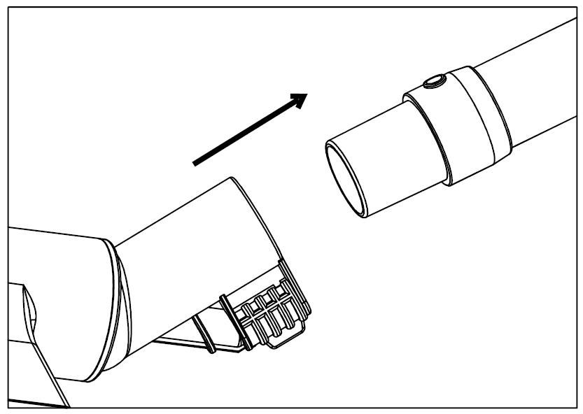

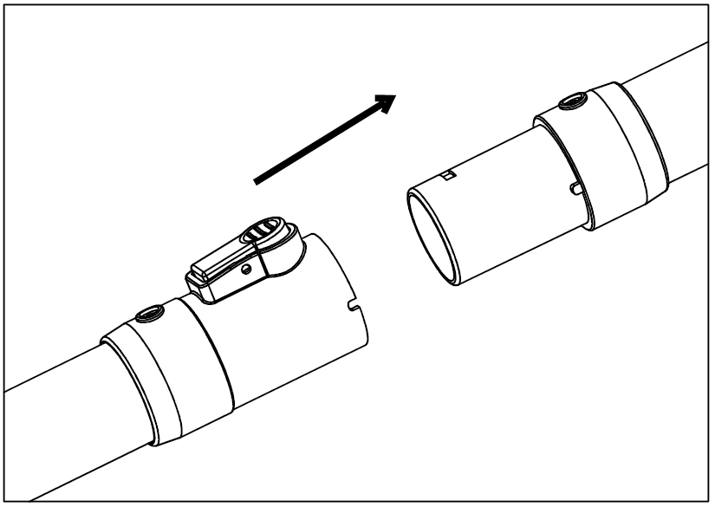

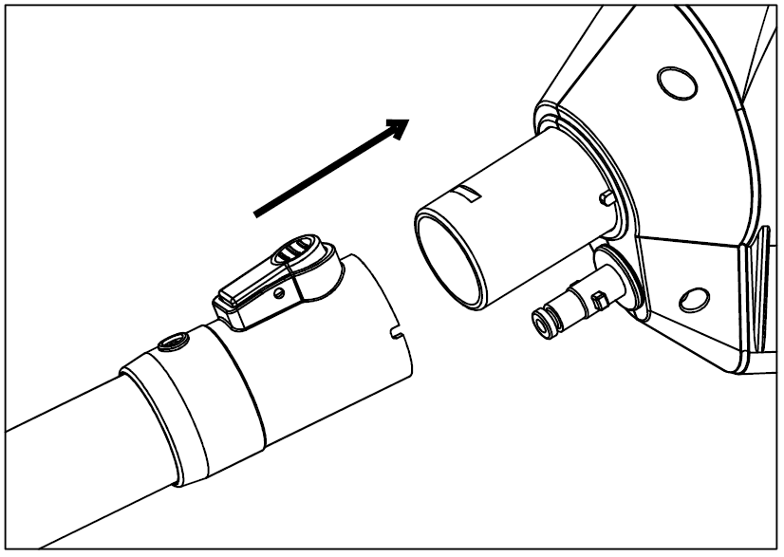

### Steam pipe

Steam pipe-1, the steam pipe used to connect the floor brush and the handle, the joint is fixed by a rotatable buckle, and there are two clamp rings on the pipe that can be fixed on the extension pipe.

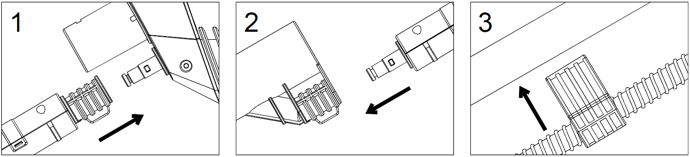

Steam pipe-2, used to connect the air outlet of the host and the steam pipe of the handle. There are two clamps on the pipe that can be fixed on the dust suction hose.

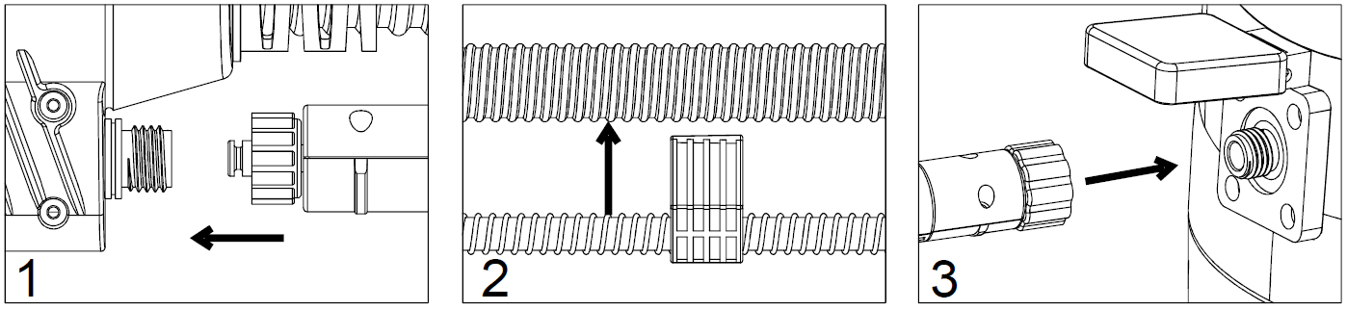

**Note：**

1. Please check whether all connectors are connected in place before use.
2. The outside temperature of the steam pipe is high during use, please do not touch it
3. Do not drag the steam pipe during use to prevent the joint from loosening and falling off.

**Do not remove the steam pipe during use.**

**If you find that there is steam leakage at the steam pipe joint, please stop using it immediately, and you can continue to use it after replacing the seal .**

**When removing the steam pipe, the steam in the pipe must be discharged first, otherwise there is a danger of scalding.**

### Floor brush

When cleaning the floor, connect 2 extension pipes together and install them on the control handle, and connect the other end to the floor brush. There are two types of brush heads for the floor brush that can be replaced. When replacing, push the sliders on both sides of the floor brush outward to remove the scraper, and reset the slider after installing the scraper. The wiper strip is suitable for hard bottom, and the brush strip is suitable for carpet.

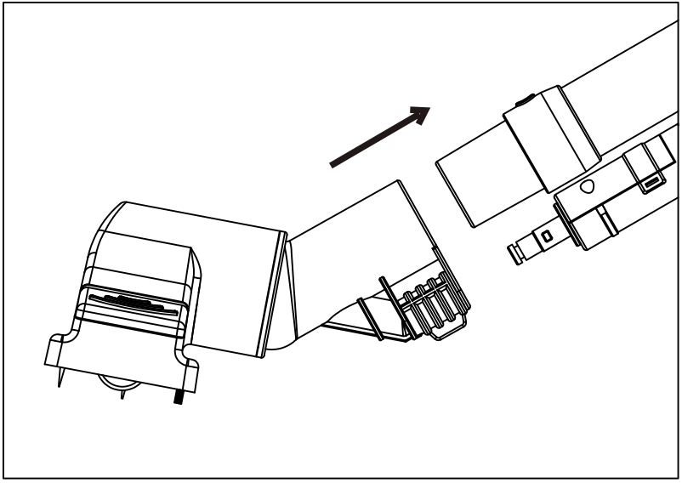

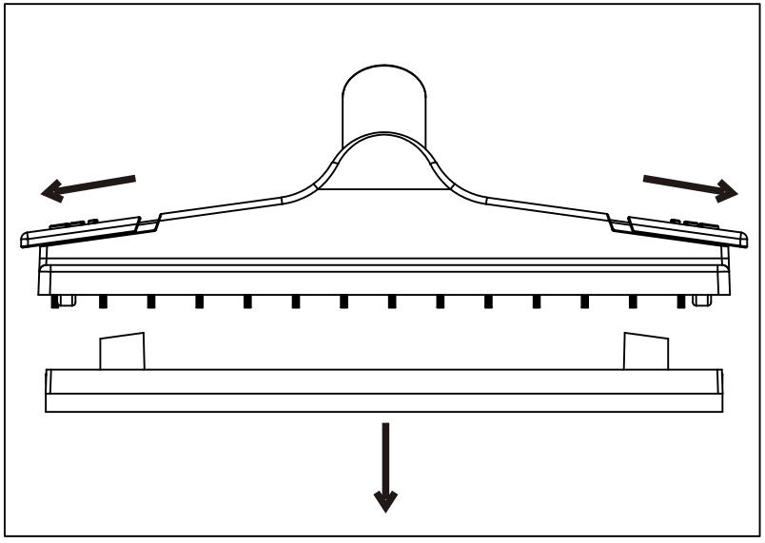

### 4、Sofa brush

Please use the sofa brush when cleaning the sofa. The sofa brush can be directly connected to the control handle or to the extension tube. Sofa brush can be used in combination with hair brush head and glass brush head.

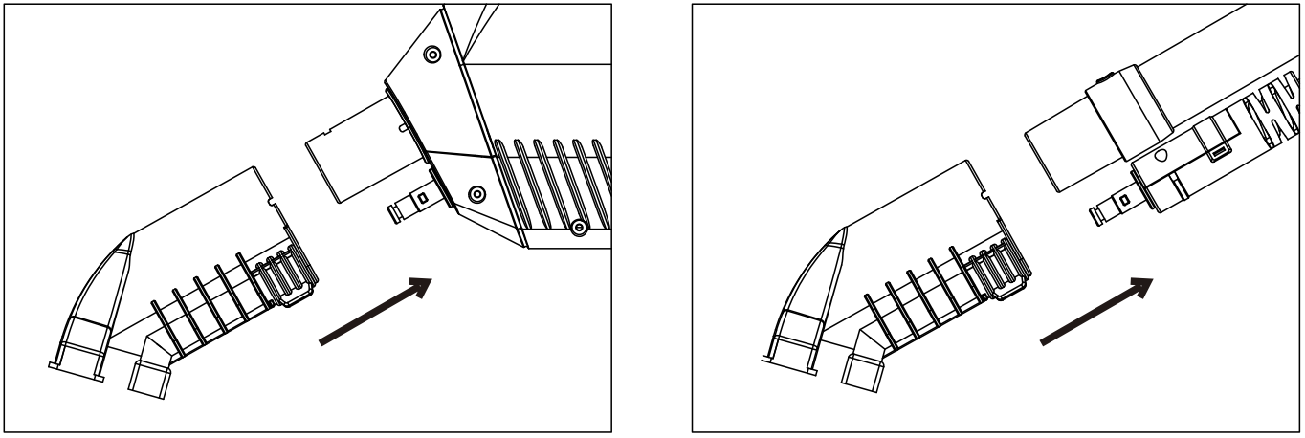

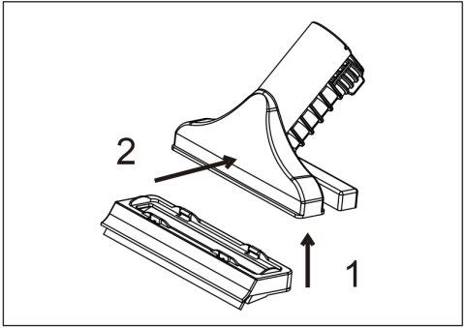

Replace the brush head: align the sofa brush with the brush head card slot, and then press the middle position of the suction mouth of the sofa brush (arrow 2), the brush head can be fixed on the sofa brush.

**When cleaning sofas and other fabrics, adjust the amount of steam appropriately to prevent excessive steam from damaging the sofa.**

**When the ambient temperature is lower than 0℃, do not use it to clean the glass.**

**When cleaning the glass, do not put the glass brush in the same position for more than 2 seconds.**

### 5、Point spray nozzle

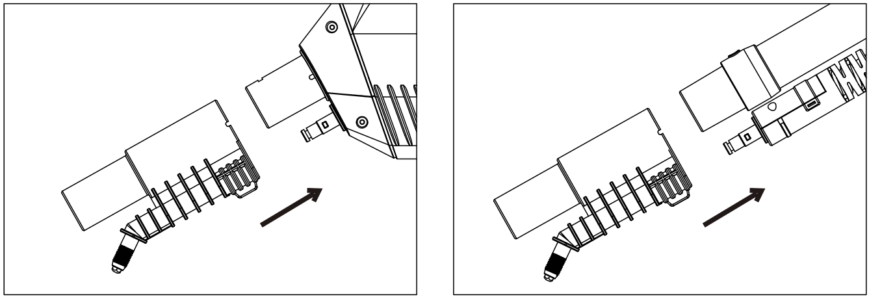The point spray nozzle is more suitable for cleaning some dead corners. The steam injection is more concentrated and the flow rate is faster. It can be used in places that are more difficult to clean, such as tile gaps, door and window guides, etc. The connection method is the same as the sofa brush.

**Storage and cleaning**

1. After use, please turn off the power and unplug the power plug. Excess steam in the pipeline must be released cleanly. Pour out the excess water in the water tank.
2. Clean the garbage and filters in the dust bin regularly. The filter can be rinsed with clean water, and then placed in a ventilated place to dry naturally, no exposure to the sun.

There is an accessory storage shelf behind the machine, and the floor brush and pipe can be directly stuck to the rear of the machine. (as the picture shows)

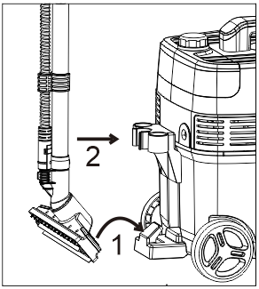

1. In the heating process of the heater, scale will be attached to the pipe inside the heater, which will block the pipe for a long time and affect the use effect of steam. Therefore, it is necessary to regularly use citric acid scale removals to remove the scale of the pipes inside the heater (operation steps are as follows).

① Pour 500mL clean water into the measuring cup, pour the scale remover (10g) into the cup and stir until it is fully dissolved.  
② Pour the detergent solution into the water tank and connect the power supply.  
③ Turn the steam switch to "-" and heat for 1 minute.  
④ Put the steam switch to the "=" file, press the trigger of the control handle, and collect the discharged water with a measuring cup and pour it away.  
⑤ Add 500mL clean water to the water tank, and repeat the steps (③~④) to clean and discharge the residual scale remover in the internal pipe of the heater.

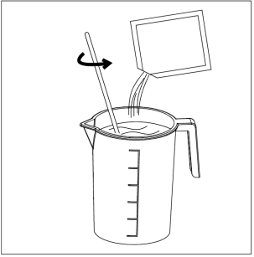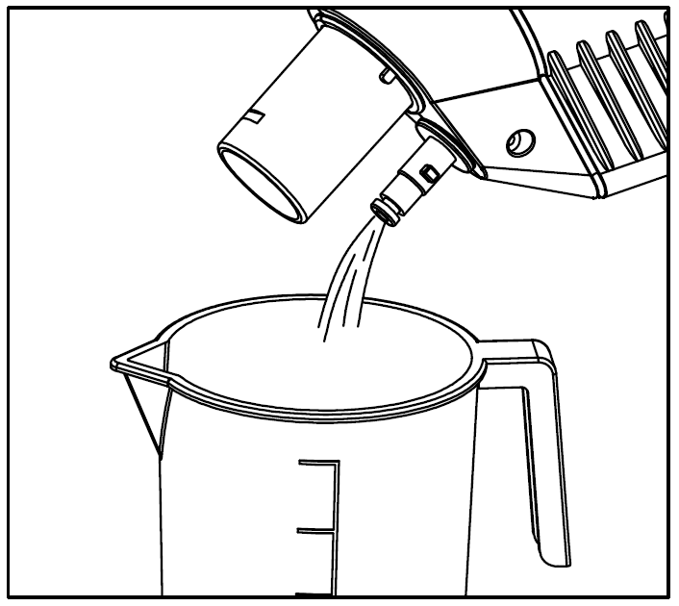

Descaling operation sequence

**6、Technical data**

|  |  |  |  |
| --- | --- | --- | --- |
| Model | **Power (W)** | **Voltage (V)** | **Rate(HZ)** |
|
|  |  |  |  |
| **BJC2021** | **2100W** | **220-240~** | **50/60** |
|
|  |  |  |  |