HWX-HD/1400W（112.5MM/115MM）:
HWX-HD/1400W（109.5MM/105MM）:
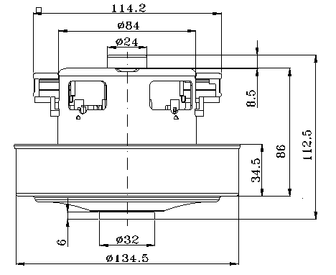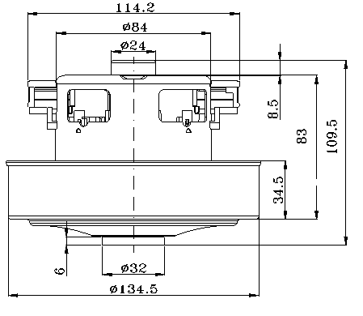
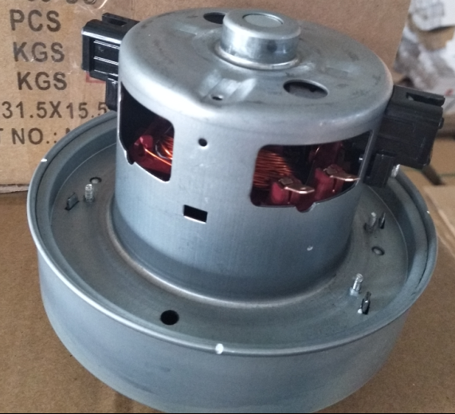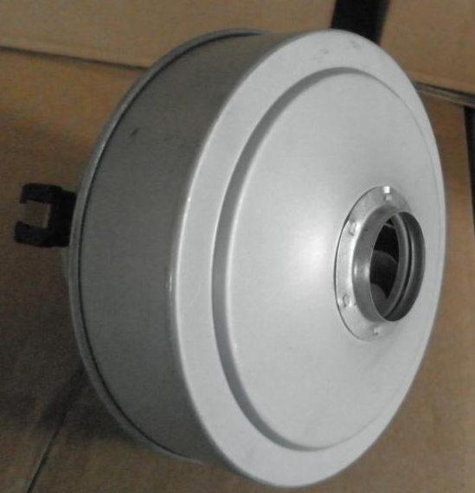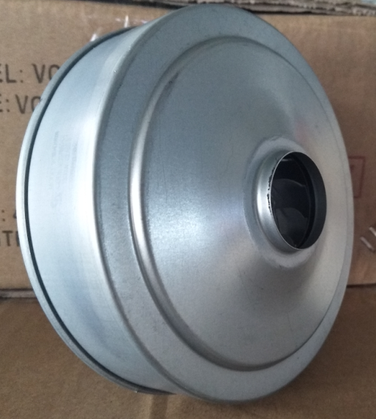

HWX-HD-1/1600W：
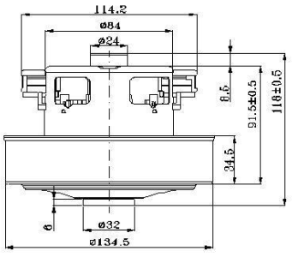

K40/1400W:
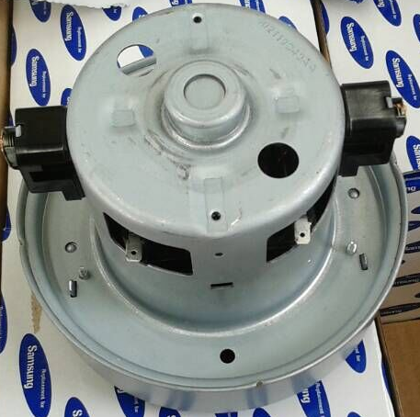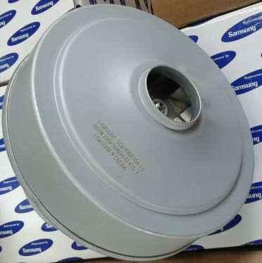
K60/1600W:
K90/1800W：
K90/2000W:
(for this model,some times,with label 2200W or 2400W,real power 2000W)

